ISAPA 2025 Organising Committee
UNESCO@MTU.ie
ISAPA 2025 Program
incorporating IMSVI the
Mental Health Summit
and UNESCO ISAPA International Consultation
16th – 20th June 2025
Theme, Events, Sessions, Presenter Guidelines



Abstract
ISAPA 2025 is a landmark international event that brings together global leaders, researchers, practitioners, and advocates in Adapted Physical Activity to ignite systemic change under the unifying theme “Shifting the Dial: From Awareness to Transformation.” Hosted in Kerry, Ireland, under the patronage of UNESCO, the symposium integrates five major events into one dynamic platform. The program reflects IFAPA’s mission to advance inclusion, research, professional excellence, and international cooperation, while also contributing meaningfully to the implementation of global frameworks such as the UN Convention on the Rights of Persons with Disabilities (CRPD), the Sustainable Development Goals (SDGs), the Paris 2024 Call to Action, Fit for Life, and Quality Physical Education (QPE). ISAPA 2025 challenges all participants to move beyond awareness and embrace action, leveraging inclusive sport, education, and health systems as powerful tools for equity and sustainable development.
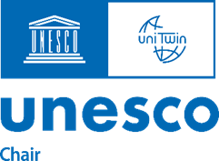


Preface
We are excited to share this document, which provides an overview of ISAPA2025 as of the 08th May 2025 under the patronage of UNESCO.
ISAPA 2025 combines five events which all delegates can attend. All events are included in the schedule below.
- ​The International Symposium of Adapted Physical Activity (ISAPA) 2025
- International Symposium on Physical Activity and Visual Impairment or Deafblindness
- Mental Health Summit: Physical Activity, Nutrition, and Digital Technology: Shifting the Dial for Better Outcomes
- UNESCO – ISAPA International Consultation: Policy Change for Disability Inclusion in Sport: Paris 2024 Call to Action Follow-Up
- Disability Sport Trade Exhibition

What you need to do now:
- Register: If you have not already done so, register on www.isapa2025.com. There are 20 registration types to suit your needs. We strongly recommend including the Gala Dinner in your registration.
- Authors now need to check for any errors or omissions in the schedule vis-à-vis your session. You will need your manuscript number on your acceptance letter (it is a four-digit number beginning with 1 or as listed below if not beginning with 1).
- Attendee Survey. All attendees must complete the Attendee Survey.
- Errors or Omissions: The Attendee Survey must be used to record any errors or omissions.
- Presenter's guidelines: You must follow the guidelines in the annex of this document and incorporate the dial into your presentation and thoughts for ISAPA 2025.
We look forward to welcoming you to Kerry, Ireland.

ISAPA 2025 Shifting the Dial: From Awareness to Transformation

ISAPA 2025 is more than a symposium, it is a global platform to shift the dial toward a more equitable and inclusive world through Adapted Physical Activity (APA). As illustrated in our inclusion continuum graphic, we invite the global community to move beyond awareness and passivity, toward responsiveness and ultimately transformation. This means turning knowledge and acknowledgement of inequality into concrete action, reshaping policies, investing in inclusive practices, and amplifying the voices of those most affected.

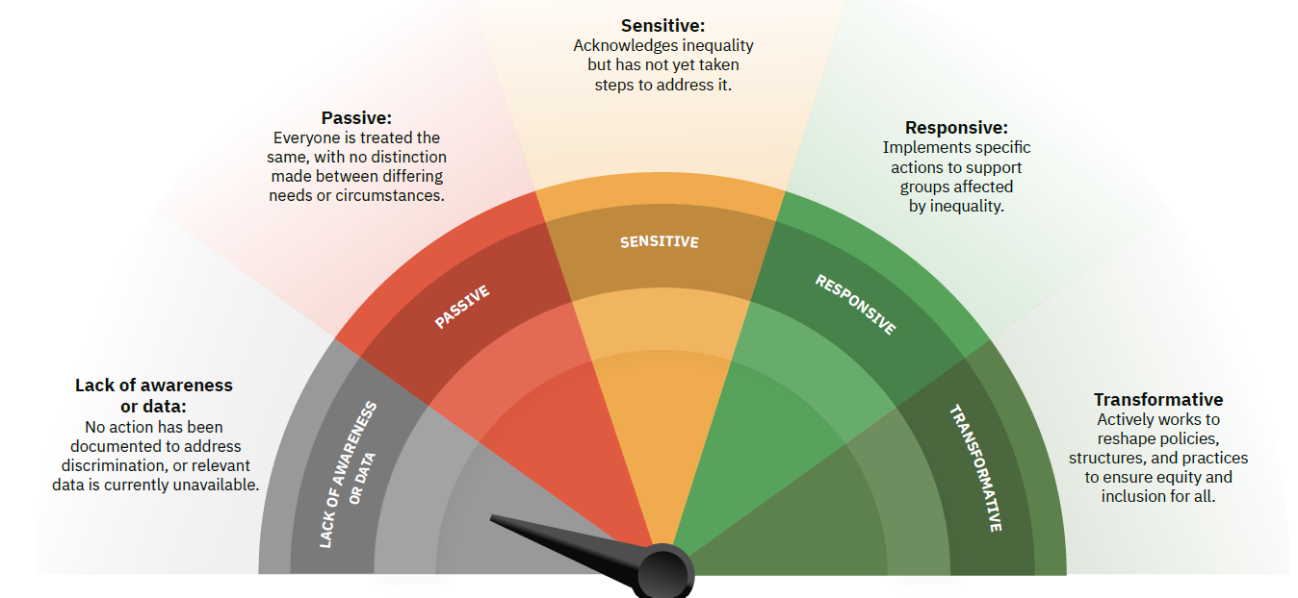

The mission of ISAPA 2025 is firmly rooted in the broader purpose of the International Federation of Adapted Physical Activity (IFAPA): to advance inclusion, equity, and excellence in adapted physical activity worldwide. By fostering global standards, supporting research, and promoting professional development, IFAPA works to ensure that individuals of all abilities can access safe, inclusive, and high-quality physical activity experiences, a purpose amplified by IMSVI in the case of those with visual impairment and deafblindness. ISAPA 2025 brings this mission to life, mobilising researchers, practitioners, and policymakers to engage in international cooperation, exchange knowledge, and co-create solutions that make APA more impactful, more inclusive, and more aligned with global human rights and development agendas.
Our mission is clear: to build meaningful partnerships that drive systemic change in the sector and align our collective efforts with major international frameworks, including the UN Sustainable Development Goals (SDGs), the UN Convention on the Rights of Persons with Disabilities (CRPD), and landmark initiatives like the Paris 2024 Call to Action, Fit for Life, and Quality Physical Education (QPE).
ISAPA 2025 aligns with:
- CRPD Articles such as Article 24 (Education), Article 25 (Health), Article 27 (Work and Employment), and Article 30.5 (Sport and Leisure), which demand inclusive access and active participation in all areas of life, including sport and physical education​.
- SDGs including SDG 3 (Good Health and Well-being), SDG 4 (Quality Education), SDG 5 (Gender Equality), SDG 10 (Reduced Inequalities), SDG 11 (Sustainable Cities and Communities), and SDG 17 (Partnerships for the Goals.
By grounding our conference in these frameworks, ISAPA 2025 is positioned to demonstrate the relevance and impact of APA in delivering on global policy agendas. Whether through scientific research, community-based programs, inclusive design, or policy innovation, your contributions at ISAPA 2025 will help operationalise the commitments laid out in:
- The UNESCO Fit for Life framework, which drives social inclusion through sport;
- The Quality Physical Education (QPE) guidelines, advocating for inclusive, rights-based education;
- The Paris 2024 Call to Action, calling on all stakeholders to ensure the full participation of persons with disabilities in sport, education, and public life​.
We urge all presenters and participants to consider where their work sits on the inclusion continuum and how it can help shift the dial toward transformation. Let ISAPA 2025 be a catalyst for collective action, policy alignment, and measurable impact.

Contents
Preface 1
ISAPA 2025 Shifting the Dial: From Awareness to Transformation 2
Enhancing Your ISAPA 2025 Experience 6
📱 Social Media Engagement 6
🎉 Interactive Engagement Activities 6
🗂️ Session Navigation & Access 7
🛠️ Workshop Participation Expectations 7
Monday 16th June 2025 8
Keynote 9
Oral Presentations (Research /Academic) 9
Oral Presentation (Oral Presentation (Policy/Program)) 10
Practical Workshop 11
Tuesday 17th June 2025 12
Keynote 13
Oral Presentations (Research /Academic) 13
Panel 16
Oral Presentation (Policy/Program) 16
Poster Presentation 17
Practical Workshop 20
Local Legacy 20
Wednesday 18th June 2025 21
Keynote 22
Oral Presentations (Research /Academic) 22
Panel 24
Oral Presentation (Policy/Program) 24
Poster Presentation 24
Practical Workshop 27
ISAPA AGM and SOI Signing Ceremony 27
Local Legacy 28
Thursday 19th June 2025 29
Mental Health Summit Welcome 30
Mental Health Summit Keynotes (See https://www.isapa2025.com/mental-health-summit) 30
Panel 30
Oral Presentations (Research /Academic) 30
Poster Presentation 33
UNESCO ISAPA International Consultation (See: https://www.isapa2025.com/paris-follow-up) 34
Mental Health Summit Demonstrations 34
IFAPA Awards & Gala Dinner 34
Friday 20th June 2025 35
Masterclass 36
Meeting 36
Excursions (self-funded) 36
Guidelines for presenters 37
Technical notes for all presenters 39

Enhancing Your ISAPA 2025 Experience
The ISAPA 2025 Program is designed to offer rich opportunities to learn, connect, and shape global practice in Adapted Physical Activity (APA). To foster an immersive, impactful, and enjoyable event, we’re introducing a range of engaging initiatives:

📱 Social Media Engagement
We invite all presenters and attendees to share their professional social media handles (X, Instagram, LinkedIn). This will:
• Boost online engagement
• Promote your work across networks
• Build community before, during, and after the event

🎉 Interactive Engagement Activities
Get ready to participate, play, and connect with these exciting experiences:
🧠 Adapted Physical Activity Trivia
Quick, fun, and themed trivia moments throughout the event to test your APA knowledge!
🏅 Mini Adaptive Sport Competitions
Experience inclusive sports hands-on — try boccia, goalball, or a wheelchair slalom challenge.
✨ Social Media Spotlights
Share your “Highlight of the Day” using #ISAPA2025 — we’ll feature community posts daily!
👋 Meet the Presenter Corners
Join informal networking corners post-session or over lunch to connect directly with speakers.
🧩 Themed Networking Tables
Find and connect with others around shared interests, topics, or regions.
🎯 “Shift the Dial” Reflection Wall
Contribute to our collaborative display (digital or physical) reflecting on how you’re shifting the dial. Highlights will be featured during the event close.

🗂️ Session Navigation & Access
• The final digital program will include hyperlinked sessions with detailed descriptions and presenter profiles.
• A live information system will provide real-time updates and access to session materials during the event.

🛠️ Workshop Participation Expectations
Each practical workshop will be clearly labelled in the program to indicate whether:
- Active participation is expected
- Observation is suitable
🥂 Social & Activities Program
A full schedule of social activities and community engagement opportunities will be released closer to the event. Subscribe at www.isapa2025.com and stay updated via our news posts and blogs. Evening gatherings will centre around our Social Hub at The Rose Hotel, and the much-anticipated Gala Dinner will be held at the beautiful Ballygarry Hotel.

Monday 16th June 2025
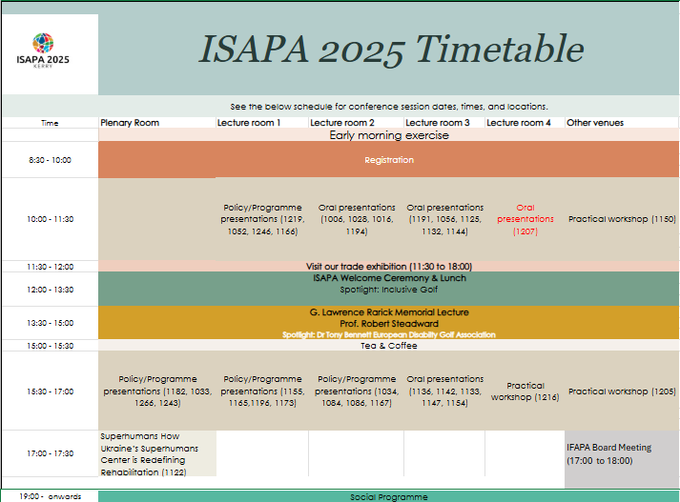

Keynote
Time | Title |  | Venue
13:30-15:00 | G. Lawrence Rarick Memorial Lecture (#3001) | Dr Robert Steadward | Plenary Room

Oral Presentations (Research /Academic)
Time | Title | Authors | Venue
10:00-11:30 | Preliminary convergent and known-groups validity evidence for scores from various executive function tasks in US adolescents with visual impairment (#1006) | Adam Pennell, Alexandra Stribing, Peter Rifenburg, Andrea Taliaferro, Pamela Beach, Lauren Lieberman, Ali Brian | Lecture Room 2
10:00-11:30 | “I didn’t think I qualified”: Adult wheelchair basketball players’ journey to and experience in the sport. (#1207) | Steven K. Holland, Katherine Holland, Cathy McKay | Lecture Room 4
10:00-11:30 | Making the case for using mobile technology to facilitate inclusion in outdoor physical activity for those who live with disabilities (#1132) | TA Loeffler | Lecture Room 3
10:00-11:30 | Redeveloping for accessibility: Applying design thinking approach to create a card game for people with visual impairment (#1125) | Rosa Aysegul Aksoy | Lecture Room 3
10:00-11:30 | Inclusivizing Campus Recreation: Addressing Accessibility Barriers for College Students with Disabilities (#1144) | Kayla Abrahamson, Samantha Ross-Cypcar | Lecture Room 3
10:00-11:30 | Inclusivising Our World: Co-designing an Inclusive Play Space in the Crann Centre, Cork, Ireland (#1191) | Alice Moore | Lecture Room 3
10:00-11:30 | Enhancing Movement: Fundamental Movement Skills in Foundation Phase Children with Visual Impairments in a South African Community (#1194) | Candace Vermaak, Catherine De Wet | Lecture Room 2
10:00-11:30 | The Exploration of an Orientation and Mobility Internship Program at a Summer Sports Camp for Children who are Visually Impaired (#1016) | Benjamin Lytle, Katie Ericson, Lauren Lieberman, Pamela Beach, Amy Parker | Lecture Room 2
10:00-11:30 | Sleep and Physical Activity in Youth with Visual Impairments (#1028) | Pamela Beach, Jack Peltz, Marlee Pontello, Ali Brian, Sarah Decker, Lauren Lieberman, Andrea Taliaferro, Adam Pennell | Lecture Room 2
10:00-11:30 | Design and validation of a questionnaire to measure students ‘perception of inclusive hiking’ (#1056) | Clara Climent Oltra, Héctor Esteve Ibáñez, Lidia Ramos López, Francisco De Asís Martínez Manchón, Laura Jiménez Monteagudo | Lecture Room 3
15:30-17:00 | Mamanet: An Intervention Program to Promote Health Among Women Aged 21–53 with Intellectual and Developmental Disabilities (#1136) | Sharon Barak, Riki Tesler | Lecture Room 3
15:30-17:00 | Co-production of a Mixed Abilities Physical Education Curriculum for Youth with Intellectual and Developmental Disabilities and varying Intersectional Identities (#1142) | Thi Nancy Huynh, Rebecca Bassett-Gunter, Michael Atkinson, Kelly Arbour-Nicitopoulos | Lecture Room 3
15:30-17:00 | Teaching Physical Education (PE) to Students With Learning Difficulties From the Perspective of Non-Specialist Teachers (#1133) | Laura Kummert, Matthias Zimlich | Lecture Room 3
15:30-17:00 | The Paralympic Pathway: Evolution of Participation for Athletes with Intellectual Impairments in the Paralympic Games since 2012 (#1147) | Debbie Van Biesen, roi charles pineda, Jan Burns | Lecture Room 3
15:30-17:00 | Device-based methods for monitoring physical activity in children and adolescents with disabilities (#1154) | Piritta Asunta, Janne Kulmala, Tuomas Kukko, Harto Hakonen, Tuija Tammelin, Kati Karinharju | Lecture Room 3
17:00 – 17:30 | Experience of Superhumans Center in Rehabilitation and Prosthetics for Patients with Limb Amputations Due to Combat Injuries (#1122) | Andrii Vilenskyi | Plenary Room

Oral Presentation (Oral Presentation (Policy/Program))
Time | Title | Authors | Venue
10:00-11:30 | Disability Studies on a Global Landscape: Pedagogical Study Abroad Experiences (#1219) | Brenda Rossow-Kimball, Doug Cripps | Lecture Room 1
10:00-11:30 | Why Inclusion in Physical Education is not Working, and How to Make it Work! (#1052) | Martin E Block | Lecture Room 1
10:00-11:30 | Inclusive Physical and Sports Education as a Prerequisite for a Healthy Society (Czech-Slovak Corossborder Cooperation) (#1246) | Martin Kudláček, Ondřej Ješina, Tomáš Vyhlídal, Dušana Augustovičová, Stanislav Kraček, Dagmar Němček | Lecture Room 1
10:00-11:30 | Connecting Policy with Practice: How the Dutch Ministry of Sport Builds Inclusive and Sustainable Communities (#1166) | Biko Blommestein | Lecture Room 1
15:30-17:00 | Advancing Inclusion and Wellbeing: The Hauora (Wellbeing) Inclusion Initiative in New Zealand (#1182) | Tracey-Lee Dalton | Lecture Room 1
15:30-17:00 | Inclusive hiking project with Joëlette chair in the educational environment (#1033) | Laura Jimenez-Monteagudo, Clara Climent Oltra, Marta Martin Rodríguez, Héctor Esteve Ibáñez | Lecture Room 1
15:30-17:00 | Policy Advocacy in Sport and Society (#1266) | Alana Richardson , Sally-Ann Jennifer Fische | Lecture Room 1
15:30-17:00 | Inclusive active courtyards (#1243) | Anna Fillat | Lecture Room 1
15:30-17:00 | Move as You Are: Promoting Inclusion of Children with Visual Impairments through Sports (#1155) | Giulia Chiara Castiglioni, Sofia Del Governatore | Lecture Room 2
15:30-17:00 | Bridging Science and Sports: The Role of Paralympic Science Support NL in creating a sustainable community (#1165) | Eline Blaauw | Lecture Room 2
15:30-17:00 | Paralympics Ireland NextGen community series (#1196) | Cliona Horan | Lecture Room 2
15:30-17:00 | Knowledge-based multidisiplinary testing of assistive devices for activities in a rehabilitation context (#1173) | Tor Erik Nyquist, Viljar Aasan | Lecture Room 2
15:30-17:00 | Calgary Adapted Hub Powered by Jumpstart (#1034) | David Legg, Cheri Bradish, Marco DiBuono | Lecture Room 3
15:30-17:00 | Special Olympics Healthy Athletes Screenings: Using A Universal Design for Learning in the Health Promotion Discipline (#1084) | Franziska Loetzner, Leah R. Ketcheson, Andrew Pitchford | Lecture Room 3
15:30-17:00 | Reducing inequality in high school sports - authentic sport participation through Friday Night Prime Time an inclusive interscholastic athletic program (#1086) | Nathan Murata, Allison Tsuchida, John Solomon, Kiera Glodowski | Lecture Room 3
15:30-17:00 | Research to Practice: An Opportunity to Support Teachers Further with Inclusion in Physical Education (#1167) | Susan Marron | Lecture Room 3

Practical Workshop
Time | Title | Authors | Venue
10:00-11:30 | Practical Strategies for Children and Adults who are Deafblind to Access Physical Activities (#1150) | Deirdre J Leech, Sorcha Nallen | Sports Academy
15:30-17:00 | Golf a Game Changer as Therapeutic Recreation for ASD (#1205) | Edel Randles, Adrian Whitehead, Mike Keane | Sports Academy
15:30-17:00 | Neurotraining for Adapted Physical Activity: Enhancing Coordination, Balance, and Perception. (#1216) | Markéta Křivánková | Sports Academy

Tuesday 17th June 2025
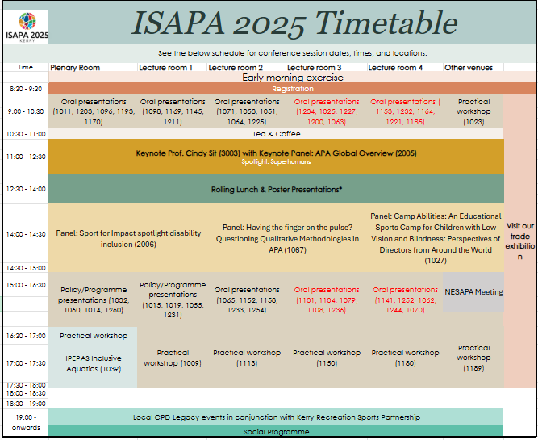

Keynote
Time | Title | Venue
11:00-12:30 | Professor Cindy Sit, President of IFAPA will deliver a keynote and moderate a panel discussion APA Regional Leads on APA Status Quo Across the Regions(#3003) | Plenary Room

Oral Presentations (Research /Academic)
Time | Title | Authors | Venue
09:00-10:30 | Demographic Factors Influencing Parental Support for Physical Activity in Children with Autism Spectrum Disorder in Saudi Arabia (#1011) | M. Alhumaid, Tânia Bastos | Plenary Room
09:00-10:30 | Inclusion of Students with Intellectual Disabilities in Mainstream PE, PA, and Sports (#1153) | Amanda Farrugia, Andrew Soundy | Lecture Room 4
09:00-10:30 | Class-Wide Peer Tutoring: Insights from the Same Class-Context Through Perspectives of Pre-Service Teachers, Typically Developing Students, Students with Down Syndrome (#1232) | An Van de Putte, Matthieu Lenoir, Hilde Van Keer, Geert Van Hove, Elisabeth De Schauwer | Lecture Room 4
09:00-10:30 | Exploring Grappling Sports Participation among Visually Impaired Athletes: A Qualitative Study (#1063) | Jaepyo Sim, T N Kirk | Lecture Room 3
09:00-10:30 | Barriers and Facilitators of Physical Activity Participation among Children with Visual Impairments in the Middle East (#1200) | Samir Qasim, Omar Hindawi, Amr Saad | Lecture Room 3
09:00-10:30 | Enhancing Physical Activity Participation for Students with Visual Impairments through Smart Sport Assistance Systems (#1227) | Philipp Kornfeind, Arnold Baca | Lecture Room 3
09:00-10:30 | A case-study on measurement of motor competence and health-related fitness in children with a vision impairment in Ireland. (#1025) | Úna Britton, Stephen Behan | Lecture Room 3
09:00-10:30 | Motor competence assessment tool for children with visual impairment - - Proposal for validation (#1234) | Carla Lourenço, Dinis Figueiredo | Lecture Room 3
09:00-10:30 | Universal Design for Learning to Applied to Physical Education (#1164) | Carla Lourenço, Omar BEN RAKAA | Lecture Room 4
09:00-10:30 | MTS2Dance - Educational Environment for Teaching Wheelchair Dance (#1098) | Jose Honorio Glanzmann, Eliana Lucia Ferreira, Regina Maciel Braga | Lecture Room 4
09:00-10:30 | Predictors of Preservice Physical Educators’ Self-Efficacy Towards Teaching Students with Autism Spectrum Disorder (#1135) | Chunxiao Li | Lecture Room 4
09:00-10:30 | The Effect of Disability Education among College Students' Attitudes and Perceptions of People with Disabilities in Society (#1064) | Allison J Jackson, Mallory Marshall | Lecture Room 2
09:00-10:30 | Unhearing and unheard: Emancipating the voices of individuals with hearing impairments toward equity in opportunities for sport participation (#1225) | Roi Charles Pineda, Silke De Waelle | Lecture Room 2
09:00-10:30 | Physical Educators’ Self-Efficacy to Teach Students with Disabilities Across Instructional Placements (#1053) | Lindsey Nowland, Justin Haegele | Lecture Room 2
09:00-10:30 | Physical education teaching program according the universal design for learning principles: accessibility for students with disabilities (#1071) | Mey van Munster, Aline Basso-Braz | Lecture Room 2
09:00-10:30 | Exploring a system of able-bodied privilege that creates and maintains barriers to disability inclusion. (#1211) | Lynn Kilpatrick | Lecture Room 1
09:00-10:30 | From Soldiering On to Rebirth and Resilience: How Disability Sport Reconceptualises Recovery Among Injured and Ill Military Veterans their Families (#1145) | Emma V Richardson, Gyozo Molnar, Don Vinson | Lecture Room 1
09:00-10:30 | How do we get a[head] of the game?: An examination of disability sport staff understandings of quality sport and athlete mental health in disability sport and an exploration of disability sport staff preferences for a mental health educational resource in disability sport (#1169) | Roxy H O'Rourke, Catherine M Sabiston, Andrea Bundon, Kelly P Arbour-Nicitopoulos | Lecture Room 1
09:00-10:30 | The Effects of a Digital Physical Activity Intervention On Individuals with a Severe Mental Illness. (#1082) | Shannon Aisling Forde | Lecture Room 1
09:00-10:30 | A behaviour analysis of adult nutrition behaviours and technology use of individuals living with severe mental illness in high support hostels in Ireland. (#1069) | Ciara M O'Sullivan, Alison Merrotsy, Indika Dhanapala, Tara Coppinger | Lecture Room 1
09:00-10:30 | The Impact of Adapted Physical Activity on the Socio-Economic Development of Families with children with Profound and Multiple Disabilities (#1170) | MIRA SHVED | Plenary Room
09:00-10:30 | The right to use leisure time for physical activities and sport in families with children with disabilities: parental burnout syndrome (#1193) | Julie Wittmannová, Renáta Kratochvílová | Plenary Room
09:00-10:30 | Effects of a structured exercise intervention incorporating behavioral interventions on children with ADHD: a randomized controlled pilot study (#1096) | Meiyuan Chen, Xiaozan Wang, Guifeng Xu, Fang Liu | Plenary Room
09:00-10:30 | Feasibility and Usability Testing of ‘MoveMuse’, an AI Chatbot to deliver a Brief Physical Activity intervention for Autistic College Students (#1203) | Gary Rodgers, Mary Rose Sweeney, Anthony Staines, Debbie van Biesen, Natalia Morgulec-Adamowicz, Anna Ogonowska-Słodownik, Sean Healy | Plenary Room
09:00-10:30 | Parental Perceptions of Teaching Competence of Children with and without CHARGE Syndrome (#1051) | Melanie Perreault, Pamela Beach, Lauren Lieberman | Lecture Room 2
15:00-16:30 | Defining “Inclusion”: Scholars’ Use and Operationalization in Major Physical Education Journals (#1062) | Jenna Fesemyer, Justin Haegele, Wesley J. Wilson | Lecture Room 4
15:00-16:30 | Psychometric Validation of the Physical Educators’ Judgments of Inclusion in Angola (#1252) | Agueda Gomes | Lecture Room 4
15:00-16:30 | Alignment of Disability Simulations with Intended Learning Outcomes for Pre-service Physical Education Teachers (#1141) | Amelia C Simpson, Samantha Ross-Cypcar, Abby Fines, Xiaoxia Zhang | Lecture Room 4
15:00-16:30 | Participant Insights on Fitness Program Implementation in an Underserved Community (#1236) | Whitney N Neal, Laurie A Malone | Lecture Room 3
15:00-16:30 | Pre-Service Physical Education Teachers' Sentiments, Attitudes, and Concerns Toward Inclusion of Students with Disabilities: A Study at CACPE (#1254) | Shraddha Abhijit Naik, Vilma Faleiro | Lecture Room 2
15:00-16:30 | The Effect of Participation in the Adapted Baseball Program on Visual Perception and Attention of Adolescents with Developmental Disabilities (#1079) | Seungeun Choi, Hyundo Jun, Yongho Lee | Lecture Room 3
15:00-16:30 | The Relationship Between Weight Stigma and Exercise Avoidance: Exploring the Role of Internalized Weight Stigma and Social Anxiety (#1104) | Qingqing LI, Yun Li | Lecture Room 3
15:00-16:30 | Dietary Intake, body composition analysis, muscle Soreness, fatigue, Mental Stress, Sleep Patterns and Alertness observance in Jordanian Paralympic athletes (#1101) | Omar Suleiman Hindawi, Tamara Mohammad Alhalaiqah, Mohammad Hassan Abualtaieb | Lecture Room 3
15:00-16:30 | Game changers: school sport as a resource of hope for students with disabilities (#1005) | Daniel B Robinson | Lecture Room 4
15:00-16:30 | Comparison of Functional Movement Screen and Balance Assessments After 6-Week Corrective Exercise Programs Developed for Deaf and Hard-of-Hearing Individuals (#1233) | Pelin Aksen, Pamela Beach, Lauren Lieberman, Melanie Perreault, Sean Flanagan | Lecture Room 2
15:00-16:30 | Applicability of Standardized Physical Fitness Test in Schools for Children with Special Education Needs in Latvia (#1158) | Aija Klavina, Zinta Galeja, Edgars Ozols, Rihards Ansons | Lecture Room 2
15:00-16:30 | Using Administrative Health Data to Explore Diabetes Rates in Special Olympics Participants in Ontario, Canada (#1152) | Meghann Lloyd, Robert Balogh | Lecture Room 2
15:00-16:30 | Invalidity Rates of Baseline ImPACT Concussion Assessments in High School Athletes with Disabilities (#1065) | Kiera Glodowski, Troy Furutani, Nathan Murata, Allison Tsuchida | Lecture Room 2
15:00-16:30 | Effects of Short-Term Physical Exercise on Stress Biomarker and Mental Health Issues in Adolescents with ADHD: A Randomized Controlled Trial (#1108) | Sima Dastamooz, Cindy H.P. Sit, Kelly P. Arbour-Nicitopoulos, Rainbow T. H. Ho, Stephen H.S. Wong, Juanita Cheung | Lecture Room 3
15:00-16:30 | The physical fitness of youth with special educational needs in Hungary based on NETFIT® measurement in school year 2023/2024 (#1244) | Katalin Tóthné Dr. Kälbli, Tamás Dr. Csányi, Alexandra Cselkó, Mónika Dr. Kaj | Lecture Room 4
15:00-16:30 | Building Physical Literacy: The PLAYshop Approach for parents of children with intellectual disabilities (#1070) | Hayley Kavanagh, Sarah Meegan, Valerie Carson, Nathan Gavigan, Morgan Potter, Mika Manninen | Lecture room 4
09:00-10:30 | Quality of Participation in Sports Programs of Special Olympics Korea (#1185) | Soomin Lee, Jooyeon Jin | Lecture room 4
09:00-10:30 | The Influence of Physical Educator’s Teaching Competency on Physical Activity Levels of Students with/without a Developmental Disability (#1221) | Young Rok Oh, Jooyeon Jin | Lecture Room 4

Panel
Time | Title | Author | Venue
11:30-12:30 | APA Global Overview (#2005) |  | Plenary Room
14:00-15:00 | Having the finger on the pulse? Questioning Qualitative Methodologies in APA (#1067) | Martin Giese, Janine Coates, Justin Haegele, Anthony J Maher, Sebastian Ruin, Maria Luiza Tanure Alves | Lecture Room 1
14:00-15:00 | Sport for Impact spotlight disability inclusion (#2006) | Paolo Bertaccini | Plenary Room
14:00-15:00 | Camp Abilities: An Educational Sports Camp for Children with Low Vision and Blindness: Perspectives of Directors from Around the World (#1027) | Lauren Lieberman, Ingi Por Einarsson, Valierie Caron, Ursula Barret, Jane Blaine, Molly Armstrong | Lecture Room 2

Oral Presentation (Policy/Program)
Time | Title | Authors | Venue
15:00-16:30 | An inclusive sport in a perceived exclusive industry - Golf is creating a more inclusive and accessible landscape. (#1032) | Tony Bennett | Plenary Room
15:00-16:30 | Beyond the Court: The Support System of Singaporean Wheelchair Rugby (#1060) | Daniel W.H. Seah, Heng Yeow Yap, Jernice S.Y. Tan | Plenary Room
15:00-16:30 | Together Rapid: Inclusive Football for People with Disabilities (#1260) | Gabriel Mayr, Matias Costa, Margit Straka, Jürgen Kerber | Plenary Room
15:00-16:30 | The Effective Use of a Pre-Teaching Checklist for Physical Education for Children with Blindness, Low Vision, or Deafblindness (#1019) | Pamela Beach, Melanie Perreault, Ciara Murphy, Brianna Bowman, Lauren j Lieberman | Lecture Room 1
15:00-16:30 | Enhancing Physical Activity Participation among Adults with Visual Impairments through a Student-led Exercise Program (#1055) | Klára Daďová, Jitka Vařeková, Markéta Křivánková | Lecture Room 1
15:00-16:30 | Boccia for Participants with CVI (Cortical/Cerebral Visual Impairment) (#1231) | Jane D Blaine | Lecture Room 1

Poster Presentation
Time | Title | Authors | Venue
12:30-14:00 | Exploring the (Ex/In)clusion of Disability within Social Justice PE Research (#1007) | Justin Haegele, Fabian Arroyo Rojas, Jennifer Walton-fisette | Plenary Room 2
12:30-14:00 | Research on the Dilemmas and Countermeasures in the Development of Early Childhood Physical Education: A Case Study of Xixian County, Xinyang City (#1102) | 好 张 | Plenary Room 2
12:30-14:00 | Optimized Analysis of Parental Behavioral Styles and Student Health Outcomes: Significant Correlation Findings (#1099) | Rui Wu, Fu Sheng Liang, Xiao Zan Wang | Plenary Room 2
12:30-14:00 | “Inclusion in primary physical education from the perspectives of educational staff and pupils with disabilities: a qualitative systematic review” (#1097) | Chloe Leydon, Katy Pedlow, Sinead Connolly, Jean Daly-Lynn, Karen McConnell | Plenary Room 2
12:30-14:00 | Exercise Intervention and Attention Improvement in a Child with ADHD: A Case Study (#1095) | Zicheng Wang, Xinyue Mao, Meiyuan Chen, Xiaozan Wang | Plenary Room 2
12:30-14:00 | A Single Subject Study on the Improvement of Depressive Emotions in Junior High School Students through Exercise Intervention (#1094) | xinyue mao, chuanfu xiong, mengxiao shen, pengcheng li, yue che, yuanzhen Huang, zichao Chen | Plenary Room 2
12:30-14:00 | The Effects of the Rehabilitation Exercise Program on Functional Movement for Children with Brain Injuries (#1092) | Jiin Heo, Bogja Jeoung | Plenary Room 2
12:30-14:00 | Inclusive Surfing Programme (#1085) | Maeve Johnston, Nuria Smyth | Plenary Room 2
12:30-14:00 | A Scoping Review of Aquatic Therapy for Children and Adolescents with Disabilities (#1083) | Natalia Morgulec-Adamowicz, Oliwia Jakobowicz, Lyndsay Alexander, Andresa Marinho-Buzelli, Catherine Devion, Anna Ogonowska-Slodownik | Plenary Room 2
12:30-14:00 | Beliefs and Experiences of Latina Mothers of Individuals with Developmental Disabilities toward Dance as Physical Activity: A Qualitative Study (#1077) | Nicole M Montanez-Alicea, Luis Columna | Plenary Room 2
12:30-14:00 | Camp Abilities Brazil: accessibility and inclusion of people with visual impairment (#1075) | Maria Luiza Tanure Alves, Mey van Munster, Joslei Viana Souza, José Júlio Gavião de Almeida | Plenary Room 2
12:30-14:00 | Accessibility on trails and the experience of nature from the perspective of people with physical disabilities (#1073) | Mey van Munster, Gustavo Almeida Silva | Plenary Room 2
12:30-14:00 | Shared physical education program: cooperative learning and inclusion of students with disabilities (#1072) | Mey van Munster, Melina Radaelli Gatti | Plenary Room 2
12:30-14:00 | The Positive Impact of Collaborative Research Communities on Physical Education Teachers’ TPACK (#1103) | Xiang Meng, Yangming Zhu, XiaoZan Wang | Plenary Room 2
12:30-14:00 | Assessment of Para Table Tennis Classification: From the Technological Approach to Examine the Fairness of Classification (#1068) | Sheng Wu, Yung-Hoh Sheu | Plenary Room 2
12:30-14:00 | Analysis of Brain Activity during Walking on Soft Uneven Surface among Individuals Post-Stroke (#1054) | Jongmin Lee, Kiara Todd, Mai Narasaki-Jara, Youngok Jung, Brenda Meza, Taeyou Jung | Plenary Room 2
12:30-14:00 | Protocoll on the implementation of the concept “Sports assistance for people with disabilities” (SpAss) in Bavaria (#1050) | Christiane Reuter, Jakob Prechtl, Leonie Sauer | Plenary Room 2
12:30-14:00 | School development towards an active school (#1049) | Leonie Sauer, Christiane Reuter, Jakob Prechtl | Plenary Room 2
12:30-14:00 | Measuring daily physical activity of students with ID during school using accelerometers (#1048) | Jakob Prechtl, Leonie Sauer, Christiane Reuter | Plenary Room 2
12:30-14:00 | Analysis of Energy Expenditure during Game-based Aerobic Exercise among Individuals with Spinal Cord Injury (#1046) | Jordan J Arteaga, Remy J Ortega, Elvin O Garcia, Jesus D Aguilar, Taeyou Jung, Ethan Palache | Plenary Room 2
12:30-14:00 | Evaluating the level of assistance needed for daily activities in children with spinal muscular atrophy (#1045) | Huan Richard Xu | Plenary Room 2
12:30-14:00 | Analysis of Brain Activity during Game-Based Aerobic Exercise in Individuals with Spinal Cord Injury (#1044) | Kiara S Todd, Edith Arrieta, Fatima Elias, Diana Vela, Taeyou Jung | Plenary Room 2
12:30-14:00 | Accessing Physical Activity: Perspectives of Blind and Visually Impaired Emerging Adults (#1043) | T N "Nicole" Kirk | Plenary Room 2
12:30-14:00 | Attitudes of Saudi Students toward the Inclusion of Students with Disabilities in Physical Education Classes (#1029) | Zuhair Abdaladeem Al Salim | Plenary Room 2
12:30-14:00 | Inclusive experiences through alpine skiing? Perspectives towards inclusion by people with visual impairments (#1026) | Felix Oldörp, Martin Giese | Plenary Room 2
12:30-14:00 | The effectivement of inclusive sports activities in the improving Skill performance in individuals with cerebral palsy (#1020) | ISHAK HAMDINI, Hadjer Dridi | Plenary Room 2
12:30-14:00 | A Systematic Review of Gymnastics-Based Interventions on Motor Skills in Children with Intellectual Disabilities (#1018) | Madeline Gose, Phil Esposito | Plenary Room 2
12:30-14:00 | Amplifying the Voices of Students with Disabilities in Integrated Physical Education (#1012) | Cathy McKay, Maria Damewood | Plenary Room 2
12:30-14:00 | Exploring Leisure Activity Interest, Participation, and Satisfaction in Visually Impaired Adults (#1106) | Kathryn E Creveling, Justin Haegele, Xihe Zhu | Plenary Room 2

Practical Workshop
Time | Title | Authors | Venue
09:00-10:30 | Surfing and the Sea beyond sight (#1023) | Tom E Losey | FENIT?
16:30-18:00 | Creative Movement in Action: An Adapted Dance Workshop (#1009) | Baillie R Ollila | Sports Academy
16:30-18:00 | IPEPAS Inclusive Aquatics Practical for Practitioners (#1039) | Eileen Sayers | Sports Academy
16:30-18:00 | Trying to be heard (#1189) | Rebecca J Foster, Alice Smyth | Sports Academy
16:30-18:00 | Experiencing Ancient Movement Cultures (#1113) | Tarik Orliczek | Sports Academy
16:30-18:00 | The Adventure Toolkit; Enhancing the therapy experience using adventures in blue and green spaces (#1262) | Philip G Stallard, Jasmin A Stallard | Sports Academy
16:30-18:00 | Exploring enablers of creating inclusive opportunities (#1180) | Tracey-Lee Dalton | Sports Academy

Local Legacy
Time | Title |  | Venue
19:00-21:00 | Local CPD Legacy events in conjunction with Kerry Recreation Sports Partnership (#3004) | Football for all, GAA for All, Cycling | Various

Wednesday 18th June 2025
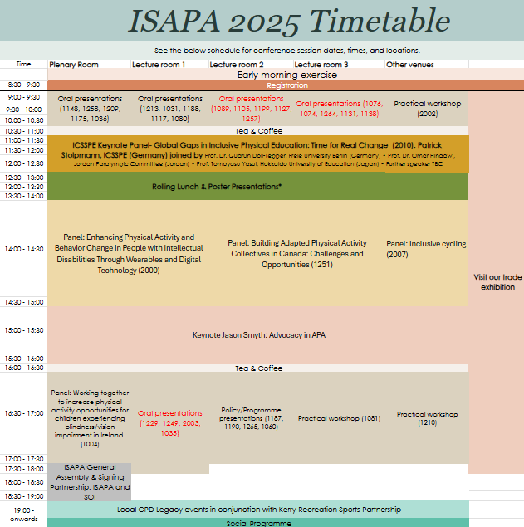

Keynote
Time | Title | Venue
15:00-16:00 | Jason Smyth, World's Fastest Paralympian, Winner of Dancing with the Stars and Paralympics Ireland Staff. (#3022). Supported by The Institute of Movement Studies for Individuals with Visual Impairments (IMSVI) | Plenary Room 1

Oral Presentations (Research /Academic)
Time | Title | Authors | Venue
09:00-10:30 | Bridging the gaps: trends and disparities in sport participation among people with disabilities, mental health disorders and chronic diseases in Flanders, Belgium (#1148) | Debbie Van Biesen, Roi charles pineda, Silke Dewaelle, Jeroen Scheerder | Plenary Room 1
09:00-10:30 | “I didn’t even know any other visually impaired people, I was just on my own”: generative outcomes of football for visually impaired women (#1138) | Jessica L Macbeth, Andrew Sprake | Lecture Room 3
09:00-10:30 | Development of fundamental motor skills of children with visual impairment in Switzerland: One step at a time (#1131) | Valerie Caron, Lauren Lieberman, Ali Brian | Lecture Room 3
09:00-10:30 | The existential nature of touch exchange for blind people as a bridge to confidence and participation in physical activities. A qualitative preparatory study using Reflexive Thematic Analysis (#1264) | Mathias Alberton | Lecture Room 3
09:00-10:30 | An Intersectional Examination of Blind and Visually Impaired Women's Physical activity Experiences (#1074) | Lindsay E Ball | Lecture Room 3
09:00-10:30 | Lessons Learned using Participatory Research to Develop Physical Education Resources and Recommendations for Blind Students (#1076) | Mary A Keene, Nina Marranca, Julia LaGrand, Andrew Mead-Colegrove | Lecture Room 3
09:00-10:30 | Parasport Development Model (#1257) | Mariana Simões Pimentel Gomes, ciro Winckler, Elke Lima Trigo | Lecture Room 2
09:00-10:30 | Exploring the Adaptation Process and Experiences of Para Baseball Player with Physical Disabilities after an Accident (#1127) | Hyundo Jun, Soojung Yoo, Seungeun Choi, Yongho Lee | Lecture Room 2
09:00-10:30 | Qualitative Exploration of Applied Sport Psychology Practices in Deaflympic Sports (#1105) | Alon Markov-Glazer, Rainer Schliermann | Lecture Room 2
09:00-10:30 | Social Impact of Friday Night Prime Time: An evaluation of athlete, peer, teacher, and fan experience (#1089) | Allison Tsuchida, Nathan Murata, John Solomon | Lecture Room 2
09:00-10:30 | Gateways and Pathways within Para Sport in Ireland; the Perspectives of Athletes (#1199) | Alan Dineen, Phil Kearney, Elaine Murtagh, Frank Nugent, Ian Sherwin, Brian Hughes, sean healy | Lecture Room 2
09:00-10:30 | Safe Spaces or Enclaves? Negotiating Social Hierarchies in Specialized PE for Students with VI (#1117) | Martin Giese, Brigitta Höger, Stefan Meier | Lecture Room 1
09:00-10:30 | From barriers to bridges: Key Learnings from the IDEAL Journey (2018–2025) (#1188) | Debbie Van Biesen, Ingi Einarsson, Sean Healy, Alba roldan, Natalia Morgulec, jan burns | Lecture Room 1
09:00-10:30 | Chances and challenges for physical activity in adolescents and young adults with hemophilia (#1031) | Tabea Nauschuetz, Ulrich Theobald | Lecture Room 1
09:00-10:30 | Progressive strength and balance training enhances physical functioning in older adults with decreased functional capacity (#1213) | Saila Hänninen, Katja Borodulin | Lecture Room 1
09:00-10:30 | Body Normativity and Inclusion in Physical Education: A Critical Reflection Through bell hooks' Lens (#1036) | Maria Luiza Tanure Alves, Justin Haegele, Janine Coates, Martin Giese, Sebastian Ruin, Anthony J. Maher | Plenary Room 1
09:00-10:30 | Physical activity and gaming activity among adolescents with disabilities (#1175) | Kwok Ng | Plenary Room 1
09:00-10:30 | Adapted Sports in Brazilian Universities: Are We Truly Preparing Future Professionals? (#1209) | Ciro Winckler, Pablo B Souza, Anselmo Costa e Silva, Ricardo Tanhoffer, Otávio Furtado | Plenary Room 1
09:00-10:30 | Contributions of sport to Venezuelan refugees with disabilities (#1258) | VINICIUS DENARDIN CARDOSO, Rafaele Rodrigues Bastilha, Alyne Tavares Honorato, ALLANA LITHICIA OLIVEIRA CAMILO | Plenary Room 1
09:00-10:30 | The Health-Related Quality of Life and Putative Factors of Icelandic and American Youth with Multiple Disabilities including Visual Impairments (#1080) | Ali S Brian, Andrea R Taliaferro, Pamela S Beach, Ben Lytle, Adam Pennell, Lauren J. Lieberman, Ingi Thor Einarsson | Lecture Room 1
16:30-17:30 | Adherence to Physical Activity Wearables: Pilot Data from Special Olympics’ Project ALL STAR Longitudinal Evaluation (#2003) | Alicia Dixon-Ibarra, Calvin Trisolini, Suzanne O’Neal, John Hanley, Brian Helsel, and Andrew Lincoln | Lecture Room 1
16:30-17:30 | Adults with intellectual disabilities and motor intervention in trampolines (#1229) | Carla Lourenço, Antonino Pereira | Lecture Room 1
16:30-17:30 | Exploring the Interplay between diet, obesity, mental health, and the gut microbiome. The MIND-GUT pilot intervention study (#1249) | Deborah Gustafson, Elisabet Rothenberg, Fabrizio Belloni, Nagalakshmi Eruvuri, Steinn Steinngrimsson, Hanne Carlssen, Rajna Knez, Erika Olsson, Robert D Burk, Hellas Cena, Rachele de Giuseppe, Gianluca Tognon | Lecture Room 1
16:30-17:30 | Exploring the Influence of Group-Based Organized Physical Activity on Social Abilities and Motor Skills in Autistic Children: A Multilevel Meta-Analysis (#1035) | He Jinrong, Zhang Lei, Wu Quanshuo, Wu Xueping | Lecture Room 1

Panel
Time | Title |  | Venue
14:00-15:00 | Enhancing Physical Activity and Behavior Change in People with Intellectual Disabilities Through Wearables and Digital Technology (#2000) | Andrew Lincoln; Andy Pitchford; Louise Lynch; Naveed Iqbal | Plenary Room 1
14:00-15:00 | Building Adapted Physical Activity Collectives in Canada: Challenges and Opportunities (#1251) | David Legg, Jennifer Leo, Andrea Carey | Lecture Room 1
14:00-15:00 | Inclusive cycling (#2007) |  | Lecture Room 2
16:30-17:30 | Working together to increase physical activity opportunities for children experiencing blindness/vision impairment in Ireland. (#1004) | Ann Sullivan Centre | Plenary Room 1

Oral Presentation (Policy/Program)
Time | Title | Authors | Venue
16:30-17:30 | ENHANCING PHYSICAL ACTIVITY AND EQUITY THROUGH COMMENSURATE ACCESSIBILITY INFORMATION (#1187) | Kati Karinharju, Reetta-Kaisa Kuusiluoma, Henna Niemi, Kati Seppala | Lecture Room 2
16:30-17:30 | Health and Wellbeing in Intellectual Disability: A feasibility and evaluation study of a programme for adults with intellectual disabilities. (#1190) | Helen McCready, Ken VanSomeren, Ben Fitzpatrick, Sinead Martin | Lecture Room 2
16:30-17:30 | Experience of Superhumans Center in Rehabilitation and Prosthetics for Patients with Limb Amputations Due to Combat Injuries (#1122) | Andrii Vilenskyi | Lecture Room 2
16:30-17:30 | Radical Inclusion (#1265) | Christian Lauro Rodríguez Morales | Lecture Room 2
16:30-17:30 | Beyond the Court: The Support System of Singaporean Wheelchair Rugby (#1060) | Daniel W.H. Seah, Heng Yeow Yap, Jernice S.Y. Tan | Lecture Room 2

Poster Presentation
Time | Title | Authors | Venue
12:30-14:00 | Weekdays and weekends do not contribute equally: Uncovering the association between physical activity and adiposity among children with special educational needs in Hong Kong (#1109) | Jie Feng, Cindy Hui-ping Sit, Stephen Heung-sang Wong, Wendy Yajun Huang, Martin Chi-sang Wong, Raymond Kim-wai Sum, Catherine Carty, Judy Ka-wai Kong, Jinghao Sui | Plenary Room 2
12:30-14:00 | Differences in Physical Activity Levels and Adiposity Among Children with Special Educational Needs: Disparities in Gender and SEN Type (#1261) | Min Yang | Plenary Room 2
12:30-14:00 | Effects of a School-Based Physical Activity Intervention on Physical Activity and Physical Fitness in Children and Adolescents with Disabilities: A Pre-Post Study (#1259) | Mengyao Wang | Plenary Room 2
12:30-14:00 | The relationship of health literacy with physical fitness and exercise capacity among students with mild intellectual disabilities (#1256) | Takahiro Watanabe, Yujiro Kawata, Tadashi Watari, Kunio Odaka | Plenary Room 2
12:30-14:00 | Evaluating the Impact of the 'I Can' Health and Wellbeing Programme on Adults Who Are Blind and Vision Impaired. (#1255) | Áine Stanley | Plenary Room 2
12:30-14:00 | Perceptions about Inclusion of Students with Disabilities in Education in Sub-Saharan Africa: A Scoping Review (#1253) | Agueda Gomes | Plenary Room 2
12:30-14:00 | Beyond Just Moving - Cognitively Engaging Physical Activity Enhances Inhibitory Control in Children with ADHD: A Pilot Randomized Controlled Trial (#1250) | Ruiyuan Tao, Cindy Hui-Ping Sit, Andy Chia-Liang Tsai, Wendy Yajun Huang, Stephen Heung-Sang Wong, Parco Ming-Fai Siu, Savio Wai-Ho Wong, Jie Feng, Sima Dastamooz, Chang Liu | Plenary Room 2
12:30-14:00 | Thirty Years of Applied Physical Activity at the Faculty of Physical Education and Sport of Charles University in Prague Czech Republic (#1248) | Ilona Pavlová | Plenary Room 2
12:30-14:00 | PIQ-PE - an innovative tool for assessing the student's perception of inclusion in physical education (#1247) | Basia Rosołek, Lauren j Lieberman, Melanie Perreault, Pamela Beach, Anna Zwierzchowska | Plenary Room 2
12:30-14:00 | Validation of AI-based Physical Function Test (myFitNote) in Timed Up and Go (TUG) Test (#1242) | muncheong choi, Hong-sun song, Alchan Kim, Da-Ae Kim, Ji-woong Kim, Bogja Jeoung | Plenary Room 2
12:30-14:00 | Investigation of the Relationship Between Functional Movement Screen and Postural Stability and Stability Limits in Deaf and Hard-of-Hearing Individuals (#1235) | Pelin Aksen, Lauren Lieberman, Pamela Beach, Melanie Perreault, Sean Flanagan | Plenary Room 2
12:30-14:00 | Attitudes and Intentions of Mothers of Autistic Children toward Yoga: A Qualitative Study through the Lens of the Theory of Planned Behavior (#1224) | Gayatri Swarup, Susan Andreae, Kristen Pickett, Luis Columna | Plenary Room 2
12:30-14:00 | Peer-Led Sport Socialization Intervention Programme on adaptive behavior functioning Amongst Children with Intellectual Disability in Kakamega County Kenya (#1223) | ROSELYNE AJWANG ODIANGO | Plenary Room 2
12:30-14:00 | Understanding the Experience of Participating in a University-Hosted Inclusive Sports Event (#1218) | Yaejee Kim, So-Yeun Kim | Plenary Room 2
12:30-14:00 | Conceptualizing Sustainable Physical Literacy for Children with Developmental Disabilities: A Systematic Review (#1217) | Jooyeon Jin, Hoo Kyung Lee, Jiwoo Han, Soomin Lee | Plenary Room 2
12:30-14:00 | Activities of the Head of the Secondary Schools Creating a Friendly Environment for the Inclusion (#1215) | Jurate Pozeriene, Ugne Slapsyte, Oksana Macenaite | Plenary Room 2
12:30-14:00 | Every Move Matters: Experiences of Students with Disabilities in Inclusive Physical Education Classes (#1208) | Vida Ostaseviciene, Airida Labeckaite, Kwok Ng | Plenary Room 2
12:30-14:00 | Understanding the Physical Activity Patterns of Children with Autism Spectrum Disorder in China (#1110) | Zichao Zhang, Yuemei Lu, Chenjun Zong, Zhihui Li, Xiaozan Wang | Plenary Room 2
12:30-14:00 | A pilot intervention to promote physical activity participation among youth with cerebral palsy: Action research (#1112) | Karin Kleinhans | Plenary Room 2
12:30-14:00 | The memories of failure in PE turned into success in Sport by Brazilian Paralympic athletes (#1116) | Maria Luiza Tanure Alves, Isabella Santos Alves, Nathali Fernanda Feliciano, Gustavo Cunha Silva, Janine Coates | Plenary Room 2
12:30-14:00 | Forging Paths: Understanding Outdoor Play for Children with Disabilities in Early Childhood. (#1123) | Alessia M. Capone, Maeghan E. James, Louise de Lannoy, Kelly Arbour-Nicitopoulos, Mark S. Tremblay | Plenary Room 2
12:30-14:00 | The Impact of a Self-Advocacy Physical Activity Training Program in Children with Visual Impairment (#1172) | Lauren j Lieberman, Ruth Childs, Ali Brian, Pamela Beach | Plenary Room 2
12:30-14:00 | Cross-sectional Descriptive Study Assessing Fundamental Motor and GAA Specific Motor Skills in Irish Primary-school aged Autistic Children (#1174) | Edel Ryan, Dean McDonnell, Sean Healy, Rhodri Lloyd, Sharon Kinsella | Plenary Room 2
12:30-14:00 | Brazilian School Paralympics: an analysis of the evolution (#1263) | Pedro André da Silva Lins, José Antônio Fogão, Gustavo da Cunha Silva, Pablo Henrique Carneiro de Matos Viana, João Vítor Sebastião Rodrigues, Rogerio Virginio dos Santos, Beatriz Cuppi Machado, Maria Luiza Tanure Alves | Plenary Room 2
12:30-14:00 | Validation of the Czech Version of the SRS-22r Questionnaire for Assessing Quality of Life in Adolescents with Idiopathic Scoliosis (#1176) | Pavlína Hušková | Plenary Room 2
12:30-14:00 | Proposed Digital-Based, Customized Sports Program for the Underprivileged (#1184) | Gunsang Cho, Jaehwa Kim, Hyunsu Lee | Plenary Room 2
12:30-14:00 | Comparative study of inclusive local sports clubs: Ecosystem analysis of Sapporo and Berlin (#1186) | Tomoyasu Yasui, Ai Senga, Rihito Yamamoto, Gudrun Doll-Tepper | Plenary Room 2
12:30-14:00 | Experimental study of the effect of intelligent exercise APP on TGMD-3 in children with developmental delay (#1195) | Jiayu zhou | Plenary Room 2
12:30-14:00 | Can sport counteract social isolation? The opportunity of innovative sports programs for people with Intellectual Disabilities (#1202) | Sina Eghbalpour, Liane Prof. Dr. Schirra-Weirich | Plenary Room 2
12:30-14:00 | Evaluation of the Adapted Physical Activity Master study program at Lithuanian Sports University (#1206) | Vida Ostaseviciene, Kwok Ng, Jurate Pozeriene, Diana Reklaitiene | Plenary Room 2
12:30-14:00 | Effect of intervention programs on motivation to physical activity in obese young school-age children (#1177) | Markéta Buřilová | Plenary Room 2
12:30-14:00 | Evaluating a Special Olympics Youth Fitness Testing Manual for Athletes with Intellectual and Developmental Disabilities (#2001) | Alicia Dixon-Ibarra, Gwendolyn Apgar, Janette Wakins, Heidi Stanish, Melissa Otterbein, and Andrew Lincoln | Plenary Room 2

Practical Workshop
Time | Title | Authors | Venue
09:00-10:30 | Engaging Individuals with Intellectual Disabilities in Inclusive Research: Practical Strategies for Adapted Physical Activity Researchers (#2002) | Alicia Dixon-Ibarra, Athlete Advisory Board member (TBD), Ashlyn Smith, Hope Murray, and Andrew Lincoln | Sports Academy
16:30-17:30 | Coaching Youth with Intellectual Disabilities: Practical Tools and Strategies for Success (#1081) | Hayley Kavanagh, Louise Grant, Brian McGuigan | Lecture Room 3
16:30-17:30 | Expanding Access to Adapted Sports: Preparing Future Educators to Champion Adapted Sports in Schools and Communities. (#1210) | Kathleen Happel, Rebekah Johnson, Nikki Hollett | Sports Academy

ISAPA AGM and SOI Signing Ceremony
Time | Title |  | Venue
17:30-19:00 | ISAPA AGM (#3033)  Signing of Partnership Agreement SOI and IFAPA (#3023) | Integrating with General Assembly | Plenary Room 2

Local Legacy
Time | Title |  | Venue
19:00-21:00 | Local CPD Legacy events in conjunction with Kerry Recreation Sports Partnership (#3004) | Football for all, GAA for All, Cycling | Various

Thursday 19th June 2025
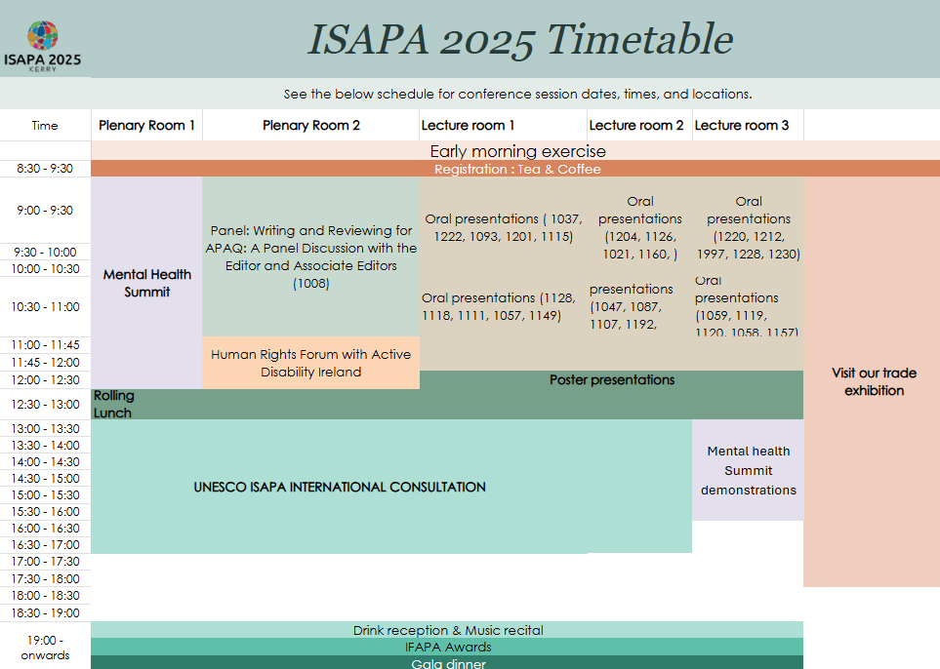

Mental Health Summit Welcome
Time | Title | Venue
09:00-12:30 | John Farrelly CE of the Mental Health Commission Ireland, Professor Maggie Cusack President of Munster Technological University (MTU) and Dr Gerardina Harnett, Head of Department of Nursing, Mental Health Nursing and Healthcare Sciences at MTU. (#3017) | Plenary Room 1

Mental Health Summit Keynotes (See https://www.isapa2025.com/mental-health-summit)
Time | Title |  | Venue
09:00-12:30 | Professor Ahmed Hankir, MBChB, MRCPsych, Consultant Psychiatrist, 2022 Recipient of WHO Director-General Award for Global Health (#3007) |  | Plenary Room 1
09:00-12:30 | Dr. Karen O’Connor, the National Clinical Lead for Early Intervention in Psychosis in Ireland (#3008) |  | Plenary Room 1
09:00-12:30 | Aoife Ní Mhuirí BSc (Physiotherapy), MSc (Sports Medicine), is the CEO and Founder of Salaso Health Solutions (#3009) |  | Plenary Room 1

Panel
Time | Title |  | Venue
09:00-12:30 | Special Olympics Mental Health Resource Co-Creation (#3010) |  | Plenary Room 1
09:00-12:30 | Keynotes join a panel with David Donoghue was the Ambassador of Ireland to the United Nations who negotiated Agenda 2030 and the Sustainable Development Goals and Niall Muldoon Dr Niall Muldoon is the Ombudsman for Children. His job is to ensure that children in Ireland are treated fairly. (#3011) |  | Plenary Room 1
10:00-11:30 | Writing and Reviewing for APAQ: A Panel Discussion with the Editor and Associate Editors (#1008) |  | Lecture Room 1

Oral Presentations (Research /Academic)
Time | Title | Authors | Venue
09:00-10:30 | Impact of a 12-week Motor Skill Intervention on Gross Motor Skill Proficiency and Adaptive Behaviour in Children Aged 3-5 years with ASD (#1160) | Hannah Lywood, Meghann Lloyd | Lecture Room 2
09:00-10:30 | Educating volunteers with disabilities to work at sport events - a chance to enhance sport participation? (#1093) | Marlene Jobst, Christoph Kreinbucher-Bekerle | Lecture Room 1
09:00-10:30 | Effects of VR-based Physical Activity Programs with/without Headset on Attention, Balance, Physical Activity, and Social Skills of Children with Disability. (#1222) | Jiwoo Han, Jooyeon Jin | Lecture Room 1
09:00-10:30 | The effects of physical activity timing and adherence to physical activity guidelines on sleep in children with ADHD (#1037) | Xiao Liang, Hui Qiu, Mengping Zhao, Nan Liu, Huan Richard Xu | Lecture Room 1
09:00-10:30 | Exploring the Longitudinal Study for Children and Youth with Physical Disabilities in Leisure Behavior: A Scoping Review (#1091) | JUNG YU FAN, Man-Yat Lee | Lecture Room 1
09:00-10:30 | #WheelchairBBStories: A co-designed resource for accessible dissemination of research (#1021) | Lesley M Sharpe, Janine K Coates, Victoria Goosey-Tolfrey | Lecture Room 2
09:00-10:30 | Exploring community-based organizations and their efforts to foster the physical literacy journey for all (#1126) | Kyle Pushkarenko | Lecture Room 2
09:00-10:30 | The role of the Paralympics in the context of the perception of people with disabilities in (competitive) sport (#1201) | Sina Prof. Dr. Eghbalpour, Liane Prof. Dr. Schirra-Weirich | Lecture Room 1
09:00-10:30 | “It’s like a big family reunion”: Parent experiences of a national wheelchair basketball tournament in the United States (#1204) | Katherine E Holland, Steven K Holland, Cathy McKay | Lecture Room 2
09:00-10:30 | Barriers to Sports Participation amongst Youth Refugees with Disabilities in Kenya: A Case of Kakuma Refugee Camp (#1228) | EDINAH SABIRI | Lecture Room 3
09:00-10:30 | Identity Formation and Social Benefits at the Intersection of Disability and Fitness: Leveraging Disabled Lived Experience to Re-Evaluate Physical Activity (#1197) | Cade Kuehl | Lecture Room 3
09:00-10:30 | THE USAGE OF MOSSTON’S SPECTRUM STYLES OF TEACHING FOR STUDENTS WITH AUTISM WITHIN UNIVERSAL DESIGN FRAMEWORK (#1212) | Brandon McIntire | Lecture Room 3
09:00-10:30 | Trajectories of Leisure-Time Physical Activity and Influencing Factors among Middle-Aged and Older Adults with Disabilities (#1220) | Areum Han, Jooyeon Jin | Lecture Room 3
09:00-10:30 | Reaching In and Reaching Out: Lessons Learned from the Co-Development and Co-Implementation of a Community-Engaged Physical Literacy Program (#1230) | Kyoung June Yi | Lecture Room 3
10:30-11.45 | Active learning strategies in adapted physical education courses in higher education (#1057) | Otávio Luis Piva da Cunha Furtado, Justin Haegele, Roberta Caveiro Gaspar | Lecture Room 1
10:30-11.45 | Affective Reflective Theory: An Exploratory Study of the Exercise Experiences of Elite Wheelchair Curlers (#1149) | Jeffrey Martin, Klara Dadova, Eva Prokesova, Jitka Varekova, Drew J Martin | Lecture Room 1
10:30-11.45 | Increasing inclusivity for wheelchair users: Scaling up clinical-based wheelchair skills training into community sport and recreation programming. (#1059) | Jenna Smith, Kelly Arbour-Nicitopoulos, Krista Best, Ashley Stirling | Lecture Room 3
10:30-11.45 | Exploration and Practice of KDL Motor Intervention for Children with Special Needs (#1119) | Xiaozan Wang, Qinping Xu, Meiyuan Chen, Yuemei Lu | Lecture Room 3
10:30-11.45 | The Influence of an Inter-University Collaborative on the Socialization of Adapted Physical Activity Doctoral Students (#1120) | Paul H. Warner, Paul R Malinowski, Kevin A. Richards, Peter Rifenburg, Wesley J. Wilson | Lecture Room 3
10:30-11.45 | A Systematic Review of the Effects of Exercise on Gross Motor Skills and Social Abilities in Children with Autism (#1111) | Jiawei Luo, Yun Li | Lecture Room 1
10:30-11.45 | Parents of Athletes in Competitive Paralympic Sports (#1047) | Alina Vogel | Lecture Room 2
10:30-11.45 | Impact of Physical Activity on Quality of Life: Examining the Quality of Life of People with Developmental Disabilities in South Korea Using the 2023 Work and Life Status Survey (#1128) | Jiyeon Kim | Lecture Room 1
10:30-11.45 | Participation of People with Impairments in Shaping Accessible Sports Facility Standards: Opportunities and Obstacles (#1058) | Jonas Wibowo, Lasse Müller | Lecture Room 3
10:30-11.45 | Physical activity (PA) and barriers of adults with special needs – how do age, gender, living environment and the nature of special needs affect it? (#1163) | Timo Ala-Vähälä, Venla Väyrynen | Lecture Room 2
10:30-11.45 | Belonging and inclusion in Norwegian PE: An amplified analysis of supervised master’s theses (#1192) | Steven K. Holland, Katherine Holland, Oda Innvær, Nora Klaussen, Ingrid Kissten, Maren Østby | Lecture Room 2
10:30-11.45 | Active play among young children (0-4 years) with disabilities: A scoping review (#1107) | Alessia M. Capone, Kelly Arbour-Nicitopoulos, Louise de Lannoy, Suzanne Deliscar, Leah G. Taylor, Patricia Tucker, Leigh M. Vanderloo, Maeghan E. James | Lecture Room 2
10:30-11.45 | The Impact of Service-learning on Undergraduate Kinesiology Majors’ Self-efficacy Toward Working with individuals with Disabilities (#1087) | Michihito Ichihara, Chloe Simpson, Ken hansen, Mai Narasaki Jara | Lecture Room 2
10:30-11.45 | Move and Thrive: Effectiveness of a Structured Motor Intervention on Motor Behaviors and Social Development in Children with Autism Spectrum Disorder (#1118) | Yuemei Lu, Chenjun Zong, Zichao Zhang, Zhihui Li, Xiaozan Wang | Lecture Room 1
10:30-11.45 | AI-Driven Adapted Physical Activity to Promote Health and Mobility for Frail Older Adults (#1157) | Yijian Yang, Xiaoping Zheng, Jingwen Pan, Ka Po Chan | Lecture Room 3
09:00-10:30 | Move to Improve: An 8-week, coach-led fundamental movement skill intervention for children with intellectual disabilities (#1115) | Hayley Kavanagh, Sarah Meegan, Nathan Gavigan, Valerie Carson, Morgan Potter, Mika Manninen | Lecture Room 1

Poster Presentation
Time | Title |  | Venue
12:00-13:00 | Mediating Role of Self-determined Motivation in the Relationship between Mindfulness and Intention toward Physical Activity among Individuals with Physical Disabilities (#1181) | Jaehwa Kim, Sang Yeon Woo, Hyun-Su Lee, Gun-Sang Cho, Seokmin Yun | Plenary Room 2
12:00-13:00 | Analyzing the Intention to Use Digital Technology in Physical Activities for People with Disabilities: A Study Based on the Theory of Planned Behavior (#1183) | Hyunsu Lee, Jaehwa Kim, Gunsang Cho | Plenary Room 2
12:00-13:00 | Brazilian Physical Education Undergraduate Students' Attitudes Toward Different Types of Disability (#1124) | Doralice Lange de Souza, Jackeline Colere | Plenary Room 2
12:00-13:00 | An Investigation on Parental Perceived Motor Competence in Children on the autism spectrum (#1134) | Zhihui Li, Yuemei Lu, Chenjun Zong, Zichao Zhang, Xiaozan Wang | Plenary Room 2
12:00-13:00 | The Effect of Exercise Program on Musculoskeletal Changes in Individuals with Diabetic Foot Syndrome (#1139) | Eliška Vrátná, Klára Daďová, Jitka Vařeková, Vladimíra Fejfarová, Kateřina Králová | Plenary Room 2
12:00-13:00 | Move Smart MS - Online physical activity and education programmes (#1143) | Susan Coote, Hugh O'Loughlin | Plenary Room 2
12:00-13:00 | A Study on the Correlation Between Actual motor competence and Parental Perceived Motor Abilities in Children with Autism Spectrum Disorder (#1146) | Chenjun Zong, Yuemei Lu, Zhihui Li, Zichao Zhang, Xiaozan Wang | Plenary Room 2
12:00-13:00 | Football as a tool helping to tackle social issues (#1151) | Julie Wittmannová, Arnošt Svoboda, Simona Šafaříková | Plenary Room 2
12:00-13:00 | Incorporating "Exercise Snacks" into School Lunch Breaks Promotes Cardiorespiratory Fitness and Self-perceived Physical Competence among Adolescents with Attention-Deficit/Hyperactivity Disorder (#1156) | Jinghao Sui, Cindy Hui-ping Sit, Jie Feng, Sima DASTAMOOZ, Chang Liu | Plenary Room 2
12:00-13:00 | Physical Fitness Levels of Adult Special Olympics Athletes Across Sports (#1171) | Hanna H Lee, Franziska Loetzner, Andrew Pitchford | Plenary Room 2
12:00-13:00 | A Two-Year Study on Dual-Task Interventions: Advancing Elderly Care in Community Settings (#1041) | Kameliya Konstantinova, Emerick Kaitell | Plenary Room 2

UNESCO ISAPA International Consultation (See: https://www.isapa2025.com/paris-follow-up)
Time | Title |  | Venue
12:30-17:00 | Policy Change for Disability Inclusion in Sport: Paris 2024 Call to Action Follow-Up (#3012) |  | Plenary Room 1

Mental Health Summit Demonstrations
Time | Title | Venue
13:30-16:30 | Demonstration of Salaso’s Smart Therapy Engagement Platform as a Service – STEPS (#3013) | Solas Building
13:00- 16:30 | Visit our new state-of-the-art Physical and Mental Health Simulation Suite | Solas Building

IFAPA Awards & Gala Dinner
Time | Title | Venue
19:00-21:00 | This highly anticipated Gala Dinner and IFAPA awards are a not to miss event on the program. Everyone is welcome, including your guests, but you must have a ticket to attend. Wear evening wear or a national dress/costume. The Gala Dinner will be an exceptional evening of celebration of Irish culture, food, music, and hospitality. We highly recommend attending. The recipients of the IFAPA Awards will be announced on the night. (#3015) | Ballygarry Hotel

Friday 20th June 2025
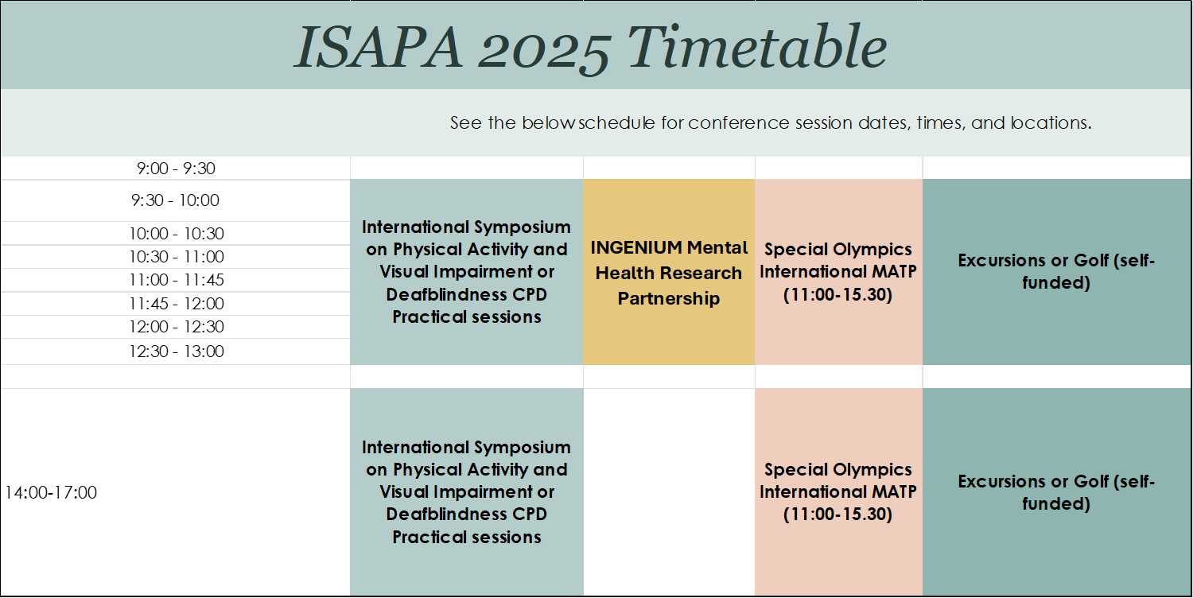

Masterclass
Time | Title |  | Venue
9:30-13:00 | APA for Visual Impairment and Deafblindness (#3018) | IMSVI | Sports Academy
9:30-13:01 | Lite bikes: Cycling for people with disabilities (#3019) | Lite Bikes – Andy Smith | Outdoors
11:00-15:30 | Special Olympics Motor Activities Training Programme (#3019) | Special Olympics International Niamh Reilly & Shaun Hennessy | Sports Academy
Morning TBC | Inclusive Dance | Dr Sharon Phelan | Sports Academy

Meeting
Time | Title |  | Venue
9:30-14:00 | INGENIUM Research Partnership on Mental Health Tara Coppinger & Catherine Carty (#3020). INGENIUM Partners from MTU, South Eastern Finland University of Applied Sciences – XAMK (Finland), Gabriele d‘Annunzio“ University Chieti – Pescara (Italy), University of Skövde (Sweden) will advance research objectives on lifestyle interventions and digital technology for mental health. |  | U306

Excursions (self-funded)
Time | Title |  | Venue
07:00-20:00 | TRIPS (#3021) or Golf |  | Various

Guidelines for presenters

A key theme of ISAPA 2025 is Shifting the Dial. All presenters should consider how their work helps shift the dial. The dial created for this event is below – feel free to use this dial in your presentation. Please note – it is still under development and may change slightly between now and ISAPA 2025.

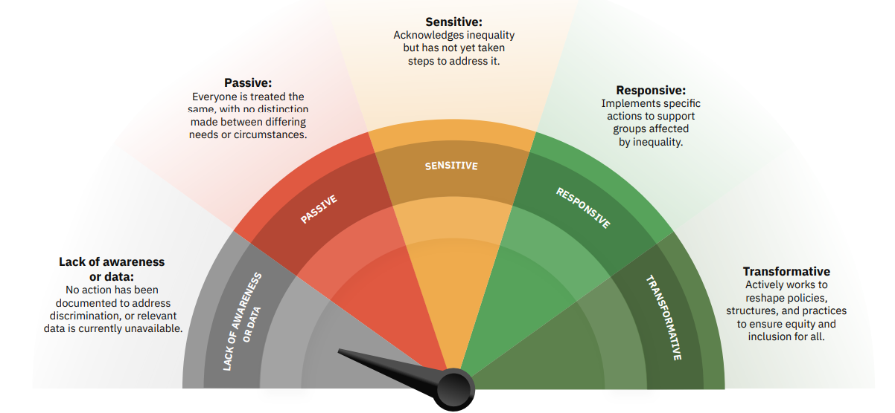
To assist the organizing committee, we kindly ask that you:
- Register for ISAPA 2025
- Complete the attendee form
- Read the guidelines below for preparing your presentation.
Please complete the above at your earliest convenience to ensure a smooth and engaging experience for all participants.
1. Academic Oral Presentations
- Duration: 10 minutes for presentation + 5 minutes for Q&A
- Format: PowerPoint or PDF slides
- Key Information:
  - Focus on research objectives, methods, findings, and implications.
  - Keep slides clear, concise, and well-structured.
  - Use visuals (e.g., graphs, charts) to aid understanding.
  - Please consider how to make your presentation accessible to all audience members. See best practices here
  - Before the start of the session, please make sure you send your slides through the app and go to your assigned lecture room
  - Bring your presentation slides with a USB stick as a back-up.
2. Poster Presentations
- Duration: 90-minute interactive session (authors present in front of their poster)
- Format: Presenters can choose one of the following options:
  - A0 size, portrait orientation (printed);
  - Print the poster in a roll-up format.
- Key Information:
  - Present key information at a glance—less text, more visuals.
  - Include title, author(s), affiliation(s), introduction, methods, results, and conclusion.
  - Mount posters at the beginning of the day and at least 1 hour before the session starts.
  - Be available by your poster for Q&A during the whole duration of your designated session.
3. Policy/Program Oral Presentations
- Duration: 15 minutes for presentation + 5 minutes for Q&A
- Format: PowerPoint or PDF slides; videos (optional, max 3 min within talk)
- Key Information:
  - Focus on program or policy objectives, implementation, outcomes, and lessons learned.
  - Tailor language and content to a mixed audience (academics, practitioners, policymakers).
  - Highlight practical implications and scalability.
4. Panel Discussions
- Duration: 60–90 minutes (depending on panel)
- Format: Moderated discussion, optional short opening presentations (3–5 minutes per speaker)
- Key Information:
  - Panels will be moderated; moderators will coordinate in advance with speakers.
  - Be prepared to engage in dialogue and respond to audience questions.
  - Avoid long presentations; aim for dynamic, interactive discussions.
  - Coordinate with panel members in advance to ensure complementary content.
5. Practical Workshops
- Duration: 90 minutes
- Format: Interactive, hands-on; can include short presentations, activities, group work
- Key Information:
  - Focus on skill-building, practical tools, and applied learning.
  - Prepare materials (e.g., handouts, templates) in advance if needed.
  - Ensure at least 50% of the session is interactive.
  - Please communicate any equipment or space requirements to the organizers on the Attendee Form at least 4 weeks in advance (deadline: 15th May). If no specific request is received from an author, the practical workshop will be scheduled in a standard, empty room.

Technical notes for all presenters
- Presentation rooms are equipped with a laptop, projector, and pointer/clicker.
- Bring a backup copy of your slides on a USB stick.
- Ensure your file is named as: Surname_Session Code_PresentationType. Your session code is also your manuscript number in your acceptance letter. For session codes not beginning with 1- use the session code on the program schedule.
- If you require additional support (e.g., audio, special formats), notify organisers at least 2 weeks prior.

General Advice
- Stick to your time limit to allow for smooth transitions between sessions.
- Practice your presentation to ensure clarity and timing.
- Engage the audience—leave room for questions or reflections.
- Reflect on how you can help shift the dial.
- Enjoy your ISAPA 2025 experience.

