





ISAPA
2025
PROGRAM GUIDE

Under the Patronage of
1

WELCOME TO ISAPA 2025
Dear ISAPA 2025 Community,

On behalf of IFAPA, it is a great honour to welcome you to ISAPA 2025, a global gathering dedicated to advancing inclusion, equity, and innovation in adapted physical activity.

Munster Technological University (MTU) is proud to host this year’s conference in Kerry, Ireland, with a dynamic programme designed to spark dialogue, deepen networks, and inspire action. We encourage you to engage fully in both sessions and informal conversations that often lead to lasting impact.

We are delighted to welcome researchers, practitioners, students, advocates, and partners from around the world to Kerry, Ireland, for a memorable week of learning, connection, and transformation. This year’s theme “Shifting the Dial: From Awareness to Transformation” calls us to move beyond conversation and into action. Whether presenting research, facilitating a workshop, participating in the UNESCO International Consultation, or simply listening and learning, each of you plays a vital role in driving change.

To celebrate our global community, we warmly invite you to wear your national costume or traditional dress to the Gala Dinner , a joyful reminder of the diversity and unity that power our shared mission.

Welcome to ISAPA 2025. Let’s shift the dial together.

Warmly,
President Cindy Sit- Chinese University Hong Kong, Catherine Carty, UNESCO Chair Manager MTU, Director

2



3



WITH GRATITUDE TO

Heartfelt thanks to our partners whose collaboration made ISAPA 2025 possible, your support is a catalyst for global inclusion and progress.














4



5

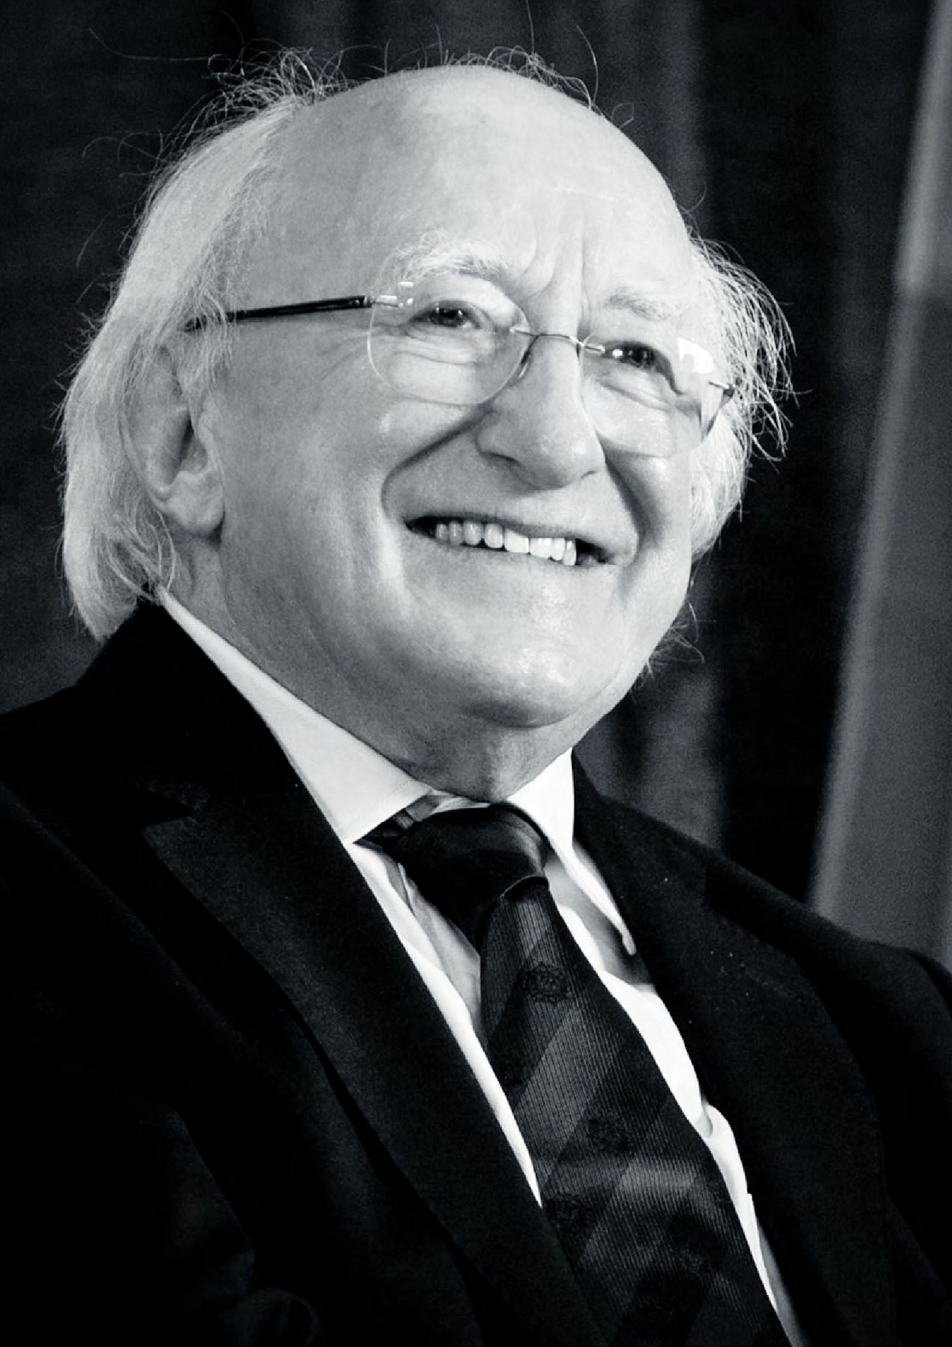

Michael D. Higgins, President of Ireland

“We strive to create a truly inclusive society in a
world where those living with disabilities are given
the opportunity to develop their personal and social
selves in conditions of freedom, communal,
solidarity, justice and equality.”

(Michael D. Higgins, President of Ireland, UNESCO Chair Launch, 2015)

7

DISABILITY INCLUSION MATTERS, BECAUSE LIFE CAN CHANGE FOR ANY OF US AND WHEN IT DOES, WE’LL ALL NEED A WORLD THAT UNDERSTANDS.

8

TABLE OF CONTENTS

WELCOME RECEPTION

P10

PREFACE

P12

TO DO LIST

P13

GUIDELINES FOR
PRESENTERS
P14-15

ABSTRACT

P18

SHIFT THE DIAL
P19

THE MISSION

P20-21

YOUR ISAPA EXPERIENCE
P22-23

KEYNOTE SPEAKERS

P26-30

SPOTLIGHT SPEAKERS

P32-35

MENTAL HEALTH SUMMIT
P36-45

MONDAY SCHEDULE

P46-51

TUESDAY SCHEDULE

P53-62

WEDNESDAY SCHEDULE

P65-73

THURSDAY SCHEDULE

P75-81

GALA BALL

P82-83

FRIDAY
SCHEDULE

P85-86

CLOSING MESSAGE

P88

THANK YOU
Partners

THANK YOU
behind the scenes

9


WELCOME RECEPTION
ISAPA WELCOME RECEPTION JUNE 16TH 2025 MUNSTER TECHNOLOGICAL UNIVERSITY
12:00- 13:30 ( 11:45-Take your Seats)

- Catherine Carty, UNESCO Chair Manager MTU, Director ISAPA 2025
- Chair of the MTU Board of Governors and KCB Board Member Mr Jimmy Deenihan
- Kerry County Council Leas Cathaoirleach Councillor Fionnán Fitzgerald
- Professor Hugh McGlynn, VP Research & Innovation, MTU
- President of ISAPA 2025, Professor Cindy Sit, Chinese University of Hong Kong
- Professor Lauren Liberman, Brockport State University of New York, Institute of
- Movement Studies for Visual Impairment and Deafblindness
- Dr Gerard Masdeu Yelamos Co- Co-Chair of the Scientific Committee of ISAPA 2025
- JuanPablo Salazar, Director of Inclusion of People with Disabilities at CAF - Development Bank of Latin America and the Caribbean.
- Skills for Life Video Production
- Special Olympics International, Gwendolyn Apgar, Senior Manager, Fitness for Sport Performance
- Lunch (music with Comhaltas)

10

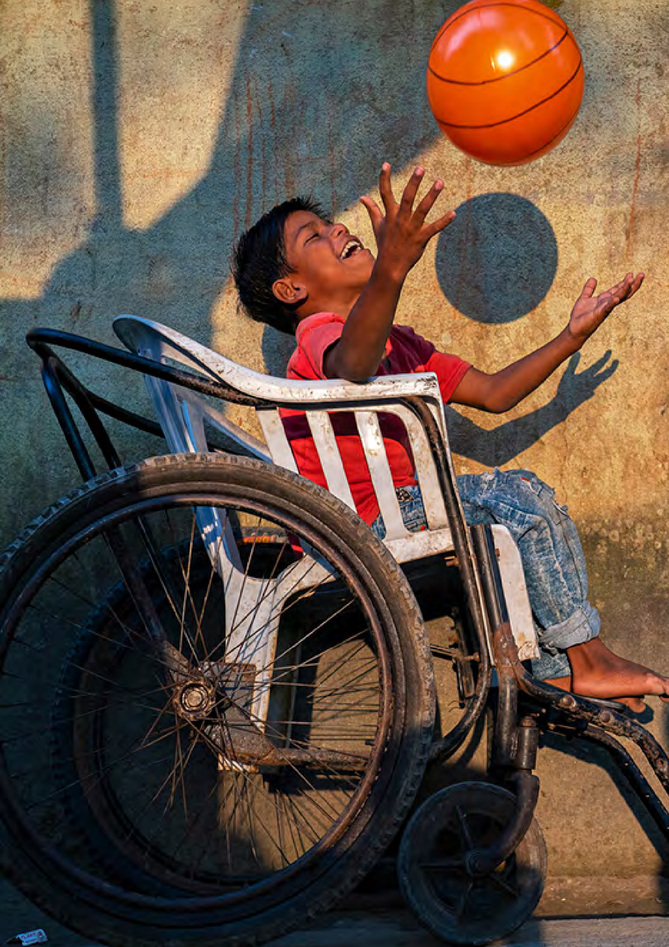

11


PREFACE

ISAPA 2025 COMBINES FIVE events which all delegates can attend. All events are included in the schedule below.

- The International Symposium of Adapted Physical Activity (ISAPA) 2025

- International Symposium on Physical Activity and Visual Impairment or Deafblindness
- Mental Health Summit: Physical Activity, Nutrition, and Digital Technology: Shifting the Dial for Better Outcomes
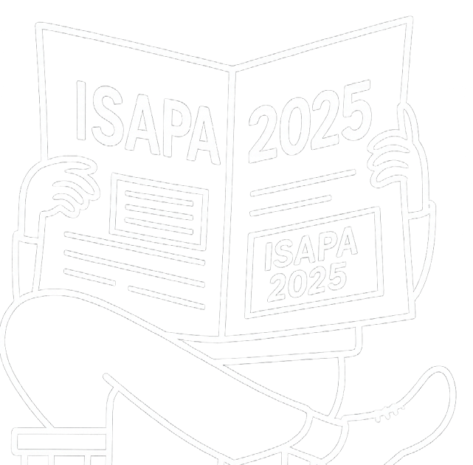
- UNESCO – ISAPA International Consultation: Policy Change for Disability Inclusion in Sport: Paris 2024 Call to Action Follow-Up
- Disability Sport Trade Exhibition.

12


TO DO LIST


- REGISTER: If you have not already done so, register on www.isapa2025.com.
REGISTER
AUTHORS ACTION
There are 20 registration types to suit your needs. We strongly recommend including the Gala Dinner in your registration.
- AUTHORS NOW NEED TO check for any errors or omissions in the schedule vis-à-vis your session. You will need your manuscript number on your acceptance letter (it is a four-digit number beginning with 1 or as listed below if not beginning with 1).
- ATTENDEE SURVEY. All attendees must complete the Attendee Survey.

- ERRORS OR OMİSSİONS: The Attendee Survey must be used to record any errors or omissions.
- PRESENTER'S GUİDELİNES: You must follow the guidelines in the annex of this document and incorporate the dial into your presentation and thoughts for ISAPA 2025.





DOWNLOAD OUR ISAPA APP
- Download the CrowdComms App from the the Appstore or Google Play here
https://onelink.to/2duqn3
Enter the event code : ISAPA2025 to access our app and plan your ISAPA
experience.

13










GUIDELINES FOR PRESENTERS
GUIDELINES

To assist the organising committee, we kindly ask that you:
- Register for ISAPA 2025
- Complete the attendee form
- Read the guidelines below for preparing your presentation.

1. ACADEMIC ORAL PRESENTATIONS
- Duration: 10 minutes for presentation + 5 minutes for Q&A
- Format: PowerPoint or PDF slides
- Key Information:
- Focus on research objectives, methods, findings, and implications.
- Keep slides clear, concise, and well-structured.
- Use visuals (e.g., graphs, charts) to aid understanding.
- Before the start of the session, please make sure you send your slides through the app and go to your
assigned lecture room
- Bring your presentation slides with a USB stick as a back-up.
- Please consider how to make your presentation accessible to all audience members. See best prac- tices LINK

2. POSTER PRESENTATIONS
- Duration: 90-minute interactive session (authors present in front of their poster)
- Format: Presenters can choose one of the following options:
- A0 size, portrait orientation (printed);
- Print the poster in a roll-up format.
- Key Information:
  - Present key information at a glance—less text, more visuals.
  - Include title, author(s), affiliation(s), introduction, methods, results, and conclusion.
  - Mount posters at the beginning of the day and at least 1 hour before the session starts.
  - Be available by your poster for Q&A during the whole duration of your designated session.

3. POLICY/PROGRAM ORAL PRESENTATIONS
- Duration: 15 minutes for presentation + 5 minutes for Q&A
- Format: PowerPoint or PDF slides; videos (optional, max 3 min within talk)
- Key Information:
  - Focus on program or policy objectives, implementation, outcomes, and lessons learned.
  - Tailor language and content to a mixed audience (academics, practitioners, policymakers).
  - Highlight practical implications and scalability.

14










GUIDELINES FOR PRESENTERS
GUIDELINES

4. PANEL DISCUSSIONS
- Duration: 60–90 minutes (depending on panel)
- Format: Moderated discussion, optional short opening presentations (3–5 minutes per speaker)
- Key Information:
  - Panels will be moderated; moderators will coordinate in advance with speakers.
  - Be prepared to engage in dialogue and respond to audience questions.
  - Avoid long presentations; aim for dynamic, interactive discussions.
  - Coordinate with panel members in advance to ensure complementary content

5. PRACTICAL WORKSHOPS
- Duration: 90 minutes
- Format: Interactive, hands-on; can include short presentations, activities, group work
- Key Information:
- Focus on skill-building, practical tools, and applied learning.
- Prepare materials (e.g., handouts, templates) in advance if needed.
- Ensure at least 50% of the session is interactive.
- Please communicate any equipment or space requirements to the organizers on the Attendee Form at least 4 weeks in advance (deadline: 15th May). If no specific request is received from an author, the practical workshop will be scheduled in a standard, empty room.
- Coordinate with panel members in advance to ensure complementary content.

6. TECHNICAL NOTES FOR ALL PRESENTERS
  - Presentation rooms are equipped with a laptop, projector, and pointer/clicker.
  - Bring a backup copy of your slides on a USB stick.
  - Ensure your file is named as: Surname_Session Code_PresentationType.
  - Your session code is also your manuscript number in your acceptance letter.
For session codes not beginning with 1- use the session code on the program schedule.
  - If you require additional support (e.g., audio, special formats), notify organisers at least 2 weeks prior.
  - Please communicate any equipment or space requirements to the organizers on the Attendee Form at least 4 weeks in advance (deadline: 15th May). If no specific request is received from an author, the practical workshop will be scheduled in a standard, empty room.
  - Coordinate with panel members in advance to ensure complementary content.
GENERAL ADVICE
  - Keep within your time limit to support smooth transitions between sessions.
  - Rehearse your presentation to ensure clarity and confident delivery.
  - Connect with your audience—allow time for questions or reflections.
  - Consider how your message can help shift the dial.
  - Most importantly, enjoy your ISAPA 2025 experience. 15



16
WELCOME TO ISAPA 2025

Your story belongs here

#ISAPA2025
#ISAPA

17



ABSTRACT

ISAPA 2025 is a landmark international event that brings together global leaders, researchers, practitioners, and advocates in Adapted Physical Activity to ignite systemic change under the unifying theme “Shifting the Dial: From Awareness to Transformation.” Hosted in Kerry, Ireland, under the patronage of UNESCO, the sympo- sium integrates five major events into one dynamic platform.

The program reflects IFAPA’s mission to advance inclusion, research, professional excellence, and international cooperation, while also contributing meaningfully to the implementation of global frameworks such as the UN Convention on the Rights of Persons with Disabilities (CRPD), the Sustainable Development Goals (SDGs), the Paris 2024 Call to Action, Fit for Life, and Quality Physical Education (QPE).
ISAPA 2025 challenges all participants to move beyond awareness and embrace action, leveraging inclusive sport, education, and health systems as powerful tools for equity and sustainable development.

18


SHIFT THE DIAL

A key theme of ISAPA 2025 is SHİFTİNG THE DİAL.
All presenters should consider how their work helps shift the dial.
The dial created for this event is below – feel free to use this dial in your presentation.

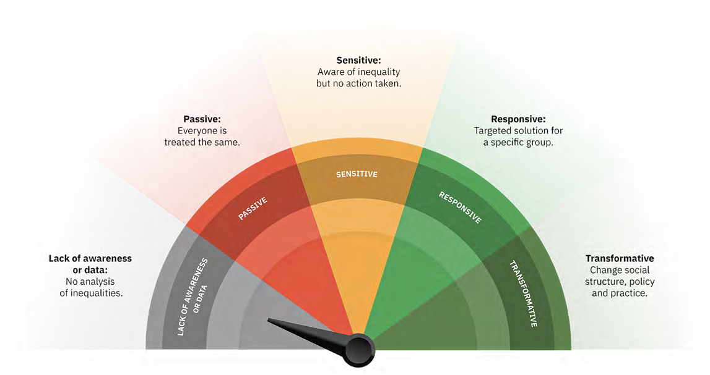

19
ISAPA 2025 Shifting the Dial: From Awareness to Transformation


THE MISSION
The mission of ISAPA 2025 is firmly rooted in the broader purpose of the International Federation of Adapted Physical Activity (IFAPA): to advance inclusion, equity, and excel- lence in adapted physical activity worldwide. By fostering global standards, supporting research,andpromotingprofessionaldevelopment,IFAPAworkstoensurethatindividuals of all abilities can access safe, inclusive, and high-quality physical activity experiences, a purposeamplifiedbyIMSVIinthecaseofthosewithvisualimpairmentanddeafblindness. ISAPA 2025 brings this mission to life, mobilising researchers, practitioners, and policymakers to engage in international cooperation, exchange knowledge, and co-c- reate solutions that make APA more impactful, more inclusive, and more aligned with global human rights and development agendas.

Ourmission is clear: to build meaningfulpartnerships that drive systemic change in the sector and align our collective efforts with major international frameworks, including the UN Sustainable Development Goals (SDGs), the UN Convention on the Rights of Persons with Disabilities (CRPD), and landmark initiatives like the Paris 2024 Call to Action, Fit for Life, and Quality Physical Education (QPE).

20


THE MISSION
ISAPA 2025 aligns with:

- CRPD Articles such as Article 24 (Education), Article 25 (Health), Article 27 (Work and Employment), and Article 30.5 (Sport and Leisure), which demand inclusive access and active participation in all areas of life, including sport and physical education.
- SDGs including SDG 3 (Good Health and Well-being), SDG 4 (Quality Education), SDG 5 (Gender Equality), SDG 10 (Reduced Inequalities), SDG 11 (Sustainable Cities and Communities), and SDG 17 (Partnerships for the Goals.
By grounding our conference in these frameworks, ISAPA 2025 is positioned to demonstrate the relevance and impact of APA in delivering on global policy agendas. Whether through scientific research, community-based programs, inclusive design, or policy innovation, your contributions at ISAPA 2025 will help
operationalise the commitments laid out in:

- The UNESCO Fit for Life framework which drives social inclusion through sport;
- The Quality Physical Education (QPE) guidelines, advocating for inclusive, rights-based education;
- The Paris 2024 Call to Action, calling on all stakeholders to ensure the full participation of persons with disabilities in sport, education, and public life.
21

ENHANCING YOUR ISAPA 2025 EXPERIENCE
 Plan. Connect. Engage.

The ISAPA 2025 Program is designed to offer rich opportunities to learn, connect, and shape global practice in Adapted Physical Activity (APA). To foster an immersive, im- pactful, and enjoyable event, we’re introducing a range of engaging initiatives:

ISAPA 2025


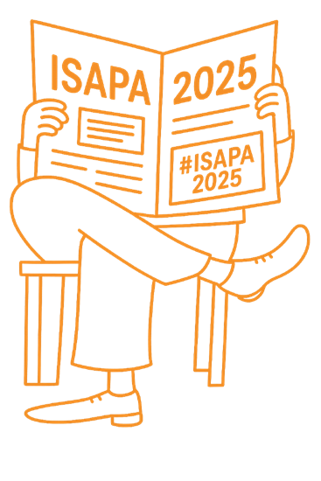
FROM KEYNOTE INSIGHTS TO CULTURAL MOMENTS — make it YOURS. Tag it: #ISAPA2025 #ISAPA
LETS CONNECT
#ISAPA2025
#ISAPA

22

We invite all presenters and attendees to share their

SOCIAL MEDIA ENGAGEMENT

LETS CONNECT

#ISAPA2025

professional social media handles (X, Instagram, LinkedIn). This will:
- Boost online engagement
- Promote your work across networks

SPORT COMPETITIONS
- Build community before, during, and after the event
— we’ll feature community posts daily!
Include your social media handles in the app.

Use #ISAPA2025 and #ISAPA where relevant.

KEY LINKS
Website: www.ISAPA2025.com Email: UNESCO@mtu.com IFAPA: ifapa.net
LinkedIn: International Federation of Adapted Physical Activity
Instagram
https://www.instagram.com/ifapa-
Mini Adaptive Sport Competitions
Experience inclusive sports hands-on — try boccia, goalball, or a wheelchair slalom challenge.

net/#ifapanet/# X: @ifapanet
Facebook: @IFAPA | facebook.com/ Ifapa.
YouTube: @IFAPA board Bluesky: ifapanet.bsky.social
Interactive Engagement Activities. Get ready to participate, play,
and connect with these exciting experiences:
ACTIVITIES
Adapted Physical Activity Trivia Quick, fun, and themed trivia moments throughout the event to test your APA knowledge!

THE PRESENTER CORNERS

“Shift the Dial” Reflection Wall Contribute to our collaborative display (digital or physical) reflect- ing on how you’re shifting the dial. Highlights will be featured during the event close.
SHIFT THE DIAL
Join informal networking corners post-session or over lunch to connect directly with speakers. Themed Networking Tables
Find and connect with others around
shared interests, topics, or regions. 23

Snap it. Share it. Tag it.
#ISAPA2025

#ISAPA

24

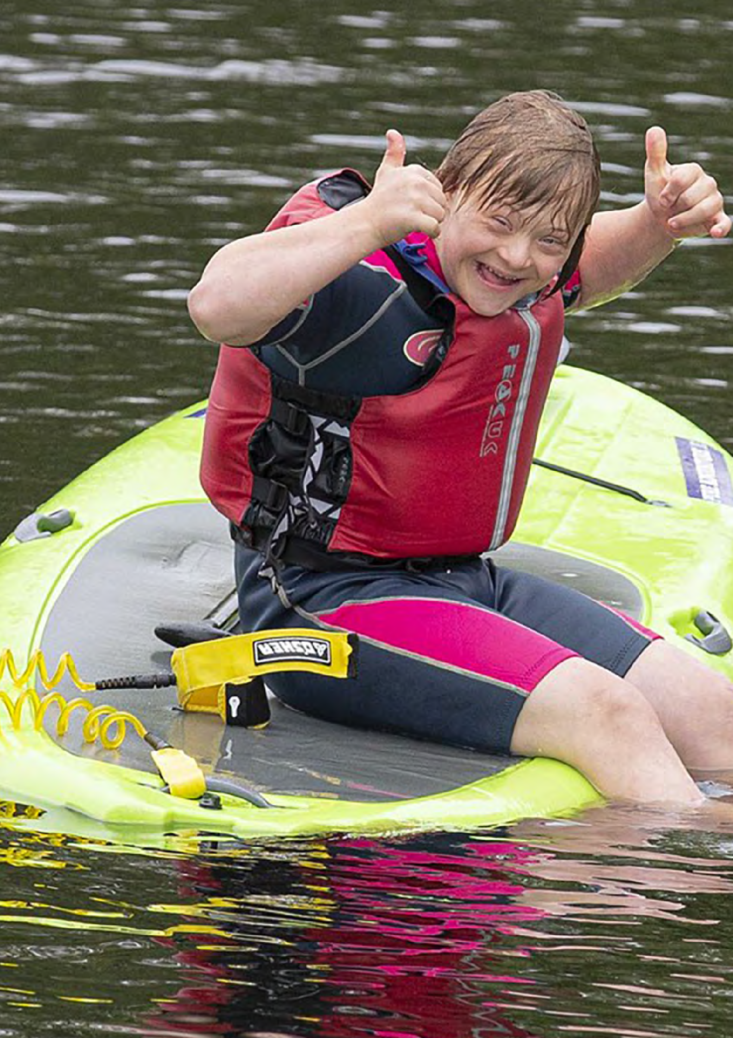

25




ISAPA 2025
KEYNOTE
SPEAKERS

26

Dr. Robert
01 | MONDAY  16th June
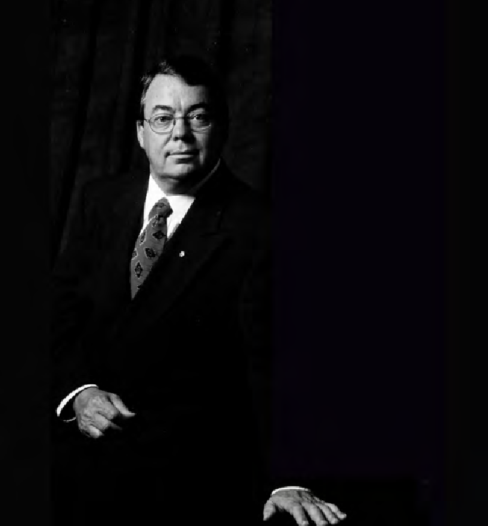

STEADWARD
G. Lawrence Rarick Memorial Lecture.
| 13:30-15:00 |
Plenary Room

Dr. Robert Steadward is a leading Canadian figure in sport, education, and disability advocacy. As Founding President of the International Paralympic Committee and an Honorary Life Member of both the IPC and Canadian Olympic Committee, he has been instrumental in advancing inclusive sport worl- dwide. He also served on the International Olympic Commit- tee and led the Canadian Paralympic Committee.
ISAPA 2025
ISAPA 2025
A respected sport scientist and educator, Dr. Steadward foun- ded The Steadward Centre at the University of Alberta, a global leader in disability sport and fitness research. He hel- ped establish NAFAPA and played key roles in major interna- tional events, including the 1978 Commonwealth Games, 1983 World University Games, 2001 World Athletics Champions- hips, 2005 World Masters Games, and the 2010 Olympic and Paralympic Winter Games bid.

27


TUESDAY
02
17th June

Professor Cindy

SIT
President of IFAPA
State of the Regions Address & Panel
| 11:00-12:30 |
Plenary Room
ISAPA 2025

Professor Cindy Sit, from the Department of Sports Science and Physical Education at The Chinese University of Hong Kong, is a glo- bal leader in adapted physical activity. She serves as President of the International Federation of Adapted Physical Activity (IFAPA), Honorary Advisor to the Asian Society for Adapted Physical Education andExercise(ASAPE),andFoundingPresidentoftheSocietyforAdapted Physical Activity of Hong Kong China (HKSAPA).
ISAPA 2025
Her research centers on physical activity, sedentary behavior, and health promotion for children with special educational needs and di- sabilities (SEND). She has published over 150 scientific papers and sits on several editorial boards. Dedicated to inclusion and well-being, she uses adapted sport to enhance physical and mental health in youth with SEND.
Professor Sit joins a global panel featuring experts from Africa, Asia,
Europe, the Middle East, North America, Oceania, and South & Central
America.
28

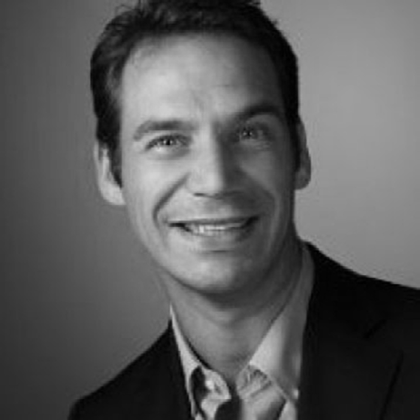
WEDNESDAY
03
18th June

Patrick

STOLPMANN
& Guests Discuss: Global Gaps in Inclusive Physical Education: Time for Real Change
| 11:00-12:30 |
Plenary Room

Patrick Stolpmann (Germany) Executive Director, ICSSPE. A leading advocate for Diversity & Inclusion, Patrick brings decades of global ex- perience from the Paralympic Movement and sport policy, offering a sharp lens on systemic change.
ISAPA 2025
ISAPA 2025
PANELLISTS
Prof. Dr. Gudrun Doll-Tepper (Germany) Freie Universität Berlin. Prof. Dr. Omar Hindawi (Jordan) Jordan Paralympic Committee. Prof. To- moyasu Yasui (Japan) Hokkaido University of Education. Liezel Gouws (South Africa) International para-athlete and motivational speaker.

29

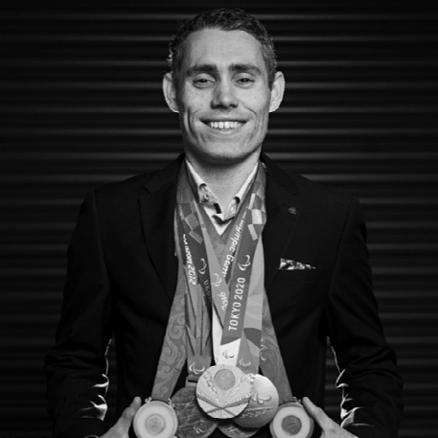
WEDNESDAY
03
18th June

Jason

SMYTH
Paralympian and Dancing with the Stars Winner: From Podium to Policy
| 15:00-16:30 |
Plenary Room

Jason Smyth is Ireland’s most decorated Paralympian, winning 21 gold medals in the 100m and 200m, and is the fastest Paralympi- an in history. Beyond sport, he’s a leading voice for disability inclu- sion, using his platform to challenge perceptions and drive change highlighted by his 2024 win on Dancing with the Stars.
ISAPA 2025
ISAPA 2025
As Strategy Manager at Paralympics Ireland, he focuses on long- term growth and impact. He also consults on accessible design, col- laborates with tech companies to enhance access for visually impa- ired athletes, and serves on boards shaping inclusive sport policy. A motivational speaker, he shares his journey to promote inclusion and excellence.

30

One tag. One movement.

#ISAPA #ISAPA2025

31



ISAPA 2025

SPOTLIGHT
SPEAKERS
ISAPA 2025

32

ISAPA 2025

SPOTLIGHT
SPEAKERS
Spotlight Sessions are powerful, 10-minute interventions that shine a focused light on a critical issue, lived experience, or emerging innova- tion in the disability and inclusion space.

Placed at the heart of each keynote session, these spotlights are designed to disrupt, inspire, and challenge thinking, bringing authentic voices, cutting-edge ideas, or urgent calls to action directly to the stage.


They’re not side notes; they’re centre stage moments that elevate the voices that need to be heard most.
33

ISAPA 2025

SPOTLIGHT

SPEAKERS
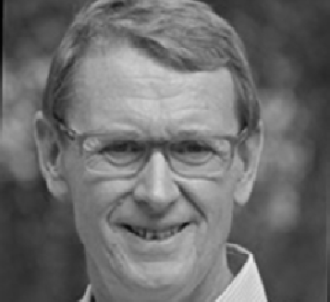

DR. TONY BENNETT, PRESIDENT, EUROPEAN DISABLED GOLF ASSOCIATION (EDGA) MONDAY SPOTLIGHT: GOLF & DISABILITY | 13:30|
PLENARY ROOM
Golf isn’t in the Paralympics yet, but the EDGA is growing the gamxe xfoxrxpxlaxyers with disabilities worldwide. Dr. Tony Bennett
highlights how golf fosters identity, rehabilitation, and inclusion and how it’s evolving to welcome all abilities. Join the movement.


DR. ANDRII VILENSKYI, MEDICAL DIRECTOR, SUPERHUMANS

TUESDAY SPOTLIGHT: SUPERHUMANS CENTRE,
UKRAINE |11:00 | PLENARY ROOM
In the face of war, the Superhumans Centre in Ukraine is rede- fining trauma care, rehabilitation, and human dignity. Dr. Andrii Vilenskyi presents a powerful vision of a country refusing to let disability define limits. Discover how the Superhumans Centre is pioneering integrated care, advanced prosthetics, and psycho- logical support, making it a model of hope for the world.

 ADAM HARRIS, FOUNDER AND CEO, ASIAM
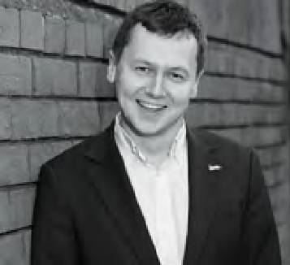
WEDNESDAY AM SPOTLIGHT: ASIAM – AUTISM INCLUSION |
11:00| PLENARY ROOM
AsIAm has become Ireland’s leading voice for the autism commu- nity, advocating for systemic change across education, employ- ment, and social policy. In this Spotlight, Adam Harris shares his journey as a changemaker and outlines what true autism inclu- sion looks like when led by lived experience. Expect a compelling call to dismantle barriers and reimagine accessibility.
34
ISAPA 2025

ISAPA 2025

SPOTLIGHT 

SPEAKERS

GERALDINE (GEARÓIDÍN) MCTAVISH, DISABILITY IN SPORT LEAD,

SPORT IRELAND
WEDNESDAY PM SPOTLIGHT: SPORT IRELAND – DRIVING SYSTEMIC CHANGE | 15:00 PLENARY ROOM
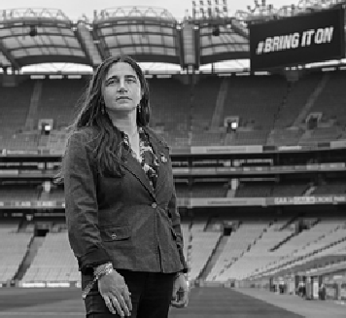
From grassroots to governance, Sport Ireland is embedding disability inclusion across the sporting landscape. In this closing Spotlight, Gearóidín McTavish offers a candid view into Ireland’s national strategy, what’s working, what’s not, and what needs to happen next. A must-hear for anyone committed to structural transformation in sport.

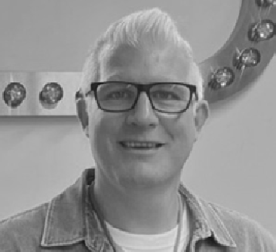
PAUL WALKER (PRIMARY PENNYS), MENTAL HEALTH FIRST RESPONDER
WEDNESDAY PM SPOTLIGHT - | 15:00 PLENARY ROOM
At Primark, we believe true inclusivity starts with equal access to clothing, representation but also to sports. These values are deeply embedded in our culture and guide us in our ongoing efforts to create meaningful change. We want both our colleagues and customers to experience what it feels like to belong.



SOPHIE EL-MASRY - SENIOR MANAGER RUNNING FTW, ADIDAS. THURSDAY PM SPOTLIGHT - | 13:00 PLENARY ROOM
At Adidas, we believe sport has the power to change lives.
Sophie El-Masry shares the adidas running team’s experience on connecting with the community and the brand’s step toward authentically involving the community in the product creation journey.
35

ISAPA 2025

ISAPA 2025

MENTAL HEALTH

SUMMIT
ISAPA 2025
Ireland's ‘Sharing the Vision’ policy for Mental Health outlines a road- map for change, focusing on outcomes while placing the individual at the centre of the service. The policy aims to enhance service provision and support across a continuum of care, ranging from mental health promotion and prevention to early intervention, as well as acute and specialist mental health services.
Physical Activity, nutrition, and digital technology offer innovative solutions at each point of the continuum of care and can be part of the shift to a more holistic, rights-based, and sustainable approach in Mental Health, as called for nationally, at the EU level, and globally. Join us to Learn, Shape and Share your thoughts on co-creating innovations in Mental Health Care.
.

JUNE
19TH
THURSDAY
AGENDA
08.30 -16.30 Munster Technological University, Kerry North Campus Program Starts at 9:00
Optional Afternoon Programme & Gala Dinner at Ballygarry Estate Hotel and Spa
36

ISAPA 2025



PHYSICAL ACTIVITY, NUTRITION, AND DIGITAL: SHIFTING THE DIAL FOR BETTER MENTAL HEALTH OUTCOMES
xxxxxx

ISAPA 2025

37

ISAPA 2025

MENTAL HEALTH

SUMMIT

WELCOME ADDRESS

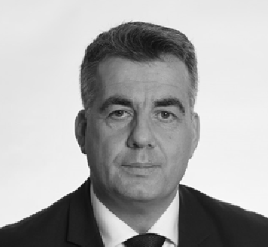
JOHN FARRELLY
BA, MSc Psych, MBA, MinstD is CE of the Mental Health Commission Ireland. He is an innovator in strategy, regulation governance and digital transformation. He is committed to human rights-based approaches in mental health treatment and care.

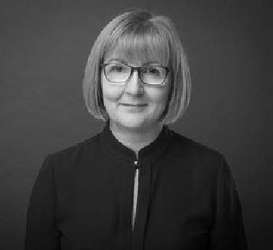
PROFESSOR MAGGIE CUSACK
President of Munster Technological University, welcomes MTU's national and international partners.

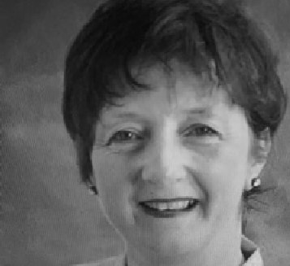
DR. GERARDINA HARNETT
Head of the Department of Nursing, Mental Health Nursing, and Healthcare Sciences, Munster Technological University.
Gerardina is a Public Health Nurse with an interest in rural remote and isolated settings, sustainability, leadership and health behaviour change.
38

ISAPA 2025

ISAPA 2025

MENTAL HEALTH 

SUMMIT

INVITED SPEAKERS & PANELLISTS
Opener: A short introductory video on Aclú
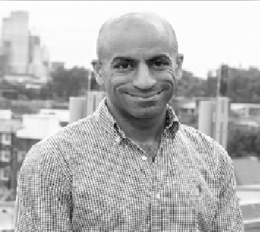
PROFESSOR AHMED HANKIR - KEYNOTE SPEAKER
Professor Ahmed Hankir, MBChB, MRCPsych, is a Consultant Psychiatrist (Canada and UK), Honorary Visiting Professor at the School of Medicine, Cardiff University (UK), Assistant Professor of Psychiatry at Western University (Canada), and Professor of Academic Psychiatry at Carrick Institute for Graduate Studies
Professor Hankir's research interests include global and Muslim mental health and pioneering and evaluating innovative inter- ventions that reject mental health-related stigma and Islamop- hobia. He has published widely in these areas. He has co-edited four textbooks on psychiatry and religion, published by Springer, with Senior Members of the American Psychiatric Association. Professor Hankir is the author of 'Breakthrough. A Story of Hope, Resilience and Mental Health Recovery' .
Professor Hankir is the recipient of multiple prestigious awards, most notably the 2022 WHO Director-General Award for Global Health and the 2025 American Psychiatric Association Patient Ad- vocate Award. He identifies as a survivor and is passionate about empowering, dignifying and humanising persons living with mental health conditions and advocates for lifestyle interventions, including regular physical activity and a balanced diet, to protect mental health. charities.
Professor Hankir is also passionate about broadening access to medical school for persons from low-income backgrounds. Ah- med enjoys going for long walks in parks, immersing himself in nature, travelling and drinking coffee in local cafes. He also enjoys cycling, running and raising funds for charities.
39

ISAPA 2025

ISAPA 2025

MENTAL HEALTH

SUMMIT


DR KAREN O’CONNOR - KEYNOTE SPEAKER
MB BCh BAO, BMed Sci, MRCPsych, MD, MSc in Leadership, PDip Med Ed, is a Consultant at Cork University Hospital and a Consultant Psychiatrist, as well as National Clinical Lead of the Na- tional Clinical Programme for Early Intervention in Psychosis (EIP).

EIP is an evidence-based approach that can transform experien- ces and outcomes, offering hope and efficiency. With each €1 in- vested in EIP, there is a €18 saving to the economy.

Dr. O'Connor is a medical graduate of University College Cork. She completed her postgraduate training in Psychiatry in Dublin and on a fellowship at Orygen Youth Mental Health Service in Melbourne, Australia.
Dr. O'Connor holds a Medical Doctorate in Early Intervention in Psychosis from RCSI. She is the clinical lead of the RISE service, an Early Intervention in Psychosis service in South Lee Cork.
Dr. O Connor is the Vice Dean for postgraduate basic specialist training in psychiatry in the UCC Deanery and a member of the Irish Psychosis Research Network.

Karen discusses the challenges of beginning antipsychotic medication and the role of complementary therapies on cardiometabolic indicators, stigma, self-esteem, and quality of life.

40 ISAPA 2025

ISAPA 2025

MENTAL HEALTH

SUMMIT

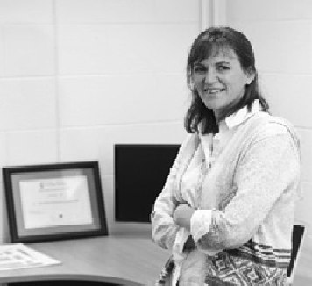
AOIFE NÍ MHUIRÍ- KEYNOTE SPEAKER
Aoife Ní Mhuirí BSc (Physiotherapy), MSc (Sports Medicine), is the CEO and Founder of Salaso Health Solutions, an award-winning digital health company based in Kerry and New York. Aoife is a chartered physiotherapist with over twenty years of experience in clinical physiotherapy and exercise physiology, specialising in physical rehabilitation, lifestyle medicine, physical rehabilitation, and chronic condition management.

Aoife is also a lecturer in Health and Leisure Studies at the MTU in Tralee and physiotherapy who is passionate about the power and value of exercise and physical activity in supporting health and well-being. As a leading digital health innovator, Aoife leveraged her diverse knowledge and experience to establish Salaso Health Solutions. Salaso’s mission is to integrate digital solutions into he- althcare delivery to improve outcomes and empower organisati- ons, clinicians, and patients with accessible, scalable healthcare.

As a clinician herself, Aoife leverages her combined clinical and technology industry experience to demonstrate how incorpora- ting digital technologies provides an essential platform for trans- forming the healthcare system and rethinking how we deliver Mental Health services. Aoife will discuss the application of digital technology, including AI, in shaping and delivering mental health services. During the afternoon programme, Aoife and her team will guide delegates through how the Salaso a digital solution (Sa- laso’s Smart Therapy Engagement Platform as a Service – STEPS) Health Solutions system supports education, exercise and lifestyle change in delivery of mental health services.
ISAPA 2025 41

ISAPA 2025

MENTAL HEALTH

SUMMIT
Evidence on the efficacy and practicality of physical activity and nutrition interventions in clinical and community settings, utilising digital technology, will be explored with insights from leading global authorities.

REFRAMING MENTAL HEALTH TREATMENT
To cost effectively embrace interventions for physical health into routine clinical practice.

MULTIDISCIPLINARY APPROACH
Pioneering a multidisciplinary approach of a balanced care model that’s in line with human rights and the sustainable development goals.

EVALUATING THE INFLUENCE OF DIGITAL TECHNOLOGY –
in reducing sedentary behaviour and maintaining physical activity levels in the long term for those enduring menta health difficulties.

42 ISAPA 2025

ISAPA 2025

MENTAL HEALTH

SUMMIT
INTEGRATING SUSTAINABLE DEVELOPMENT & HUMAN RIGHTS IN MENTAL HEALTH
Our speakers join the panellists below for a fireside chat.

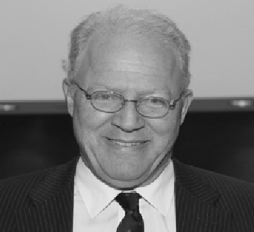
DAVID DONOGHUE
David Donoghue was the Ambassador of Ireland to the United Nations who negotiated Agenda 2030 and the Sustainable Development Goals. SDG Target 3.4 Reduce by one-third premature mortality from NCDs through prevention and treatment and promote mental health and well-being.

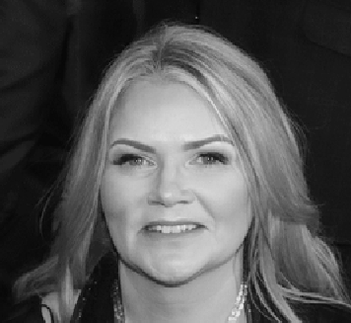
CATHERINE CARTY
Catherine Carty is the UNESCO Chair Manager at MTU and the Principal Investigator at Aclú, working alongside colleagues Dr. Tara Coppinger and Dr. Susan Rea. wCatherine will moderate the panel.


DR NIALL MULDOON
Dr Niall Muldoon is the Ombudsman for Children.
His job is to ensure that children in Ireland are treated fairly, and he frequently calls on the State to uphold the rights of children with disabilities to special measures of protection and assistance, to physical and mental health.

ISAPA 2025 43

ISAPA 2025

SPOTLIGHT

SPEAKERS

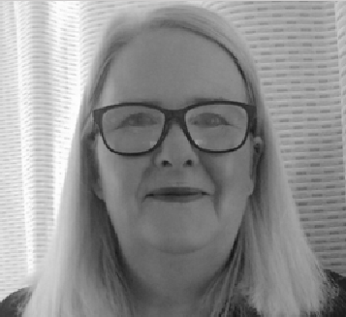
CLAIRE FLYNN
THURSDAY: SPOTLIGHT: SPECIAL OLYMPICS MENTAL HEALTH RESOURCE DEVELOPMENT
Claire Flynn is the Mental Health Promotion Coordinator at Mental Health Ireland, leading national campaigns and suppor- ting mental health initiatives across communities, workplaces, and individuals. With four years at the organisation, she previous- ly served as Development Officer for the Mid-West region and managed Limerick Mental Health Association. Claire holds a B.A. in Psychology and Media from Mary Immaculate College and a PG Cert in Mental Health Promotion from NUIG.
Based in Limerick, she also volunteers as Chairperson of Garryowen Community Development Project and a board member of GOSHH.

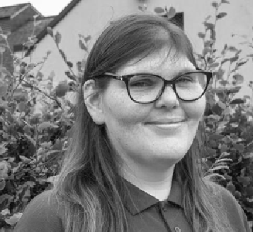
MARGARET TURLEY
THURSDAY: SPOTLIGHT: SPECIAL OLYMPICS MENTAL HEALTH RESOURCE DEVELOPMENT
Margaret Turley is a Special Olympics athlete, originally from Kil- kenny, with experience in swimming, athletics, bocce, skiing and basketball. She represented Ireland at the 2023 Special Olympics World Games in Berlin, winning gold in basketball. A passionate advocate for disability inclusion, Margaret is a Health Messenger and one of ten, Sargent Shriver Global Messengers for 2024–2027. She has spoken in the Oireachtas and supported national inclusion campaigns. Margaret studied at Trinity College Dublin and works part-time at Ernst & Young. Her voice and leadership continue to inspire inclusive change both in Ireland and globally.

44 ISAPA 2025

DEMONSTRATIONS & APPLIED  PRACTICE

3013
Demonstration of Salaso’s Smart Therapy Engagement Platform as a Service – STEPS
SPEAKER: AOIFE NÍ MHUIRÍ
3013
Demonstration of Dr Rebecca Spelman Private Therapy Clinic
SPEAKER: DR REBECCA SPELMAN

1069
A Behaviour Analysis of Adult Nutrition Behaviours and Technology Use of Individuals
SPEAKER: CIARA O'SULLIVAN

1082
The Effects of a Digital Physical Activity Intervention on Individuals with a Severe Mental Illness
SPEAKER: SHANNON AISLING FORDE

3014
MTU Mental and Physical Health Simulation Suite
SPEAKER: UNA CRONIN

From Kerry to the globe your moment matters.

#ISAPA #ISAPA2025

45

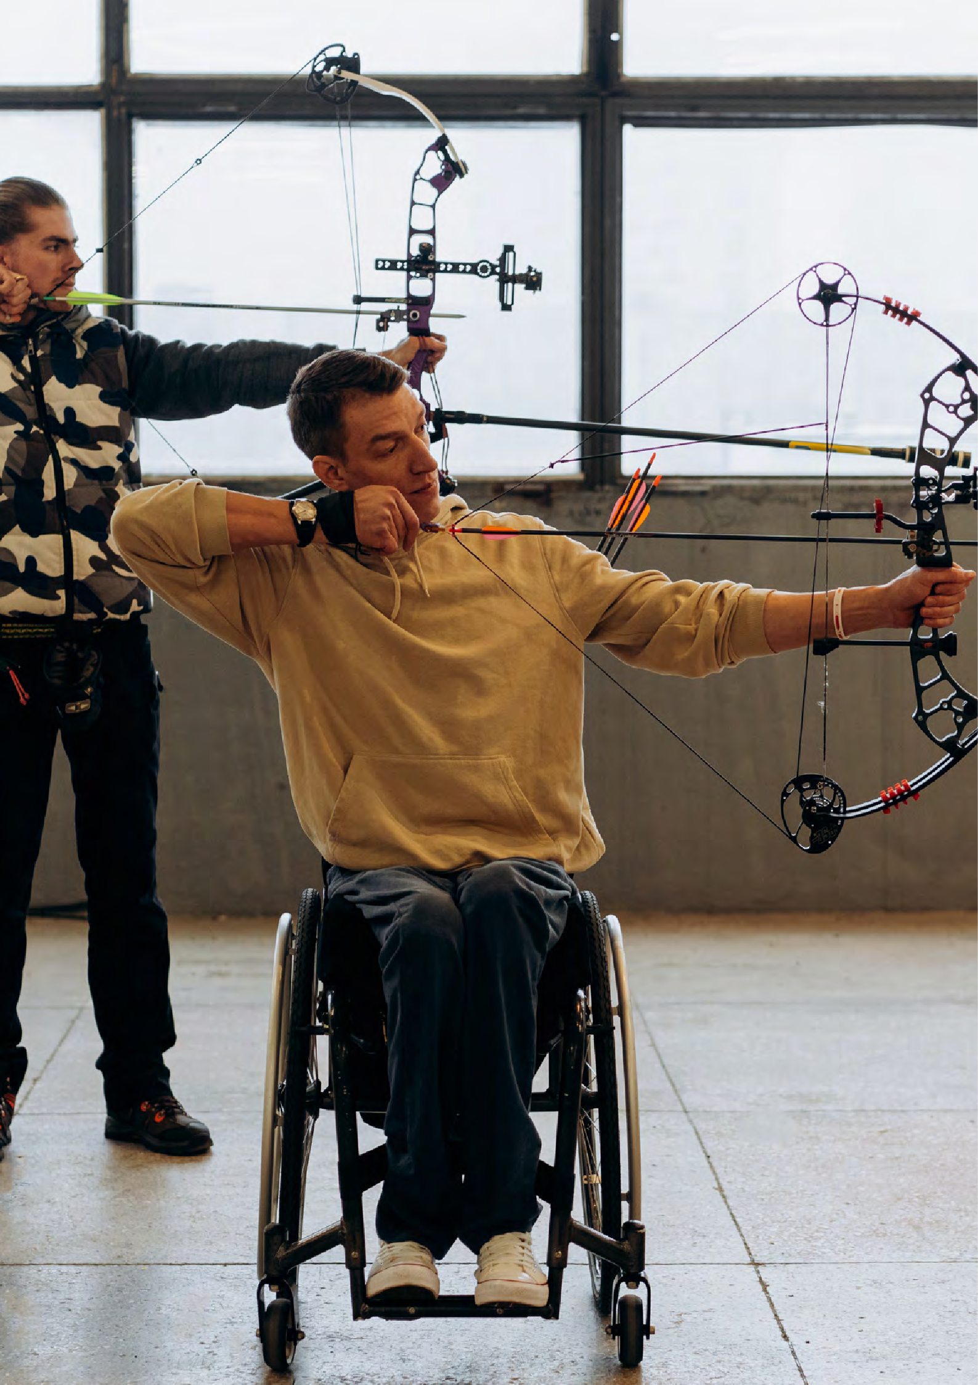
event

16th June 2025
schedule

46

ISAPA 2025 TIMETABLE - MONDAY

TIME |  | PLENARY ROOM | KSA HALL A | DUCHAS |  | KSA ROOM 1 |  | OTHER VENUES
 |  | EARLY MORNING EXERCISE
08.30-10:00 |  | REGISTRATION
10.00-11.30  11.30-18.00 |  | POLICY/ ORAL ORAL PRATICAL PROGRAMME PRESENTATIONS PRESENTATIONS WORKSHOP  PRESENTATIONS (1006, 1028, (1191, 1056, (1150)  (1219, 1246, 1016,1194) 1125,1132,  1167) 1144)  VISIT OUR ALL DAY TRADE EXHIBITION
12.00-13.30 |  | ISAPA WELCOME CEREMONY & LUNCH
13:30-15.00 |  | G. LAWRENCE RARICK MEMORIAL LECTURE PROF. ROBERT STEADWARD  SPOTLIGHT: DR TONY BENNETT EUROPEAN DISABILITY GOLF ASSOCIATION
 |  | TEA & COFFEE
 | TIME | PLENARY KSA HALL A ROOM |  |  | DUCHAS |  | KSA HALL 1 |  | OTHER VENUES
15:30-17.00 |  | POLICY/ POLICY/ POLICY/ POLICY/ PRACTICAL PROGRAMME PROGRAMME PROGRAMME PROGRAMME WORKSHOP PRESENTA- PRESENTA- PRESENTA- PRESENTA- (1205)  TIONS TIONS TIONS TIONS  (1182, 1033 ( 1155, 1165, ( 1034, 1084, (1136, 1142,  1266, 1243) 1196, 1173) 1086, 1167) 1133, 1147,  1154)
17:00-17.30 |  | SUPERHUMANS IFAPA Board  How Ukraine’s Superhumans Meeting  Center is Redefining (17:00 to  Rehabilitation 18:00)  (1122) U306  17.00 -19.00
19.30  onwards |  | SOCIAL PROGRAMME

47

KEYNOTE SPEAKER

MONDAY
schedule

TIME  13:30-15:00 | TITLE | AUTHORS | VENUE
 | G. Lawrence Rarick Memorial Lec- ture (#3001) | Dr Robert Steadward | Plenary Room

4
TIME | TITLE | AUTHORS | VENUE
10:00-11:30 | “Preliminary convergent and known- groups validity evidence for scores from various executive function tasks in US adolescents with visual impairment” (#1006) | Adam Pennell, Alexan- dra Stribing, Peter Rifen- burg, Andrea Taliaferro, Pamela Beach, Lauren Lieberman, Ali Briann | Duchas
10:00-11:30 | “I didn’t think I qualified”: Adult wheelchair basketball players’ jour- ney to and experience in the sport”. (#1207)” | Steven K. Holland, Katherine Holland, Cathy McKay | Duchas
10:00-11:30 | Making the case for using mobile technology to facilitate inclusion in outdoor physical activity for those who live with disabilities (#1132) | TA Loeffier | KSA ROOM 1
10:00-11:30 | Redeveloping for accessibility: Ap- plying design thinking approach to create a card game for people with visual impairment (#1125) | Rosa Aysegul Aksoy | KSA ROOM 1
10:00-11:30 | Inclusivizing Campus Recreation: Addressing Accessibility Barriers for College Students with Disabilities (#1144) | Kayla Abrahamson, Samantha Ross-Cypcar | KSA ROOM 1
10:00-11:30 | Inclusivising Our World: Co-design- ing an Inclusive Play Space in the Crann Centre, Cork, Ireland (#1191) | Alice Moore | KSA ROOM 1
10:00-11:30 | Enhancing Movement: Fundamen- tal Movement Skills in Foundation Phase Children with Visual Impair- ments in a South African Communi- ty (#1194) | Candace Vermaak, Catherine De Wet | Duchas
10:00-11:30 | “The Exploration of an Orientation and Mobility Internship Program at a Summer Sports Camp for Children who are Visually Impaired (#1016)” | Benjamin Lytle, Katie Ericson, Lauren Lieb- erman, Pamela Beach, Amy Parker | Duchas
10:00-11:30 | Sleep and Physical Activity in Youth  with Visual Impairments (#1028) | Pamela Beach, Jack Peltz, Marlee Pontello, Ali Brian, Sarah Deck- er, Lauren Lieberman, Andrea Taliaferro, Adam Pennell | Duchas
10:00-11:30  8 | Design and validation of a question- naire to measure students ‘percep- tion of inclusive hiking’ (#1056) | Clara Climent Oltra, Héc- tor Esteve Ibáñez, Lidia Ramos López, Francisco De Asís Martínez Man- chón, Laura Jiménez Monteagudon | KSA ROOM 1

MONDAY 
schedule

TIME  15:30-17:00 | TITLE | AUTHORS | VENUE
 | Mamanet: An Intervention Program to Promote Health Among Women Aged 21–53 with Intellectual and Developmental Disabilities (#1136) | Sharon Barak, Riki Tesler | KSA ROOM 1
15:30-17:00 | Co-production of a Mixed Abilities Physical Education Curriculum for Youth with Intellectual and Devel- opmental Disabilities and varying Intersectional Identities (#1142) | Thi Nancy Huynh, Re- becca Bassett-Gunter, Michael Atkinson, Kelly Arbour-Nicitopoulos | KSA ROOM 1
15:30-17:00 | Teaching Physical Education (PE) to Students With Learning Difficulties From the Perspective of Non-Spe- cialist Teachers (#1133) | Laura Kummert, Matthi- as Zimlich | KSA ROOM 1
15:30-17:00 | The Paralympic Pathway: Evolu- tion of Participation for Athletes with Intellectual Impairments in the Paralympic Games since 2012 (#114/) | Debbie Van Biesen, roi charles pineda, Jan Burns | KSA ROOM 1
10:00-11:30 | Device-based methods for monitor- ing physical activity in children and adolescents with disabilities (#1154) | Piritta Asunta, Janne Kulmala, Tuomas Kukko, Harto Hakonen, Tuija Tammelin,  Kati Karinharju | KSA ROOM 1
17:00 – 17:30 | Experience of Superhumans Center in Rehabilitation and Prosthetics for Patients with Limb Amputations Due to Combat Injuries (#1122) | Andrii Vilenskyi | Plenary Room

ORAL PRESENTATION (ORAL PRESENTATION (POLICY/PROGRAM)

TIME  10:00-11:30 | TITLE | AUTHORS | VENUE
 | Disability Studies on a Global Land- scape: Pedagogical Study Abroad Experiences (#1219) | Brenda Rossow-Kimball, Doug Cripps | KSA HALL A
10:00-11:30 | Inclusive Physical and Sports Ed- ucation as a Prerequisite for a Healthy Society (Czech-Slovak Corossborder Cooperation) (#1246) | Martin Kudláček, Ondřej Ješina, Tomáš Vyhlídal, Dušana Augustovičová, Stanislav Kraček, Dagmar Němček | KSA HALL A
10:00-11:30 | Connecting Policy with Practice: How the Dutch Ministry of Sport Builds Inclusive and Sustainable Communities (#1166) | Biko Blommestein | KSA HALL A

49

MONDAY
schedule
ORAL PRESENTATION (ORAL PRESENTATION (POLICY/PROGRAM)

TIME  15:30-17:00 | TITLE | AUTHORS | VENUE
 | Advancing Inclusion and Wellbeing: The Hauora (Wellbeing) Inclusion Initiative in New Zealand (#1182) | Tracey-Lee Dalton | Plenary Room
15:30-17:00 | Inclusive hiking project with Joëlette chair in the educational environ- ment (#1033) | Laura Jimenez-Mon- teagudo, Clara Climent Oltra, Marta Martin Rodríguez, Héctor Este- ve Ibáñez | Plenary Room
15:30-17:00 | Policy Advocacy in Sport and Socie- ty (#1266) | Alana Richardson , Sal- ly-Ann Jennifer Fische | Plenary Room
15:30-17:00 | Inclusive active courtyards (#1243) | Anna Fillat | Plenary Room
15:30-17:00 | Move as You Are: Promoting Inclu- sion of Children with Visual Impair- ments through Sports (#1155) | Giulia Chiara Castiglioni, Sofia Del Governatore | KSA Hall A
15:30-17:00 | Bridging Science and Sports: The Role of Paralympic Science Support NL in creating a sustainable com- munity (#1165) | Eline Blaauw | KSA Hall A
15:30-17:00 | Paralympics Ireland NextGen com- munity series (#1196) | Cliona Horan | KSA Hall A
15:30-17:00 | Knowledgebased multidisiplinary testing of assistive devices for activities in a rehabilitation context (#1173) | Tor Erik Nyquist, Viljar Aasan | KSA Hall A
15:30-17:00 | Calgary Adapted Hub Powered by  Jumpstart (#1034) | David Legg, Cheri Brad- ish, Marco DiBuono | Duchas
15:30-17:00 | Special Olympics Healthy Athletes Screenings: Using A Universal Design for Learning in the Health Promotion Discipline (#1084) | Franziska Loetzner, Leah  R. Ketcheson, Andrew Pitchford | Duchas
15:30-17:00 | Reducing inequality in high school sports - authentic sport participa- tion through Friday Night Prime Time an inclusive interscholastic athletic program (#1086) | Nathan Murata, Allison Tsuchida, John Solomon, Kiera Glodowski | Duchas
15:30-17:00 | Research to Practice: An Oppor- tunity to Support Teachers Further with Inclusion in Physical Education (#116/) | Susan Marron | Duchas

50

PRACTICAL WORKSHOP

MONDAY
schedule

TIME  10:00-11:30 | TITLE | AUTHORS | VENUE
 | Practical Strategies for Children and Adults who are Deafblind to Access Physical Activities (#1150) | Deirdre J Leech, Sorcha Nallen | Sports Academy
15:30-17:00 | Golf a Game Changer as Therapeu-  tic Recreation for ASD (#1205) | Edel Randles, Adrian Whitehead, Mike Keane | Sports Academy
For Practical Workshop venues in KSA - See App or Posters in KSA

#ISAPA #ISAPA2025

51


event

17th June 2025
schedule

52

ISAPA 2025 TIMETABLE - TUESDAY

TIME | PLENARY ROOM | KSA HALL A | DUCHAS | KSA ROOM 1 | ISAPA ANNEX | OTHER VENUES
 | EARLY MORNING EXERCISE
08.30-16:00 | VISIT OUR ALL DAY TRADE EXHIBITION
08.30-10.00 | REGISTRATION
09.00-10.30 | ORAL | ORAL | ORAL | ORAL | ORAL Practical
 | PRESENTATIONS | PRESENTATIONS PRESENTATIONS |  | PRESENTATIONS | PRESENTATIONS workshop
 | (1011,1203, | (1098, 1169, | (1071, 1053, | (1234, 1025, | (1153, 1232, (1023)
 | 1096, 1193 | 1145, 1211) | 1051,1064 | 1227, 1200, | 1164,1221,
 | 1170) | 1225) |  | ,1063) | 1185)
10.30-11.00 | TEA & COFFEE
11.00-12.30 | KEYNOTE PROF. CINDY SIT (3003) WITH KEYNOTE PANEL : APA GLOBAL OVERVIEW (2005)
12.30-14.00 | ROLLING LUNCH & POSTER PRESENATIONS
 | PLENARY ROOM | KSA HALL A |  | DUCHAS
12:30-15:00 | Panel : Sport | Panel :Having the finger on the pulse? Questioning Qualitative Methodologies in  APA (1067) |  | Panel: Camp Abilities: An Educational Sports Camp for Children with Low Vision and Blindness: Perspectives of Di- rectors from Around the World (1027)
 | for Impact
 | spotlight
 | disability
 | inclusion
 | (2006)
 | TEA & COFFEE
 | PLENARY ROOM | KSA HALL A | DUCHAS | KSA ROOM 1 | ISAPA ANNEX | OTHER VENUES
15.00-16.30 | POLICY/ PROGRAMME | POLICY/ PROGRAMME | ORAL ORAL ORAL PRESENTATIONS PRESENTATIONS PRESENTATIONS  (1065, 1152, (1101, 1104, (1141, 1252,  1158, 1233, 1079, 1108, 1062, 1244,  1254) 1236) 1070) |  |  | NESAPA  MEETING
 | PRESENTA- | PRESENTA- |  |  |  | IVP Room
 | TIONS | TIONS |  |  |  | W163.
 | ( 1060, 1268, | (1019, 1055,
 | 1260) | 1231)
17.00-18.30 | Practical | Practical | Practical | Practical | Practical | Practical
 | workshop | workshop | workshop | workshop | workshop | workshop
 | IPEPAS Inclu- | (1009) | (1113) | (1150) | (1180) | (1189)
 | sive Aquatics
 | (1039)
19.00 -  onwards | LOCAL CPD LEGACY EVENTS IN CONJUNCTION WITH KERRY RECREATION SPORTS PARTNERSHIP

53

TUESDAY
KEYNOTE SPEAKER
schedule
TIME  11:00-12:30 | TITLE | VENUE
 | Professor Cindy Sit, President of IFAPA will deliver a keynote and moderate a panel discussion APA Regional Leads on APA Status Quo Across the Regions(#3003) | Plenary Room

Oral Presentations (Research /Academic)

TIME  09:00-10:30 | TITLE | AUTHORS | VENUE
 | Demographic Factors Influencing Parental Support for Physical Activ- ity in Children with Autism Spectrum Disorder in Saudi Arabia (#1011) | M. Alhumaid, Tânia Bastos | Plenary Room
09:00-10:30 | Inclusion of Students with Intellec- tual Disabilities in Mainstream PE, PA, and Sports (#1153) | Amanda Farrugia, An- drew Soundy | ISAPA Annex
09:00-10:30 | Class-Wide Peer Tutoring: Insights from the Same Class-Context Through Perspectives of Pre-Ser- vice Teachers, Typically Developing Students, Students with Down Syn- drome (#1232) | An Van de Putte, Mat- thieu Lenoir, Hilde Van Keer, Geert Van Hove, Elisabeth De Schauwer | ISAPA Annex
09:00-10:30 | Exploring Grappling Sports Partic- ipation among Visually Impaired Athletes: A Qualitative Study (#1063) | Jaepyo Sim, T N Kirk | KSA ROOM 1
09:00-10:30 | Barriers and Facilitators of Physical Activity Participation among Chil- dren with Visual Impairments in the Middle East (#1200) | Samir Qasim, Omar Hindawi, Amr Saad | KSA ROOM 1
09:00-10:30 | Enhancing Physical Activity Par- ticipation for Students with Visual Impairments through Smart Sport Assistance Systems (#122/) | Philipp Kornfeind, Arnold Baca | KSA ROOM 1
09:00-10:30 | A case-study on measurement of motor competence and health-re- lated fitness in children with a vision impairment in Ireland. (#1025) | Úna Britton, Stephen Behan | KSA ROOM 1
09:00-10:30 | Motor competence assessment tool for children with visual impair- ment - - Proposal for validation (#1234) | Carla Lourenço, Dinis Figueiredo | KSA ROOM 1
09:00-10:30 | Universal Design for Learning to Ap- plied to Physical Education (#1164) | DCarla Lourenço, Omar BEN RAKAA | ISAPA Annex

54

TUESDAY
schedule

Oral Presentations (Research /Academic)

TIME | TITLE | AUTHORS | VENUE
09:00-10:30 | The Effect of Disability Education among College Students' Attitudes and Perceptions of People with Dis- abilities in Society (#1064) | Allison J Jackson, Mallo- ry Marshall | Duchas
09:00-10:30 | Unhearing and unheard: Emanci- pating the voices of individuals with hearing impairments toward equity in opportunities for sport participa- tion (#1225) | Roi Charles Pineda, Silke De Waelle | Duchas
09:00-10:30 | Physical Educators’ Self-Efficacy to Teach Students with Disabilities Across Instructional Placements (#1053) | Lindsey Nowland, Justin Haegele | Duchas
09:00-10:30 | Physical education teaching pro- gram according the universal de- sign for learning principles: acces- sibility for students with disabilities (#10/1) | Mey van Munster, Aline Basso-Braz | Duchas
09:00-10:30 | Exploring a system of able-bodied privilege that creates and main- tains barriers to disability inclusion. (#1211) | Lynn Kilpatrick | KSA Hall A
09:00-10:30 | From Soldiering On to Rebirth and Resilience: How Disability Sport Reconceptualises Recovery Among Injured and Ill Military Veterans their Families (#1145) | Emma V Richardson, Gyozo Molnar, Don Vin- son | KSA Hall A
09:00-10:30 | How do we get a[head] of the game?: An examination of disability sport staff understandings of quality sport and athlete mental health in disability sport and an exploration of disability sport staff preferences for a mental health educational resource in disability sport (#1169) | Roxy H O'Rourke, Cathe- rine M Sabiston, Andrea Bundon, Kelly P Ar-  bour-Nicitopoulos | KSA Hall A

55

TUESDAY
schedule
Oral Presentations (Research /Academic)

TIME | TITLE | AUTHORS | VENUE
09:00-10:30 | The right to use leisure time for physical activities and sport in fam- ilies with children with disabilities: parental burnout syndrome (#1193) | Julie Wittmannová, Renáta Kratochvílová | Plenary Room
09:00-10:30 | Effects of a structured exercise in- tervention incorporating behavioral interventions on children with ADHD: a randomized controlled pilot study (#1096) | Meiyuan Chen, Xiaozan Wang, Guifeng Xu, Fang Liu | KSA Hall A
09:00-10:30 | Feasibility and Usability Testing of ‘MoveMuse’, an AI Chatbot to deliver a Brief Physical Activity intervention for Autistic College Students (#1203) | Gary Rodgers, Mary Rose Sweeney, Antho- ny Staines, Debbie van Biesen, Natalia Mor- gulec-Adamowicz, Anna Ogonowska-Słodownik, Sean Healy | Plenary Room
09:00-10:30 | Parental Perceptions of Teaching Competence of Children with and without CHARGE Syndrome (#1051) | Melanie Perreault, Pamela Beach, Lauren Lieberman | Duchas
15:00-16:30 | Defining “Inclusion”: Scholars’ Use and Operationalization in Major Physical Education Journals (#1062) | Jenna Fesemyer, Jus- tin Haegele, Wesley J. Wilson | ISAPA Annex
15:00-16:30 | Psychometric Validation of the Physical Educators’ Judgments of Inclusion in Angola (#1252) | Agueda Gomes | ISAPA Annex
15:00-16:30 | Alignment of Disability Simulations with Intended Learning Outcomes for Pre-service Physical Education Teachers (#1141) | Amelia C Simpson, Samantha Ross-Cyp- car, Abby Fines, Xiaoxia Zhang | ISAPA Annex
09:00-10:30 | How do we get a[head] of the game?: An examination of disability sport staff understandings of quality sport and athlete mental health in disability sport and an exploration of disability sport staff preferences for a mental health educational resource in disability sport (#1169) | Roxy H O'Rourke, Cathe- rine M Sabiston, Andrea Bundon, Kelly P Ar-  bour-Nicitopoulos | KSA Hall A

56

TUESDAY
schedule
Oral Presentations (Research /Academic)

TIME  15:00-16:30 | TITLE | AUTHORS | VENUE
 | Participant Insights on Fitness Pro- gram Implementation in an Under- served Community (#1236) | Whitney N Neal, Laurie A Malone | KSA Room 1
15:00-16:30 | Pre-Service Physical Education Teachers' Sentiments, Attitudes, and Concerns Toward Inclusion of Students with Disabilities: A Study at CACPE (#1254) | Shraddha Abhijit Naik, Vilma Faleiro | Duchas
15:00-16:30 | The Effect of Participation in the Adapted Baseball Program on Visual Perception and Attention of Adolescents with Developmental Disabilities (#1079) | Seungeun Choi, Hyundo Jun, Yongho Lee | KSA Room 1
15:00-16:30 | The Relationship Between Weight Stigma and Exercise Avoidance: Exploring the Role of Internalized Weight Stigma and Social Anxiety (#1104) | Qingqing LI, Yun Li | KSA Room 1
15:00-16:30 | Dietary Intake, body composition analysis, muscle Soreness, fatigue, Mental Stress, Sleep Patterns and Alertness observance in Jordanian Paralympic athletes (#1101) | Omar Suleiman Hinda- wi, Tamara Mohammad Alhalaiqah, Mohammad Hassan Abualtaieb | KSA Room 1
15:00-16:30 | Comparison of Functional Move- ment Screen and Balance Assess- ments After 6-Week Corrective Exercise Programs Developed for Deaf and Hard-of-Hearing Individu- als (#1233) | Pelin Aksen, Pamela Beach, Lauren Lieber- man, Melanie Perreault, Sean Flanagan | Duchas
15:00-16:30 | Applicability of Standardized Phys- ical Fitness Test in Schools for Chil- dren with Special Education Needs in Latvia (#1158) | Aija Klavina, Zinta Galeja, Edgars Ozols, Rihards Ansons | Duchas
15:00-16:30 | Psychometric Validation of the Physical Educators’ Judgments of Inclusion in Angola (#1252) | Aija Klavina, Zinta Galeja, Edgars Ozols, Rihards Ansons | ISAPA Annex
15:00-16:30 | Using Administrative Health Data to Explore Diabetes Rates in Special Olympics Participants in Ontario, Canada (#1152) | Meghann Lloyd, Robert Balogh | Duchas
15:00-16:30 | WhyInclusion in Physical Education is not Working, and How to Make it Work! (#1052) | Martin E Block | KSA Hall A

57

TUESDAY
schedule
ORAL PRESENTATION (POLICY/PROGRAM)

TIME  15:00-16:30 | TITLE | AUTHORS | VENUE
 | Invalidity Rates of Baseline ImPACT Concussion Assessments in High School Athletes with Disabilities (#1065) | Kiera Glodowski, Troy Furutani, Nathan Murata, Allison Tsuchida | Duchas
15:00-16:30 | Effects of Short-Term Physical Exer- cise on Stress Biomarker and Men- tal Health Issues in Adolescents with ADHD: A Randomized Controlled Trial (#1108) | Sima Dastamooz, Cin- dy H.P. Sit, Kelly P. Arbour-Nicitopoulos, Rainbow T. H. Ho, Ste- phen H.S. Wong, Juanita Cheung | KSA Room 1
15:00-16:30 | The physical fitness of youth with special educational needs in Hun- gary based on NETFIT® meas- urement in school year 2023/2024 (#1244) | Katalin Tóthné Dr. Kälbli, Tamás Dr. Csányi, Alex- andra Cselkó, Mónika Dr. Kaj | ISAPA Annex
15:00-16:30 | Building Physical Literacy: The PLAYshop Approach for parents of children with intellectual disabilities (#1070) | Hayley Kavanagh, Sarah Meegan, Valerie Carson, Nathan Gavigan, Morgan Potter, Mika Manninen | ISAPA Annex
15:00-16:30 | Quality of Participation in Sports Programs of Special Olympics Ko- rea (#1185) | Soomin Lee, Jooyeon Jin | ISAPA Annex
15:00-16:30 | The Influence of Physical Educator’s Teaching Competency on Physical Activity Levels of Students with/ without a Developmental Disability (#1221) | Young Rok Oh, Jooyeon Jin | ISAPA Annex
15:00-16:30 | Beyond the Court: The Support System of Singaporean Wheelchair Rugby" (#1060) | Daniel W.H. Seah, Heng Yeow Yap,  Jernice S.Y. Tan | Plenary Room

TIME  11:30-12:30 | TITLE | AUTHORS | VENUE
 | APA Global Overview (#2005) |  | Plenary Room
14:00-15:00 | Having the finger on the pulse? Questioning Qualitative Methodolo- gies in APA (#1067) | Martin Giese, Janine Coates, Justin Haegele, Anthony J Maher, Se- bastian Ruin, Maria Luiza Tanure Alves | KSA Hall A
14:00-15:00 | Sport for Impact spotlight disability inclusion (#2006) | Paolo Bertaccini | Plenary Room
14:00-15:00 | Camp Abilities: An Educational Sports Camp for Children with Low Vision and Blindness: Perspectives of Directors from Around the World (#1027) | Lauren Lieberman, Ingi Por Einarsson, Valierie Caron, Ursula Barret, Jane Blaine, Molly Arm- strong | Duchas
58
PANEL

TUESDAY
schedule

ORAL PRESENTATION (POLICY/PROGRAM)

TIME  15:00-16:30 | TITLE | AUTHORS | VENUE
 | An inclusive sport in a perceived exclusive industry - Golf is creating a more inclusive and accessible landscape. (#1032) | Tony Bennett | Plenary Room
15:00-16:30 | Beyond the Court: The Support System of Singaporean Wheelchair Rugby (#1060) | Daniel W.H. Seah, Heng Yeow Yap, Jernice S.Y. Tan | Plenary Room
15:00-16:30 | Together Rapid: Inclusive Football  for People with Disabilities (#1260) | Gabriel Mayr, Matias Costa, Margit Straka, Jürgen Kerber | Plenary Room
15:00-16:30 | The Effective Use of a Pre-Teaching Checklist for Physical Education for Children with Blindness, Low Vision, or Deafblindness (#1019) | Pamela Beach, Melanie Perreault, Ciara Murphy, Brianna Bowman, Lauren j Lieberman | KSA Hall A
15:00-16:30 | Enhancing Physical Activity Partic- ipation among Adults with Visual Impairments through a Student-led Exercise Program (#1055) | Klára Daďová, Jitka Vaře- ková, Markéta Křivánk- ová | KSA Hall A
15:00-16:30 | Boccia for Participants with CVI (Cortical/Cerebral Visual Impair- ment) (#1231) | Jane D Blaine | KSA Hall A
15:00-16:30 | The Effective Use of a Pre-Teaching Checklist for Physical Education for Children with Blindness, Low Vision, or Deafblindness (#1019) | Pamela Beach, Melanie Perreault, Ciara Murphy, Brianna Bowman, Lauren j Lieberman | KSA Hall A

POSTER PRESENTATION

TIME  12:30-14:00 | TITLE | AUTHORS | VENUE
 | Research on the Dilemmas and Countermeasures in the Develop- ment of Early Childhood Physical Education: A Case Study of Xixian County, Xinyang City (#1102) | 好张 | ISAPA Gallery
12:30-14:00 | Optimized Analysis of Parental Be- havioral Styles and Student Health Outcomes: Significant Correlation Findings (#1099) | Rui Wu, Fu Sheng Liang, Xiao Zan Wang | ISAPA Gallery

59

POSTER PRESENTATION

TUESDAY
schedule

TIME  12:30-14:00 | TITLE | AUTHORS | VENUE
 | “Inclusion in primary physical ed- ucation from the perspectives of educational staff and pupils with disabilities: a qualitative systematic review” (#1097) | Chloe Leydon, Katy Pedlow, Sinead Connolly, Jean Daly-Lynn, Karen McConnell | ISAPA Gallery
12:30-14:00 | "Exercise Intervention and Attention Improvement in a Child with ADHD: A Case Study" (#1095) | Zicheng Wang, Xinyue Mao, Meiyuan Chen, Xiaozan Wang | ISAPA Gallery
12:30-14:00 | "A Single Subject Study on the Improvement of Depressive Emo- tions in Junior High School Students through Exercise Intervention" (#1094) | xinyue mao, chuanfu xiong, mengxiao shen, pengcheng li, yue che, yuanzhen Huang, zichao Chen | ISAPA Gallery
12:30-14:00 | "The Effects of the Rehabilitation Exercise Program on Functional Movement for Children with Brain Injuries" (#1092) | Jiin Heo, Bogja Jeoung | ISAPA Gallery
12:30-14:00 | Preferences for Exercise among Latino Parents of Children with Developmental Disabilities: A Quali- tative Study (#1088) | Jamie L Jaime Concep- cion, Kristen A Pickett, Kecia Doyle, Luis Colum- na | ISAPA Gallery
12:30-14:00 | "Inclusive Surfing Programme"  (#1085) | Maeve Johnston, Nuria Smyth | ISAPA Gallery
12:30-14:00 | A Scoping Review of Aquatic Ther- apy for Children and Adolescents with Disabilities (#1083) | Natalia Morgulec-Ada- mowicz, Oliwia Jakobow- icz, Lyndsay Alexander, Andresa Marinho-Buzelli, Catherine Devion, Anna Ogonowska-Slodownik | ISAPA Gallery
12:30-14:00 | Beliefs and Experiences of Latina Mothers of Individuals with Devel- opmental Disabilities toward Dance as Physical Activity: A Qualitative Study (#1077) | Nicole M Montanez-Ali- cea, Luis Columna | ISAPA Gallery
12:30-14:00 | Camp Abilities Brazil: accessibility and inclusion of people with visual impairment (#1075) | Maria Luiza Tanure Alves, Mey van Munster, Joslei Viana Souza, José Júlio Gavião de Almeida | ISAPA Gallery
12:30-14:00 | Accessibility on trails and the expe- rience of nature from the perspec- tive of people with physical disabili- ties (#1073) | Mey van Munster, Gusta- vo Almeida Silva | ISAPA Gallery
12:30-14:00 | Shared physical education program: cooperative learning and inclusion of students with disabilities (#1072) | Mey van Munster, Melina Radaelli Gatti | ISAPA Gallery

60

POSTER PRESENTATION

TUESDAY
schedule

TIME  12:30-14:00 | TITLE | AUTHORS | VENUE
 | “Assessment of Para Table Tennis Classification: From the Techno- logical Approach to Examine the Fairness of Classification (#1068)” (#1068) | Sheng Wu, Yung-Hoh Sheu | ISAPA Gallery
12:30-14:00 | Analysis of Brain Activity during Walking on Soft Uneven Surface among Individuals Post-Stroke (#1054) | Jongmin Lee, Kiara Todd, Mai Narasaki-Jara, Youngok Jung, Brenda Meza, Taeyou Jung | ISAPA Gallery
12:30-14:00 | "Protocoll on the implementation of the concept “Sports assistance for people with disabilities” (SpAss) in Bavaria" (#1050) | Christiane Reuter, Jakob Prechtl, Leonie Sauer | ISAPA Gallery
12:30-14:00 | "School development towards an active school " (#1049) | Leonie Sauer, Christiane Reuter, Jakob Prechtl | ISAPA Gallery
12:30-14:00 | "Measuring daily physical activity of students with ID during school using accelerometers" (#1048) | Jakob Prechtl, Leonie Sauer, Christiane Reuter | ISAPA Gallery
12:30-14:00 | "Analysis of Energy Expenditure dur- ing Game-based Aerobic Exercise among Individuals with Spinal Cord Injury" (#1046) | Jordan J Arteaga, Remy J Ortega, Elvin O Garcia, Jesus D Aguilar, Taeyou Jung, Ethan Palache | ISAPA Gallery
12:30-14:00 | "Evaluating the level of assistance needed for daily activities in chil- dren with spinal muscular atrophy" (#1045) | Huan Richard Xu | ISAPA Gallery
12:30-14:00 | "Analysis of Brain Activity during Game-Based Aerobic Exercise in Individuals with Spinal Cord Injury" (#1044) | Kiara S Todd, Edith Arri- eta, Fatima Elias, Diana Vela, Taeyou Jung | ISAPA Gallery
12:30-14:00 | "Accessing Physical Activity: Per- spectives of Blind and Visually Impaired Emerging Adults" (#1043) | T N "Nicole" Kirk | ISAPA Gallery
12:30-14:00 | "Attitudes of Saudi Students toward the Inclusion of Students with Disa- bilities in Physical Education Class- es " (#1029) | Zuhair Abdaladeem Al Salim | ISAPA Gallery
12:30-14:00 | "Inclusive experiences through alpine skiing? Perspectives towards inclusion by people with visual im- pairments" (#1026) | Felix Oldörp, Martin Giese | PISAPA Gallery

61

POSTER PRESENTATION

TUESDAY
schedule

TIME  12:30-14:00 | TITLE | AUTHORS | VENUE
 | "The effectivement of inclusive sports activities in the improving Skill performance in individuals with cerebral palsy" (#1020) | ISHAK HAMDINI, Hadjer  Dridi | ISAPA Gallery
12:30-14:00 | "A Systematic Review of Gymnas- tics-Based Interventions on Motor Skills in Children with Intellectual Disabilities" (#1018) | Madeline Gose, Phil Esposito | ISAPA Gallery
12:30-14:00 | "Amplifying the Voices of Students with Disabilities in Integrated Physi- cal Education" (#1012) | Cathy McKay, Maria Damewood | ISAPA Gallery
12:00- 13.00 | A study of the relationship between 24h physical activity behavior and basic A study of the relationship between 24h physical activity behavior and basic mo- tor skills in 3-6 year old children (#1066) motor skills in 3-6 year old children (#1066) | Chen FeiYu, Wang Xiao- Zan, Xu QinPing | ISAPA Gallery
PRACTICAL WORKSHOP

TIME  17:00-18:30 | TITLE | AUTHORS | VENUE
 | "Beyond the Court : The Support of Singaporean Wheelchair Rugby (1060) | Daniel W.H. Seah, Heng Yeow Yap, Jernice S.Y. Tan | Plenary Room
17:00-18:30 | "Creative Movement in Action: An Adapted Dance Workshop"  (#1009) | Baillie R Ollila | KSA Workshop 1 & Dance Studio
17:00-18:30 | "IPEPAS Inclusive Aquatics Practical  for Practitioners" (#1039) | Eileen Sayers | KSA Pool
17:00-18:30 | "Experiencing Ancient Movement  Cultures" (#1113) | Tarik Orliczek | Pitch 2
17:00-18:30 | "The Adventure Toolkit; Enhancing the therapy experience using ad- ventures in blue and green spaces" (#1262) | Philip G Stallard, Jasmin A Stallard | Outdoor Classroom
17:00-18:30 | "Exploring enablers of creating in- clusive opportunities" (1180) | Tracey - Lee Dalton | KSA Workshop 2 and Hall C
For Practical Workshop venues in KSA - See App or Posters in KSA

LOCAL LEGACY
 | TITLE | AUTHORS | VENUE
 | " Legacy events in conjunction with Kerry Recreation Sports Partnership " (#3004) | Football for all, GAA for All, Cycling | Various

TIME
17:00-19:00
62

Let the world see what inclusion looks like.

#ISAPA
#ISAPA2025

63

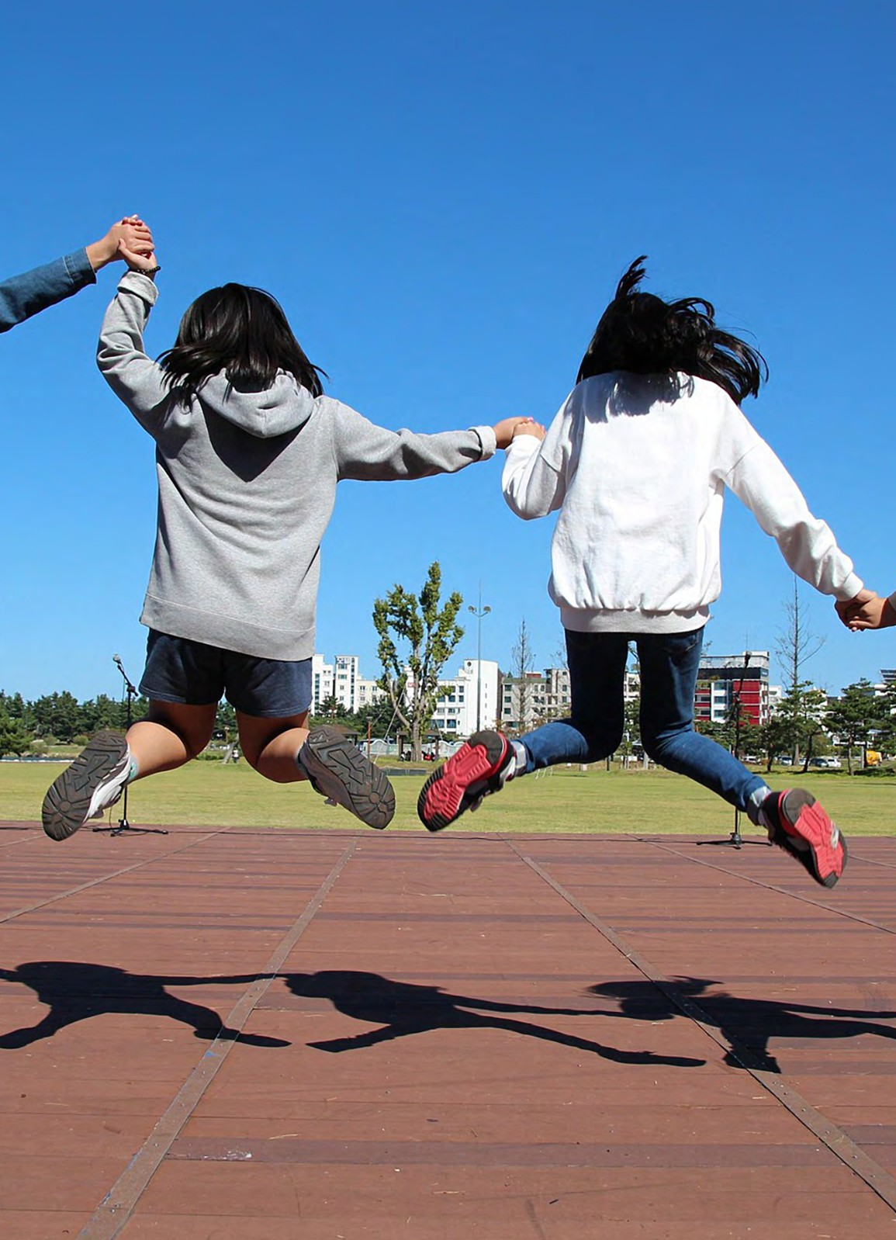
event

18th June 2025
schedule
WEDNESDAY

64

ISAPA 2025 TIMETABLE - WEDNESDAY

TIME | PLENARY KSA HALL A DUCHAS KSA ROOM 1 ISAPA OTHER ROOM ANNEX VENUES
 | EARLY MORNING EXERCISE
08.30-18.00 | VISIT OUR ALL DAY TRADE EXHIBITION
08.30- 9:00 | REGISTRATION
9:00 - 10:30 | Oral Oral Practical  presentations presentations workshop  (1148, 1258, (1213, 1031, 1188, (2002)  1209, 1175, 1036 1117, 1080)
10:30 -11:00 | TEA & COFFEE
11.00-12.30 | ICSSPE Keynote Panel- Global Gaps in Inclusive Physical Education: Time for Real Change (2010). Patrick Stolpmann, ICSSPE (Germany) & Prof. Dr. Gudrun Doll-Tepper, Freie University Berlin (Germany) Prof. Dr. Omar Hindawi, Jordan Paralympic Committee (Jordan) Prof. To- moyasu Yasui, Hokkaido University of Education (Japan) Further speaker TBC SPOTLIGHT
12:30 -14:00 | ROLLING LUNCH & POSTER PRESENTATIONS*
PLENARY DUCHAS ISAPA
ROOM ANNEX
14:00 -15:00 | Panel: Enhancing Physical Panel: Building Adapted Adaptive Cycling:From Policy Activity and Behavior Change Physical Activity Collectives to Product Innovation: A cross in People with Intellectual in Canada: Challenges and sector panel on enabling Disabilities Through Weara- Opportunities (1251) access, innovation & equity in bles and Digital Technology cycling. (14.00-15.00) #2007  (2000)
15:00 -16:30 | Keynote Jason Smyth: Advocacy in APA Spotlight:
16:30 -17:00 | TEA & COFFEE
17.00-18.30 | Policy/ Programme presentations (1229, 1249, 2003, 1035, 1168)  KSA HALL A
18:30 -19:30 | Panel: Working together to increase Policy/ Practical work- Practical physical activity opportunities for chil- Programme shop (1216) workshop dren experiencing blindness/vision presentations (1187, WORKSHOP 1 & (1210)  impairment in Ireland. (#1004) (17:00 - 1190, 1265, 1060) DANCE Workshop 2 18:00) PLENARY ROOM DUCHAS ROOM STUDIO KSA
18:30 -19:30  19.00-on-  wards | ISAPA GENERAL ASSEMBLY & SIGNING PARTNERSHIP: ISAPA AND SOI  17:30-19:00
 | Local CPD Legacy events in conjunction with Kerry Recreation Sports Partnership Social Programme

65

WEDNESDAY
schedule
KEYNOTE SPEAKER

TIME | TITLE | VENUE
15:00-16:00 | Jason Smyth, World's Fastest Paralympian, Winner of Dancing with the Stars and Paralympics Ireland Staff. (#3022). Supported by The Institute of Movement Studies for Individuals with Visual Impairments (IMSVI) (1138) | Plenary Room

ORAL PRESENTATIONS (RESEARCH /ACADEMIC)

TIME TITLE |  | AUTHORS | VENUE
09:00-10:30 | "Bridging the gaps: trends and disparities in sport participation among people with disabilities, mental health disorders and chron- ic diseases in Flanders, Belgium" (#1148) | Debbie Van Biesen, Roi charles pineda, Silke De- waelle, Jeroen Scheerd- er | Plenary Room
09:00-10:30 | “I didn’t even know any other vis- ually impaired people, I was just on my own”: generative outcomes of football for visually impaired wom- en" (#1138) | Jessica L Macbeth, An- drew Sprake | KSA Room 1
09:00-10:30 | "Development of fundamental motor skills of children with visual impairment in Switzerland: One step at a time" (#1131) | Valerie Caron, Lauren Lieberman, Ali Brian | KSA Room 1
09:00-10:30 | "The existential nature of touch ex- change for blind people as a bridge to confi-dence and participation  in physical activities. A qualitative preparatory study using Reflexive  Thematic Analysis" (#1264) | Mathias Alberton | KSA Room 1
09:00-10:30 | "An Intersectional Examination of Blind and Visually Impaired Wom- en's Physical activity Experiences" (#1074) | Lindsay E Ball | KSA Room 1
09:00-10:30 | "Lessons Learned using Participa- tory Research to Develop Physical Education Resources and Recom- mendations for Blind Students" (#1076) | Mary A Keene, Nina Mar- ranca, Julia LaGrand, An- drew Mead-Colegrove | KSA Room 1
09:00-10:30 | "Parasport Development Model "  (#1257) | Mariana Simões Piment- el Gomes, ciro Winckler, Elke Lima Trigo | Duchas
09:00-10:30 | "Exploring the Adaptation Process and Experiences of Para Baseball Player with Physical Disabilities after an Accident" (#1127) | Hyundo Jun, Soojung Yoo, Seungeun Choi, Yongho Lee | Duchas
09:00-10:30 | "Qualitative Exploration of Applied Sport Psychology Practices in Deaf- lympic Sports" (#1105) | Alon Markov-Glazer, Rainer Schliermann | Duchas
66

WEDNESDAY
schedule
ORAL PRESENTATIONS (RESEARCH /ACADEMIC)

TIME TITLE |  | AUTHORS | VENUE
09:00-10:30 | "Social Impact of Friday Night Prime Time: An evaluation of athlete,  peer, teacher, and fan experience"  (#1089) | Allison Tsuchida, Nathan Murata, John Solomon | Duchas
09:00-10:30 | “Gateways and Pathways within Para Sport in Ireland; the Perspec- tives of Athletes (#1199) | Alan Dineen, Phil Kear- ney, Elaine Murtagh, Frank Nugent, Ian Sher- win, Brian Hughes, sean healy | Duchas
09:00-10:30 | "Safe Spaces or Enclaves? Negoti- ating Social Hierarchies in Special- ized PE for Students with VI" (#1117) | Martin Giese, Brigitta Höger, Stefan Meier | KSA Hall A
09:00-10:30 | "From barriers to bridges: Key Learnings from the IDEAL Journey (2018–2025)" (#1188) | Debbie Van Biesen, Ingi Einars-son, Sean Healy, Alba roldan, Na-talia Morgulec, jan burns | KSA Hall A
09:00-10:30 | "Chances and challenges for phys- ical activity in adolescents and young adults with hemophilia" (#1031) | Tabea Nauschuetz, Ul- rich Theobald | KSA Hall A
09:00-10:30 | "Progressive strength and balance training enhances physical func- tioning in older adults with de- creased functional capacity" (#1213) | Saila Hänninen, Katja Bo- rodulin | KSA Hall A
09:00-10:30 | "Body Normativity and Inclusion in Physical Education: A Critical Re- flection Through bell hooks' Lens" (#1036) | Maria Luiza Tanure Alves, Justin Haegele, Janine Coates, Martin Giese, Sebastian Ruin, Anthony  J. Maher | Plenary Room
09:00-10:30 | "Physical activity and gaming activ- ity among adolescents with disabili- ties" (#1175) | Kwok Ng | Plenary Room
09:00-10:30 | "Adapted Sports in Brazilian Univer- sities: Are We Truly Preparing Future Profes-sionals? (#1209) | Ciro Winckler, Pablo B Souza, Anselmo Costa e Silva, Ricardo Tanhoffer, Otávio Furtado | Plenary Room
09:00-10:30 | "Contributions of sport to Vene- zuelan refugees with disabilities" (#1258) | VINICIUS DENARDIN  CARDOSO, Rafaele Rod- rigues Bastilha, Alyne Tavares Honorato, ALLA- NA LITHICIA OLIVEIRA CAMILO | Plenary Room
09:00-10:30 | "The Health-Related Quality of Life and Putative Factors of Icelandic and American Youth with Multiple Disabilities including Visual Impair- ments" (#1080) | Ali S Brian, Andrea R Taliaferro, Pamela S Beach, Ben Lytle, Adam Pennell, Lauren J. Lieb- erman, Ingi Thor Einars- son | KSA Hall A

67

WEDNESDAY
schedule
ORAL PRESENTATIONS (RESEARCH /ACADEMIC)

TIME TITLE |  | AUTHORS | VENUE
17:00-18:30 | "Adherence to Physical Activity Wearables: Pilot Data from Special Olympics’ Project ALL STAR Longitu- dinal Evaluation" (#2003) | Alicia Dixon-Ibarra, Calvin Trisolini, Suzanne O’Neal, John Hanley, Brian Helsel, and Andrew Lincoln | KSA Hall A
17:00-18:30 | “Adults with intellectual disabilities and motor intervention in trampo- lines" (#1229) | Carla Lourenço, Antonino Pereira | KSA Hall A
17:00-18:30 | "Exploring the Interplay between diet, obesity, mental health, and the gut microbiome. The MIND-GUT pilot intervention study" (#1249) | Deborah Gustafson, Elisabet Rothenberg, Fabrizio Belloni, Na- galakshmi Eruvuri, Steinn Steinngrimsson, Hanne Carlssen, Rajna Knez, Erika Olsson, Rob- ert D Burk, Hellas Cena, Rachele de Giuseppe, Gianluca Tognon | KSA Hall A
17:00-18:30 | "Exploring the Influence of Group- Based Organized Physical Activity on Social Abilities and Motor Skills in Autistic Children: A Multilevel Me- ta-Analysis (#1035) | He Jinrong, Zhang Lei, Wu Quanshuo, Wu Xue- ping | KSA Hall

PANEL

TIME TITLE |  | AUTHORS | VENUE
14:00-15:00 | "Enhancing Physical Activity and Behavior Change in People with Intellectual Disabilities Through Wearables and Digital Technology" (#2000) | Andrew Lincoln; Andy Pitchford; Louise Lynch; Naveed Iqbal | Plenary Room
14:00-15:00 | “Building Adapted Physical Activity Collectives in Canada: Challenges and Opportunities " (#1251) | David Legg, Jennifer Leo, Andrea Carey | KSA Hall A
14:00-15:00 | "Inclusive cycling (#200/) | Laura Cameron, Neil Russell, Jarlath Gantly, Sinead Kelly, Maurice O’Sullivan, Mike Sheehy | Duchas
17:00-18:00 | "Working together to increase physi- cal activity opportunities for chil- dren experiencing blindness/vision impairment in Ireland." (#1004) | Stephen Behan, Lisa Flynn, Sarahjane Belton, Ali Brian, Kristina Millar | Plenary Room

68

WEDNESDAY
schedule
ORAL PRESENTATION (POLICY/PROGRAM)

TIME TITLE |  | AUTHORS | VENUE
17:00-18:30 | "Enhancing physical activity and eq- uity through commensurate acces- sibility information" (#1187) | Reetta-Kaisa Kuusiluo- ma, Henna Niemi,  Kati Seppala | Duchas
17:00-18:30 | “Health and Wellbeing in Intellectu- al Disability: A feasibility and eval- uation study of a programme for adults with intellectual disabilities. (#1190) | Helen McCready, Ken VanSomeren, Ben Fitz- patrick, Sinead Martin | Duchas
17:00-18:30 | "Experience of Superhumans Center in Rehabilitation and Prosthetics for Patients with Limb Amputations Due to Combat Injuries" (#1122) | Andrii Vilenskyi | Duchas
17:00-18:30 | "Radical Inclusion" (#1265) | Christian Lauro Rodríguez Morales | Duchas

POSTER PRESENTATION

TIME TITLE |  | AUTHORS | VENUE
12:30-14:00 | "Weekdays and weekends do not contribute equally: Uncovering the association between physical ac- tivity and adiposity among children with special educational needs in Hong Kong" (#1109) | Jie Feng, Cindy Hui-ping Sit, Stephen Heung-sang Wong, Wendy Yajun Huang, Martin Chi-sang Wong, Raymond Kim- wai Sum, Catherine Carty, Judy Ka-wai Kong, Jinghao Sui | ISAPA Gallery
12:30-14:00 | “Differences in Physical Activity Lev- els and Adiposity Among Children with Spe-cial Educational Needs: Disparities in Gender and SEN Type" (#1261) | Min Yang | ISAPA Gallery
12:30-14:00 | "Effects of a School-Based Physical Activity Intervention on Physical Activity and Physical Fitness in Chil- dren and Adolescents with Disabili- ties: A Pre-Post Study" (#1259) | Mengyao Wang | ISAPA Gallery
12:30-14:00 | "The relationship of health literacy with physical fitness and exercise capacity among students with mild intellectual disabilities" (#1256) | Takahiro Watanabe, Yujiro Kawata, Tadashi Watari, Kunio Odaka | ISAPA Gallery
12:30-14:00 | "Evaluating a Special Olympics Youth Fitness Testing Manual for Athletes with Intellectual and Devel- opmental Disabilities" (#2001) | Alicia Dixon-Ibarra, Gwendolyn Apgar, Jan- ette Wakins, Heidi Stan- ish, Melissa Otterbein, & Andrew Lincoln | ISAPA Gallery

69

POSTER PRESENTATION

WEDNESDAY
schedule

TIME TITLE |  | AUTHORS | VENUE
12:30-14:00 | "Evaluating the Impact of the 'I Can' Health and Wellbeing Programme on Adults Who Are Blind and Vision Impaired." (#1255) | Áine Stanley | ISAPA Gallery
12:30-14:00 | “Perceptions about Inclusion of Stu- dents with Disabilities in Education in Sub-Saharan Africa: A Scoping Review " (#1253) | Agueda Gomes | ISAPA Gallery
12:30-14:00 | "Beyond Just Moving - Cognitively Engaging Physical Activity Enhanc- es Inhibitory Control in Children with ADHD: A Pilot Randomized Con- trolled Trial" (#1250) | Ruiyuan Tao, Cindy  Hui-Ping Sit, Andy Chia- Liang Tsai, Wendy Yajun Huang, Stephen Heu- ng-Sang Wong, Parco Ming-Fai Siu, Savio Wai- Ho Wong, Jie Feng, Sima Dastamooz, Chang Liu | ISAPA Gallery
12:30-14:00 | "Thirty Years of Applied Physical Activity at the Faculty of Physical Education and Sport of Charles Uni- versity in Prague Czech Republic" (#1248) | Ilona Pavlová | ISAPA Gallery
12:30-14:00 | "PIQ-PE - an innovative tool for assessing the student's perception of inclusion in physical education" (#1247) | Basia Rosołek, Lauren j Lieberman, Melanie  Perreault, Pamela Beach,  Anna Zwierzchowska | ISAPA Gallery
12:30-14:00 | "Validation of AI-based Physical Function Test (myFitNote) in Timed Up and Go (TUG) Test" (#1242) | Muncheong choi, Hong- sun song, Alchan Kim, Da-Ae Kim, Ji-woong Kim, Bogja Jeoung | ISAPA Gallery
12:30-14:00 | "Investigation of the Relationship Between Functional Movement Screen and Postural Stability and Stability Limits in Deaf and Hard-of- Hearing Individuals" (#1235) | Pelin Aksen, Lauren Lieb- erman, Pamela Beach, Melanie Perreault, Sean Flanagan | PISAPA Gallery
12:30-14:00 | "Attitudes and Intentions of Mothers of Autistic Children toward Yoga: A Qualita-tive Study through the Lens of the Theory of Planned Behavior" (#1224) | Gayatri Swarup, Susan Andreae, Kristen Pickett, Luis Columna | ISAPA Gallery
12:30-14:00 | "Peer-Led Sport Socialization Intervention Programme on adap- tive behavior functioning Amongst Children with Intellectual Disability in Kakamega County Kenya" (#1223) | Roselyne Ajwang Odi- ango | ISAPA Gallery
12:30-14:00 | "Understanding the Experience of Participating in a University-Hosted Inclusive Sports Event" (#1218) | Yaejee Kim, So-Yeun Kim | ISAPA Gallery

70

POSTER PRESENTATION

WEDNESDAY
schedule

TIME TITLE |  | AUTHORS | VENUE
12:30-14:00 | "Conceptualizing Sustainable Phys- ical Literacy for Children with Devel- opmental Disabilities: A Systematic Review" (#1217) | Jooyeon Jin, Hoo Kyung Lee, Jiwoo Han, Soomin Lee | ISAPA Gallery
12:30-14:00 | “Activities of the Head of the Secondary Schools Creating a Friendly Environment for the Inclu- sion" (#1215) | Jurate Pozeriene, Ugne Slapsyte, Oksana Mace- naite | ISAPA Gallery
12:30-14:00 | "Every Move Matters: Experiences of Students with Disabilities in Inclu- sive Phys-ical Education Classes" (#1208) | Vida Ostaseviciene, Airi- da Labeckaite,  Kwok Ng | ISAPA Gallery
12:30-14:00 | "Understanding the Physical Activity Patterns of Children with Autism Spectrum Disorder in China" (#1110) | Zichao Zhang, Yuemei Lu, Chenjun Zong, Zhihui Li, Xiaozan Wang | ISAPA Gallery
12:30-14:00 | "A pilot intervention to promote physical activity participation among youth with cerebral palsy: Action research" (#1112) | Karin Kleinhans | ISAPA Gallery
12:30-14:00 | "The memories of failure in PE turned into success in Sport by Bra- zilian Paralympic athletes" (#1116) | Maria Luiza Tanure Alves, Isabella Santos Alves, Nathali Fernanda Feli- ciano, Gustavo Cunha Silva, Janine Coates | ISAPA Gallery
12:30-14:00 | "Forging Paths: Understanding Out- door Play for Children with Disabili- ties in Ear-ly Childhood." (#1123) | Alessia M. Capone, Mae- ghan E. James, Louise de Lannoy, Kelly Arbour-Nic- itopoulos,  Mark S. Tremblay | ISAPA Gallery
12:30-14:00 | "The Impact of a Self-Advocacy Physical Activity Training Program in Children with Visual Impairment" (#1172) | Lauren j Lieberman, Ruth Childs, Ali Brian, Pamela Beach | ISAPA Gallery
12:30-14:00 | "Cross-sectional Descriptive Study Assessing Fundamental Motor and GAA Specific Motor Skills in Irish Pri- mary-school aged Autistic Children" (#1174) | Edel Ryan, Dean McDon- nell, Sean Healy, Rhodri Lloyd, Sharon Kinsella | ISAPA Gallery
12:30-14:00 | "Brazilian School Paralympics: an  analysis of the evolution" (#1263) | Pedro André da Silva Lins, José Antônio Fogão, Gustavo da Cunha Silva, Pablo Henrique Carneiro de Matos Viana, João Vítor Sebastião Rodri- gues, Rogerio Virginio dos Santos, Beatriz Cup- pi Machado, Maria Luiza Tanure Alves | ISAPA Gallery
71

POSTER PRESENTATION

WEDNESDAY
schedule

TIME TITLE |  | AUTHORS | VENUE
12:30-14:00 | "Validation of the Czech Version of the SRS-22r Questionnaire for Assessing Quality of Life in Ado- lescents with Idiopathic Scoliosis" (#1176) | Pavlína Hušková | ISAPA Gallery
12:30-14:00 | "The patterns of wheelchair bad- minton match in comparison between wheelchair class 1 and 2  "(#1179) | Jaehwa Kim, | ISAPA Gallery
12:30-14:00 | “Proposed Digital-Based, Custom- ized Sports Program for the Under- privileged" (#1184) | Gunsang Cho. | ISAPA Gallery
12:30-14:00 | "Comparative study of inclusive lo- cal sports clubs: Ecosystem analysis of Sapporo and Berlin" (#1186) | Tomoyasu Yasui, Ai Senga, Rihito Yamamoto, Gudrun Doll-Tepper | ISAPA Gallery
12:30-14:00 | "Experimental study of the effect of intelligent exercise APP on TGMD- 3 in children with developmental delay" (#1195) | Jiayu zhou | ISAPA Gallery
12:30-14:00 | "Can sport counteract social isola- tion? The opportunity of innovative sports pro-grams for people with Intellectual Disabilities (#1202) | Sina Eghbalpour, Liane Prof. Dr. Schirra-Weirich | ISAPA Gallery
12:30-14:00 | "Evaluation of the Adapted Physi- cal Activity Master study program at Lithuanian Sports University" (#1206) | Vida Ostaseviciene, Kwok Ng, Jurate Poze- riene, Diana Reklaitiene | ISAPA Gallery
12:30-14:00 | "Effect of intervention programs on motivation to physical activity in obese young school-age children" (#1177) | Markéta Buřilová | ISAPA Gallery

72

PRACTICAL WORKSHOP

WEDNESDAY
schedule

TIME TITLE |  | AUTHORS | VENUE
09:00-10:30 | "Engaging Individuals with Intel- lectual Disabilities in Inclusive Research: Practical Strategies for Adapted Physical Activity Research- ers (#2002) | Alicia Dixon-Ibarra, Athlete Advisory Board member (TBD), Ashlyn Smith, Hope Murray, and Andrew Lincoln | KSA Workshop 1
16:30-17:30 | Expanding Access to Adapted Sports: Preparing Future Educators to Champion Adapted Sports in Schools and Communities. (#1210) | Kathleen Happel, Re- bekah Johnson, Nikki Hollett | KSA Workshop 2
17:00-18:30 | Neurotraining for Adapted Physical Activity: Enhancing Coordination, Balance, and Perception. (#1216) | Markéta Křivánková | KSA Workshop 1 & Dance studio Practical workshop
For Practical Workshop venues in KSA - See App or Posters in KSA

ISAPA AGM AND SOI SIGNING CEREMONY

TIME | TITLE |  | VENUE
17:30-19:00 | ISAPA AGM (#3033)  Signing of Partnership Agreement SOI and IFAPA (#3033) | Integrating with General Assembly | Plenary Room

LOCAL LEGACY

TIME | TITLE |  | VENUE
19:00-21:00 | Local CPD Legacy events in conjunction with Kerry Recreation Sports Partnership (#3004) | Football for all, GAA for All, Cycling | Various

73

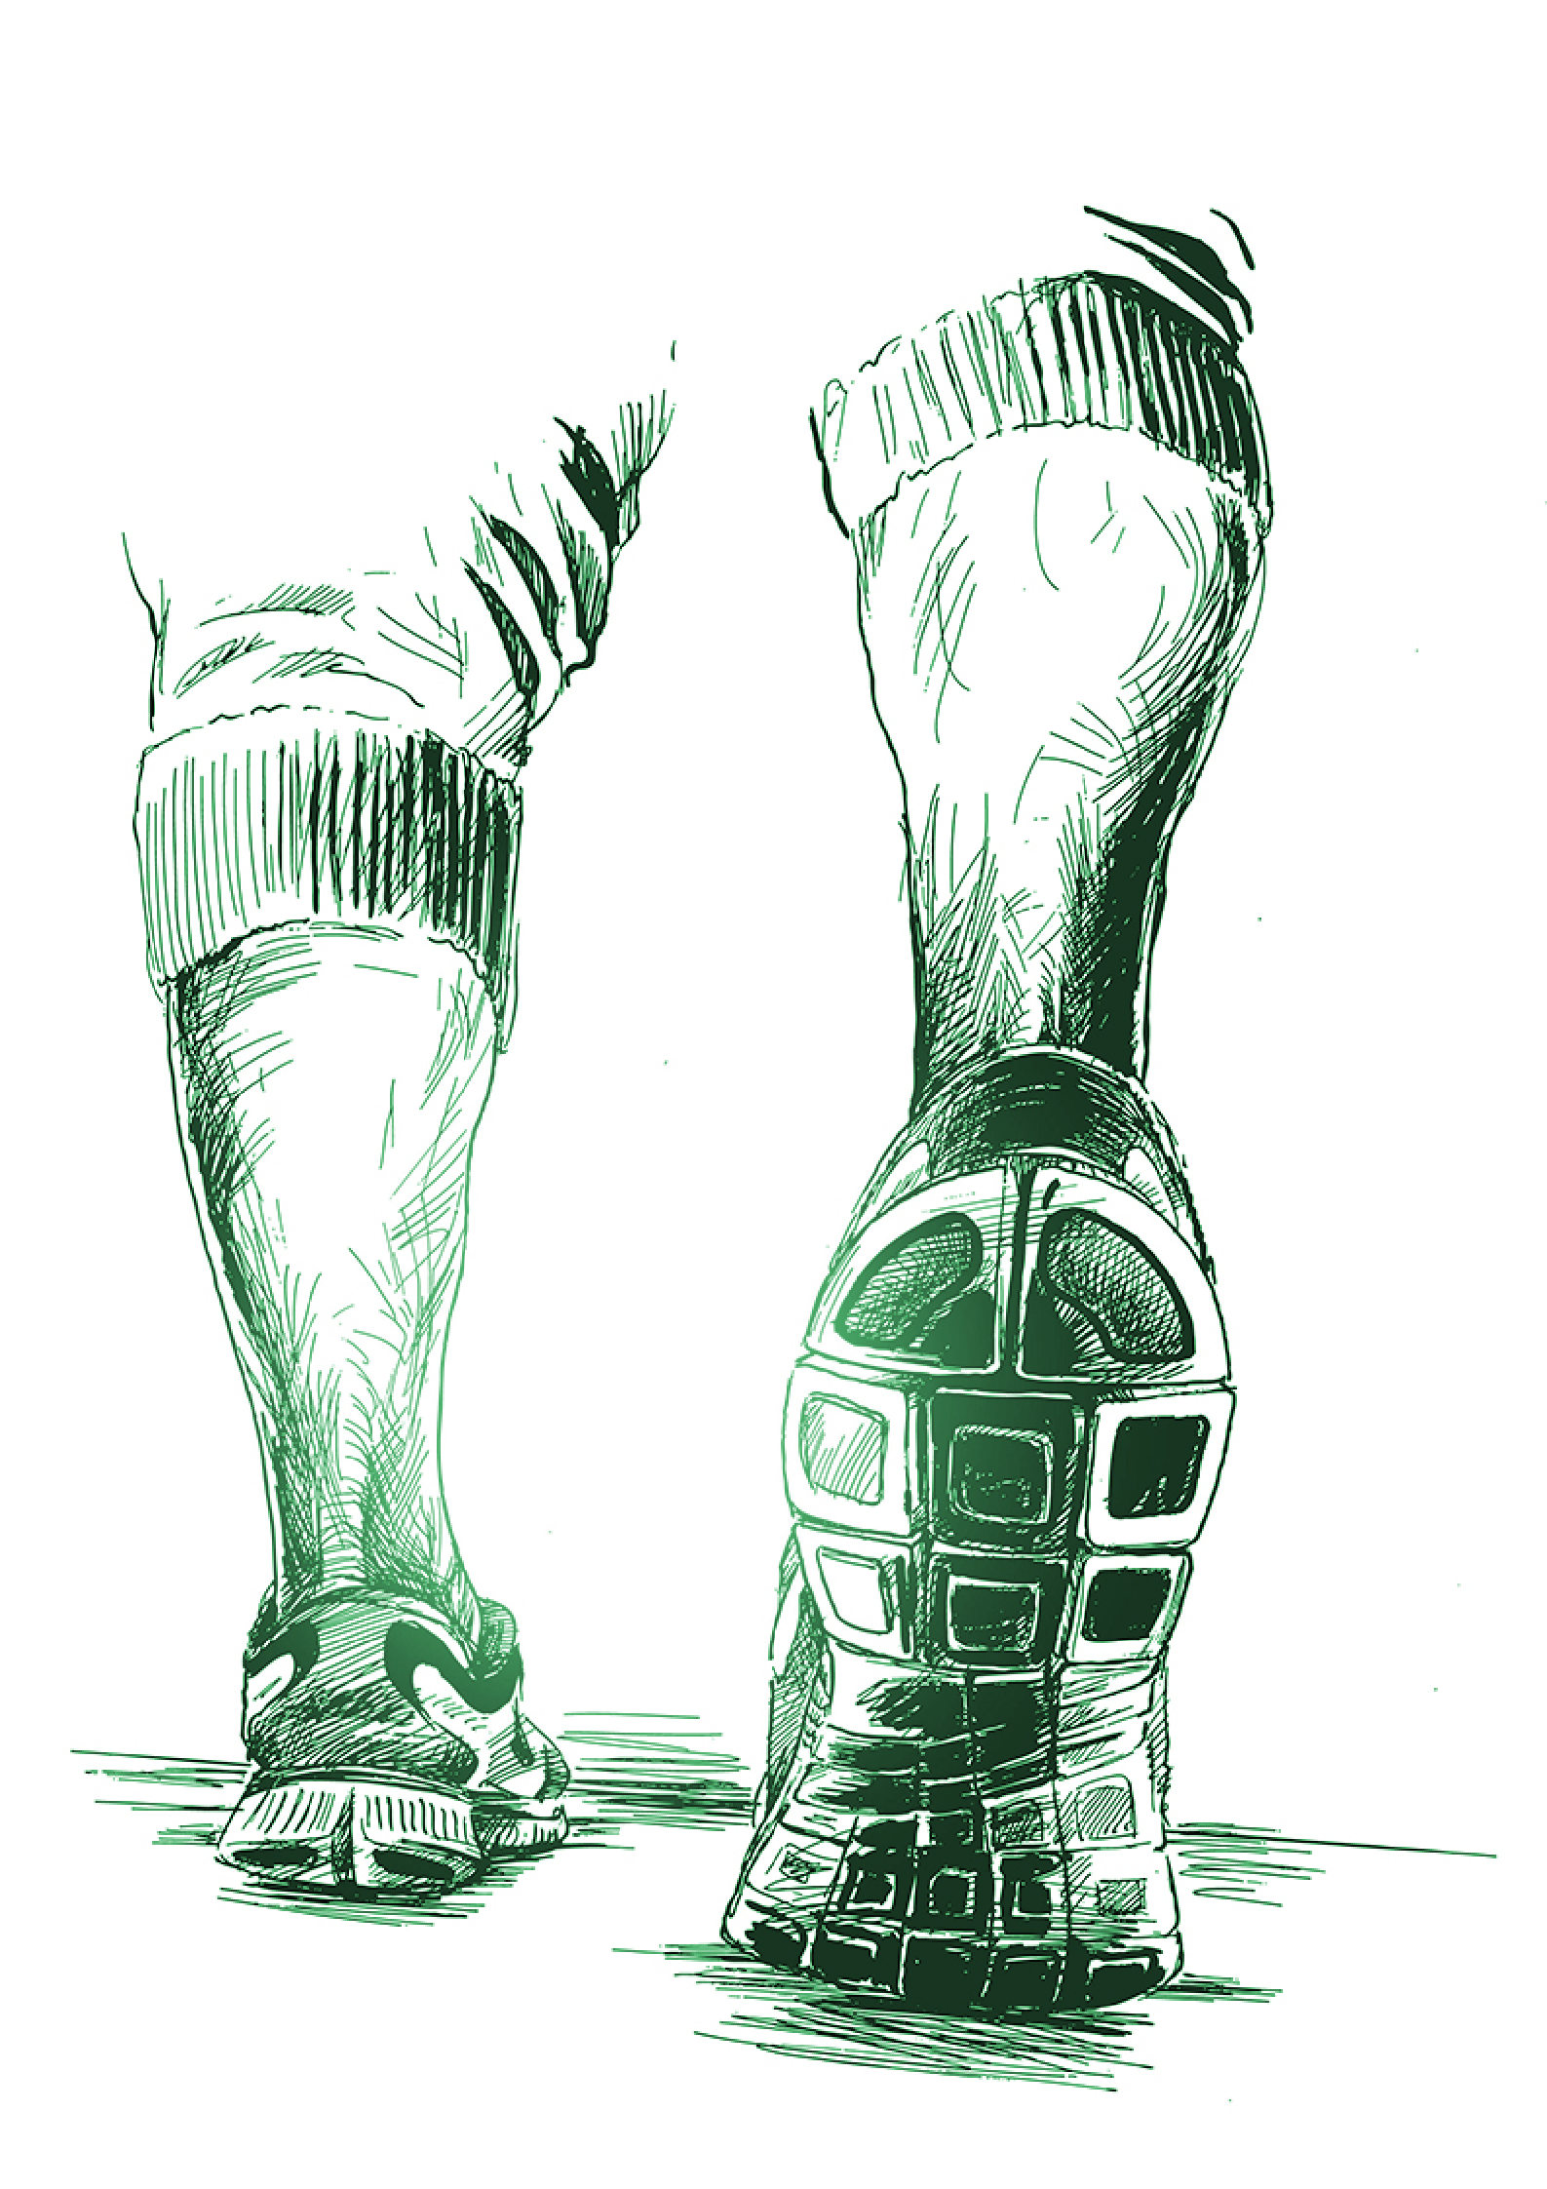
event

19th June 2025
schedule
THURSDAY

74

ISAPA 2025 TIMETABLE - THURSDAY
TIME | PLENARY ROOM | KSA HALL A | DUCHAS | KSA ROOM 1 ISAPA ANNEX
 | EARLY MORNING EXERCISE
08.30-18.00 | VISIT OUR ALL DAY TRADE EXHIBITION
08.30- 9:00 | REGISTRATION AND TEA & COFFEE
9:00 - 12:30 | Mental Health Summit (9:00 -  12:30) | Panel: Writing and Reviewing for APAQ:  A Panel Discussion with the Editor and Associate Editors (1008) (9:00 - 10:00)  Oral presentations (1047, 1087, 1107, 1192,  1163) | Oral presentations ( 1037, 1222, 1093,  1201, 1115)  Oral presentations (1128, 1118, 1111,  1057, 1149) | Oral Oral  presentations presentations (1204, 1126, (1220, 1212, 1997,  1021, 1160, ) 1228, 1230)  Human Rights Oral Forum with Active presentations Disability Ireland (1059, 1119, 1120,  (11.45- 12.30) 1058, 1157)
12:00-13:00 | ROLLING LUNCH & POSTER PRESENTATIONS*
13:00 -17:00 |  | UNESCO ISAPA |  | MENTAL HEALTH
 |  | INTERNATIONAL |  | SUMMIT
 |  | CONSULTATION |  | DEMONSTRATIONS
 |  | (12.30 - 17:00) |  | (13:30 - 16:30)
 |  | KSA HALL A |  | SOLAS BUILDING
15:00 -16:30 | TEA & COFFEE
19.00-on-  wards | DRINK RECEPTION & MUSIC RECITAL  IFAPA Awards  GALA DINNER

#ISAPA2025

75

THURSDAY
schedule
MENTAL HEALTH SUMMIT WELCOME

TIME | TITLE | VENUE
09:00-12:30 | John Farrelly CE of the Mental Health Commission Ireland,  Professor Maggie Cusack President of Munster  Technological University (MTU) and Dr Gerardina Harnett, Head of Department of Nursing, Mental Health Nursing and Health- care Sciences at MTU. (#3017) | Plenary Room

MENTAL HEALTH SUMMIT KEYNOTES

(See https://www.isapa2025.com/mental-health-summit)

TIME | TITLE | VENUE
09:00-12:30 | Professor Ahmed Hankir, MBChB, MRCPsych,  Consultant Psychiatrist, 2022 Recipient of WHO Director-Gener-  al Award for Global Health (#3007) | Plenary Room
09:00-12:30 | Dr. Karen O’Connor, the National Clinical Lead for Early  Intervention in Psychosis in Ireland (#3008) | Plenary Room
09:00-12:30 | Aoife Ní Mhuirí BSc (Physiotherapy), MSc (Sports Medicine), is the CEO and Founder of Salaso Health Solutions (#3009) | Plenary Room

PANEL

TIME | TITLE | VENUE
09:00-12:30 | Special Olympics Mental Health Resource Co-Creation (#3010) | Plenary Room
09:00-12:30 | Keynotes join a panel with David Donoghue was the Ambassador of Ireland to the United Nations who negotiated Agenda 2030 and the Sustainable Development Goals and Niall Muldoon Dr Niall Muldoon is the Ombudsman for Children. His job is to ensure that children in Ireland are treated fairly. (#3011) | Plenary Room
09:00-10:00 | Writing and Reviewing for APAQ: A Panel Discussion with the Editor and Associate Editors (#1008) | KSA Hall A
11:45 – 12:30 | Active Disability Youth Forum Panel- Niall Muldoon, Eve Grace, Ailis Malone, Annie Donnelly 11:45 – 12:30 KSA Room 1 –(Panel Discussion) #8000 | KSA ROOM 1

76

THURSDAY
schedule
ORAL PRESENTATIONS (RESEARCH /ACADEMIC)

TIME | TITLE | AUTHORS | VENUE
09:00-10:30 | "Impact of a 12-week Motor Skill Intervention on Gross Motor Skill Proficiency and Adaptive Behaviour in Children Aged 3-5 years with ASD" (#1160) | Hannah Lywood, Meghann Lloyd | KSA Room 1
09:00-10:30 | “Educating volunteers with disa- bilities to work at sport events - a chance to enhance sport participa- tion" (#1093) | Marlene Jobst, Christoph Kreinbucher-Bekerle | Duchas
09:00-10:30 | "The effects of physical activity timing and adherence to physical activity guidelines on sleep in chil- dren with ADHD" (#1037) | Xiao Liang, Hui Qiu, Mengping Zhao, Nan Liu, Huan Richard Xu | Duchas
09:00-10:30 | #WheelchairBBStories: "A co-de- signed resource for accessible dis- semination of research" (#1021) | Lesley M Sharpe, Janine K Coates, Victoria Goos- ey-Tolfrey | KSA Room 1
09:00-10:30 | "Exploring community-based organizations and their efforts to foster the physical literacy journey for all" (#1126) | Kyle Pushkarenko | KSA Room 1
09:00-10:30 | "The role of the Paralympics in the context of the perception of peo- ple with disabilities in (competitive) sport" (#1201) | Sina Prof. Dr. Eghbalpour, Liane Prof. Dr. Schir-  ra-Weirich | Duchas
09:00-10:30 | “It’s like a big family reunion”: Parent experiences of a national wheel- chair basketball tournament in the United States (#1204) | Katherine E Holland, Steven K Holland, Cathy McKay | Duchas
09:00-10:30 | "Barriers to Sports Participation amongst Youth Refugees with Disa- bilities in Kenya: A Case of Kakuma Refugee Camp" (#1228) | Edinah Sabiri | ISAPA Annex
09:00-10:30 | "Identity Formation and Social Ben- efits at the Intersection of Disability and Fitness: Leveraging Disabled Lived Experience to Re-Evaluate Physical Activity" (#1197) | Cade Kuehl | ISAPA Annex
09:00-10:30 | A behaviour analysis of adult nu- trition behaviours and technology use of individuals living with severe mental illness in high support hos- tels in Ireland. (#1069) | Ciara M O'Sullivan, Alison Merrotsy, Indika Dhana- pala, Tara Coppinger | ISAPA Annex

77

THURSDAY
schedule
ORAL PRESENTATIONS (RESEARCH /ACADEMIC)

TIME | TITLE | AUTHORS | VENUE
09:00-10:30 | “Trajectories of Leisure-Time Physi- cal Activity and Influencing Factors among Mid-dle-Aged and Older Adults with Disabilities (#1220) | Areum Han, Jooyeon Jin | ISAPA Annex
09:00-10:30 | The Effects of a Digital Physical Activity Intervention On Individuals with a Severe Mental Illness. (#1082) | Shannon Aisling Forde | KSA Room 1
09:00-10:30 | "Reaching In and Reaching Out: Lessons Learned from the Co-De- velopment and Co-Implementation of a Community-Engaged Physical Literacy Program" (#1230) | Kyoung June Yi | ISAPA Annex
09:00-10:30 | Move to Improve: An 8-week, coach- led fundamental movement skill intervention for children with intellectual disabilities (#1115) | Hayley Kavanagh, Sa- rah Meegan, Nathan Gavigan, Valerie Carson, Morgan Potter, Mika Manninen | Duchas
09:00-10:30 | "Move to Improve: An 8-week, coach-led fundamental movement skill intervention for children with intellectual disabilities" (#1115) | Hayley Kavanagh, Sa- rah Meegan, Nathan Gavigan, Valerie Carson, Morgan Potter, Mika Manninen | Duchas
10:30-12.00 | "Active learning strategies in adapt- ed physical education courses in higher education (#1057) | Otávio Luis Piva da Cunha Furtado, Justin Haegele, Roberta Cavei- ro Gaspar | Duchas
10:30-12.00 | "Affective Reflective Theory: An Exploratory Study of the Exercise Experiences of Elite Wheelchair Curlers" (#1149) | Jeffrey Martin, Klara Dadova, Eva Prokesova, Jitka Varekova, Drew J Martin | Duchas
10:30-12.00 | "Increasing inclusivity for wheelchair users: Scaling up clinical-based wheelchair skills training into com- munity sport and recreation pro- gramming". (#1059) | Jenna Smith, Kelly Ar- bour-Nicitopoulos, Krista Best, Ashley Stirling | ISAPA Annex
10:30-12.00 | "Exploration and Practice of KDL Motor Intervention for Children with Special Needs" (#1119) | Xiaozan Wang, Qinping Xu, Meiyuan Chen, Yue- mei Lu | ISAPA Annex
10:30-12.00 | "The Influence of an Inter-University Collaborative on the Socialization of Adapted Physical Activity Doctoral Students" (#1120) | Paul H. Warner, Paul R Malinowski, Kevin A. Richards, Peter Rifen- burg, Wesley J. Wilson | ISAPA Annex
10:30-12.00 | “A Systematic Review of the Effects of Exercise on Gross Motor Skills and Social Abilities in Children with Autism" (#1111) | Jiawei Luo, Yun Li | Duchas
10:30-12.00 | "Parents of Athletes in Competitive  Paralympic Sports" (#1047) | Alina Vogel | KSA Room 1
78

THURSDAY
schedule
ORAL PRESENTATIONS (RESEARCH /ACADEMIC)

TIME | TITLE | AUTHORS | VENUE
10:30-12.00 | "Impact of Physical Activity on Qual- ity of Life: Examining the Quality of Life of People with Developmental Disabilities in South Korea Using the 2023 Work and Life Status Survey" (#1128) | Jiyeon Kim | Duchas
10:30-12.00 | "Participation of People with Impair- ments in Shaping Accessible Sports Facility Standards: Opportunities and Obstacles" (#1058) | Jonas Wibowo, Lasse Müller | ISAPA Annex
10:30-12.00 | “Physical activity (PA) and barriers of adults with special needs – how do age, gender, living environment and the nature of special needs affect it ?"(#1163) | Timo Ala-Vähälä, Venla Väyrynen | ISAPA Annex
10:30-12.00 | "Belonging and inclusion in Norwe- gian PE: An amplified analysis of supervised master’s theses" (#1192) | Steven K. Holland, Katherine Holland, Oda Innvær, Nora Klaussen, Ingrid Kissten, Maren Østby | ISAPA Annex
10:30-12.00 | "Active play among young children (0-4 years) with disabilities: A scop- ing review" (#1107) | Alessia M. Capone, Kelly Arbour-Nicitopoulos, Louise de Lannoy, Su- zanne Deliscar, Leah G. Taylor, Patricia Tucker, Leigh M. Vanderloo, Maeghan E. James | ISAPA Annex
10:30-12.00 | "The Impact of Service-learning on Undergraduate Kinesiology Majors’ Self-efficacy Toward Working with individuals with Disabilities" (#1087) | Michihito Ichihara, Chloe Simpson, Ken hansen, Mai Narasaki Jara | ISAPA Annex
10:30-12.00 | "Move and Thrive: Effectiveness of a Structured Motor Intervention on Motor Behaviors and Social De- velopment in Children with Autism Spectrum Disorder" (#1118) | Yuemei Lu, Chenjun Zong, Zichao Zhang, Zhi- hui Li, Xiaozan Wang | ISAPA Annex
10:30-12.00 | "AI-Driven Adapted Physical Activity to Promote Health and Mobility for Frail Older Adults" (#1157) | Yijian Yang, Xiaoping Zheng, Jingwen Pan, Ka Po Chan | ISAPA Annex
10:30-12.00 | "The Influence of an Inter-University Collaborative on the Socialization of Adapted Physical Activity Doctoral Students" (#1120) | Paul H. Warner, Paul R Malinowski, Kevin A. Richards, Peter Rifen- burg, Wesley J. Wilson | ISAPA Annex

79

POSTER PRESENTATION

THURSDAY
schedule

TIME | TITLE | AUTHORS | VENUE
12:00-13:00 | "Mediating Role of Self-determined Motivation in the Relationship between Mindfulness and Intention toward Physical Activity among In- dividuals with Physical Disabilities" (#1181) | Jaehwa Kim | ISAPA Gallery
12:00-13:00 | “Analyzing the Intention to Use Dig- ital Technology in Physical Activities for People with Disabilities: A Study Based on the Theory of Planned Behavior" (#1183) | Hyunsu Lee, | ISAPA Gallery
12:00-13:00 | "Brazilian Physical Education Un- dergraduate Students' Attitudes Toward Dif-ferent Types of Disabili- ty" (#1124) | Doralice Lange de Souza | ISAPA Gallery
12:00-13:00 | "An Investigation on Parental Perceived Motor Competence in Children on the autism spectrum" (#1134) | Zhihui Li | ISAPA Gallery
12:00-13:00 | "The Effect of Exercise Program on Musculoskeletal Changes in Individ- uals with Diabetic Foot Syndrome" (#1139) | Eliška Vrátná, | ISAPA Gallery
12:00-13:00 | "Move Smart MS - Online phys- ical activity and education pro- grammes" (#1143) | Susan Coote | ISAPA Gallery
12:00-13:00 | "A Study on the Correlation Between Actual motor competence and Parental Perceived Motor Abilities in Children with Autism Spectrum Disorder" (#1146)) | Chenjun Zong | ISAPA Gallery
12:00-13:00 | "Football as a tool helping to tackle  social issues" (#1151) | Julie Wittmannová, | ISAPA Gallery
12:00-13:00 | "Incorporating "Exercise Snacks" into School Lunch Breaks Promotes Cardi-orespiratory Fitness and  Self-perceived Physical Compe- tence among Adoles-cents with Attention-Deficit/Hyperactivity  Disorder" (#1156) | Jinghao Sui | ISAPA Gallery
12:00-13:00 | “Physical Fitness Levels of Adult Special Olympics Athletes Across Sports" (#1171) | Hanna H Lee | ISAPA Gallery
12:00-13:00 | "A Two-Year Study on Dual-Task In- terventions: Advancing Elderly Care in Community Settings" (#1041) | Kameliya Konstantinova, | ISAPA Gallery
19:00-23:30  0 | Gala Dinner. Dress Code -evening wear or national costume/dress. Ticket required. (#3016)

8

THURSDAY
schedule

UNESCO ISAPA INTERNATIONAL CONSULTATION
(See: https://www.isapa2025.com/paris-follow-up)

TIME | TITLE | VENUE
12:30-17:00 | Policy Change for Disability Inclusion in Sport: Paris 2024 Call to Action Follow-Up (#3012) | KSA HALL A

MENTAL HEALTH SUMMIT DEMONSTRATIONS

TIME | TITLE | VENUE | VENUE
13:30-16:30 | Demonstration of Salaso’s Smart Therapy Engage-  ment Platform as a Service – STEPS (#3013) | Aoife Ní Mhuirí | Solas Building
13:30-16:30 | Demonstration of Dr Rebecca Spelman Private Therapy Clinic. (#3013) | Rebecca Spelman | Solas Building
13:30-16:30 | Presentation : "A behaviour analysis of adult nutri- tion behaviours and technology use of individuals living with severe mental illness in high support hostels in Ireland". (# 1069) | Ciara M O'Sul- livan, Alison Merrotsy, Indika Dhanapala, Tara Coppinger | ISAPA Annex
13:30-16:30 | Presentation "The Effects of a Digital Physical Activity Intervention On Individuals with a Severe Mental Illness". #1082 | Shannon Aisling Forde, Dr. Susan Rea and Dr. Tara Coppinger | KSA Room 1
13:30-16:30 | Guided Tour -MTU Mental and Physical Health Simulation Suite  (3014) | Una Cronin | Solas Building

IFAPA AWARDS & GALA DINNER

TIME | TITLE | VENUE
19:00-21:00 | This highly anticipated Gala Dinner and IFAPA awards are a not to miss event on the program. Everyone is welcome, includ- ing your guests, but you must have a ticket to attend. Wear evening wear or a national dress/costume. The Gala Dinner will be an exceptional evening of celebration of Irish culture, food, music, and hospitality. We highly recommend attending. The recipients of the IFAPA Awards will be announced on the night. (#3015) | Ballygarry Hotel

81







ISAPA 2025
GALA DINNER & IFAPA AWARDS

YOU ARE WARMLY INVITED TO THE HIGHLY ANTICIPATED GALA DINNER AND IFAPA AWARDS.

Held at the beautiful Ballygarry Hotel, this special evening will celebrate Irish culture, food, music, and hospitality in an unforgettable setting. The recipients of the prestigious IFAPA Awards will be announced during the event.

The evening will commence at 7:00 PM and continue into the late evening.

Dress code: Formal evening wear or national dress/costume.

Hosted by MTU and the International Federation of Adapted Physical Activity (IFAPA)

82

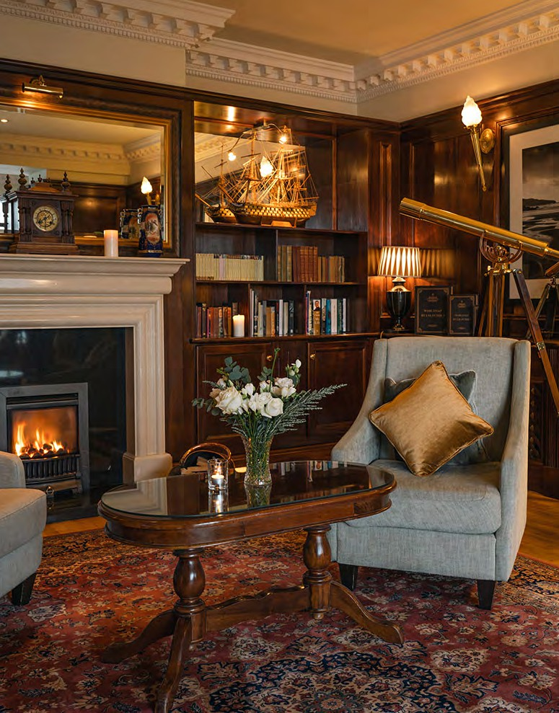

BALLYGARRY HOTEL
83



20th June 2025
event
schedule
FRIDAY

84

ISAPA 2025 TIMETABLE - FRIDAY

TIME | KERRY SPORTS ACADEMY
08:30-9:00 | TEA & COFFEE
9.00-13:00 | International Symposi- | Inclusive | INGENIUM Mental | Special Excursions
 | um on Physical Activity | Dance | Health Research | Olympics or Golf
 | and Visual Impairment |  | Partnership | International (self-funded)
 | or Deafblindness CPD |  |  | MATP (11:00-
 | Practical sessions |  |  | 15.30)
13.00-14:00 | LUNCH
14:00-17:00 | International Symposium |  | Special Olympics | Excursions
 | on Physical Activity & |  | International MATP | or Golf
 | Visual Impairment or |  | (11:00-15.30) | (self-funded)
 | Deafblindness CPD
 | Practical sessions
17:00 -17:30 | TEA & COFFEE

Capture. Connect. Celebrate.

#ISAPA2025

85

FRIDAY
schedule

MASTERCLASS

TIME | TITLE |  | VENUE
9:30-13:00 | APA for Visual Impairment and  Deafblindness (#3018) | Laura Libermann | KSA Workshop 1, KSA Hall B & Pitch 2
9:30-13:00 | Introduction to Special Olympics MAPT certified training at ISAPA 2025 (#3019) | Niamh E Mourton, Martin Block, Eleni Rossides, Ken Black, Shaun Hen- nessey, Jeff Lahart | KSA Hall C
09:00-12:30 | Irish Dancing :An Inclucive Approach | Sharon Phelan | KSA Dance Studio

MEETING

TIME | TITLE | VENUE
9:30-14:00  Meeting closed | INGENIUM Research Partnership on Mental Health Tara Cop- pinger & Catherine Carty (#3020). INGENIUM Partners from MTU, South Eastern Finland University of Applied Sciences  – XAMK (Finland), Gabriele d‘Annunzio“ University Chieti – Pes- cara (Italy), University of Skövde (Sweden) will advance re- search objectives on lifestyle interventions and digital  technology for mental health. | U306

EXCURSIONS (SELF-FUNDED)

TIME | TITLE |  | VENUE
07:00-20:00 | TRIPS (#3021) or Golf | Sonya Hannon | Various

86

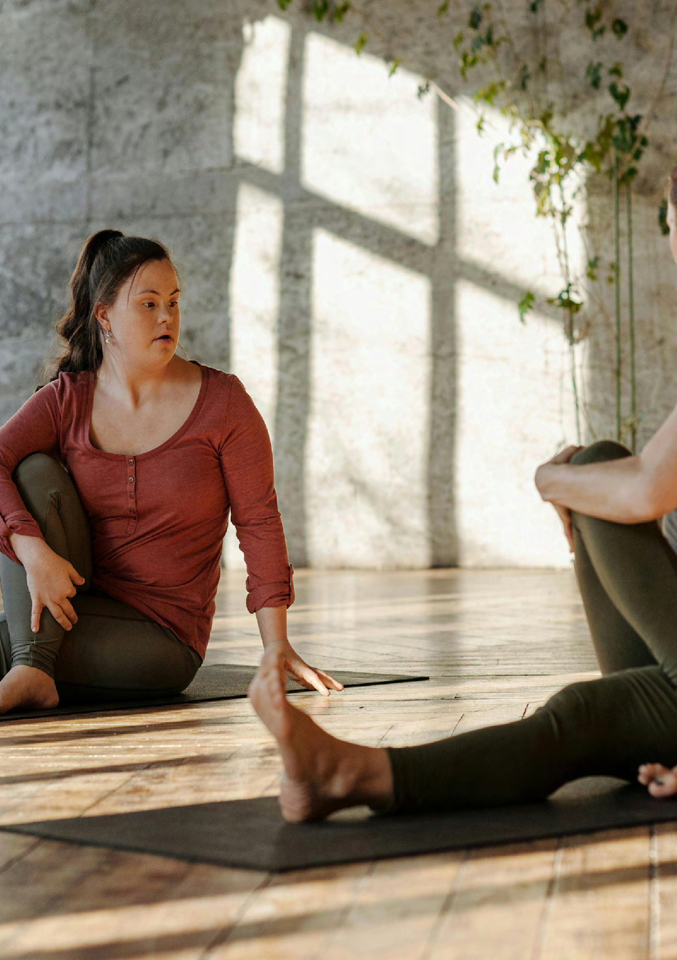

87

CLOSING MESSAGE

As ISAPA 2025 draws to a close, we extend our heartfelt thanks to all presenters, delegates, exhibitors, partners, staff and volunteers who have joined us from across the globe. Your cont- ributions, rooted in research, practice, policy, and lived experience, have made this gathering not just a symposium, but a movement.
Throughout this week, we have explored the theme "Nothing about us, without us: Inclusivi- zing our world and creating opportunities to thrive." We have challenged assumptions, shared innovations, and amplified the call for equity, dignity, and participation for all in physical acti- vity, sport, education, and community life.
But ISAPA 2025 is not an endpoint, it is a catalyst.
The conversations started here must ripple outward: into schools and universities, into sport policy and practice, into cities and rural communities. We urge each of you to take forward what you have learned, to build alliances, to implement change, and to challenge the struc- tures that exclude.
We close this programme with a collective commitment to:
- Shift the dial on inclusion, from awareness to action.
- Empower people with disabilities through meaningful participation.
- Partner across sectors and borders for systemic change.
- Transform the narrative of what is possible in and through adapted physical activity.
Together, let us move from inspiration to implementation and continue this journey toward a more inclusive, active, and just world. We thank you for being part of ISAPA 2025. We look forward to meeting again in Jordan in 2027.
The ISAPA 2025 Organising Committee together with President of IFAPA, Cindy Sit, Chinese University of Hong Kong, Catherine Carty, UNESCO Chair Manager MTU, Director ISAPA 2025.

88



89

“Where, after all, do universal human rights begin? In small places, close to home - so close and so small that they cannot be seen on any maps of the world. Yet they are the world of the individual person; the neighbourhood he lives in; the school or college he attends; the factory, farm, or office where he works. Such are the places where every man, woman, and child seeks equal justice, equal opportunity, equal dignity without discrimination. Unless these rights have meaning there, they have little meaning anywhere. Without concerted citizen action to uphold them close to home, we shall look in vain for pro- gress in the larger world”
— Eleanor Roosevelt

90

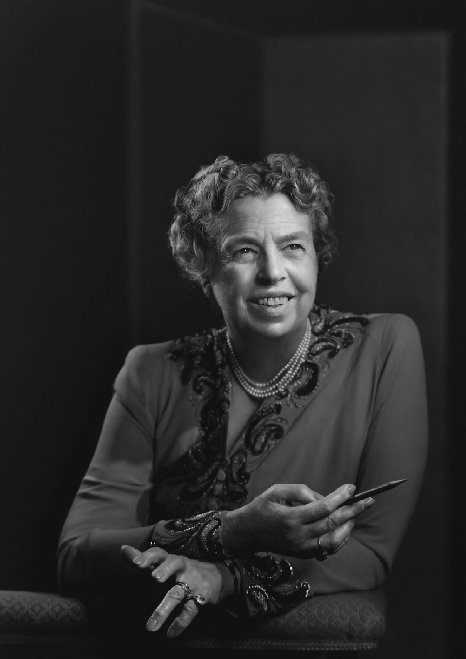

— Eleanor Roosevelt
91

With Gratitude: Behind the Scenes at ISAPA

They say teamwork makes the dream work, and that truth brought ISAPA to life. This note is a heartfelt tribute to the many behind-the-scenes enablers without whom this event simply would not have been possible. We extend our deepest gratitude to Sonya Hannon, the administrator of the UNESCO Chair. Sonya worked tirelessly with enthusiasm, generosity, and commitment; her dedication has been instrumental in bringing the ISAPA vision to reality.

We also wish to acknowledge the invaluable contributions of:
- Dr. Gerard Masdeu Yelamos, UNESCO Chair Researcher and Chair of the Scientific Committee, and his Co-Chair, Dr. Seán Healy (University of Limerick), for their expert oversight and leadership, as well as Sinéad Hanrahan, MTU Librarian, for her steadfast support with the SWORD system.

92

MTU Interns Brenda Giblin, Nicole Walker, and Clodagh Hickey, who joined the UNESCO Chair team and jumped in with critical skills and multi-tasking ability to deliver the goods.
Tomas Aylward, ultimate professional, master trouble-shooter and all-around full solution fixer. Liam McCarthy and his AV services team, Niall Twomey and Chris Bradshaw, for going above and beyond to enhance the accessibility and technical delivery of this event.
- Una Moynihan and Alan O’Callaghan, for ensuring seamless transport logistics.
•Ursula Barrett and Bríd Brown, for their vital work on accessibility coordination.
- Matías Henríquez and Kwok Ng, for their exceptional IFAPA communications support.
•Ayşegül Rosa Aksoy, International Volunteer Program Coordinator, and all the Volunteers who gave their time and energy so generously.

To our broader support network:
Susan McGillicuddy and the dedicated Finance Team, as well as Ciara Looney and Hugh McGlynn, our finance committee, Phil McSweeney, Sophie Casey, and the Skills for Life Team. We also gratefully acknowledge the contributions of our essential services teams, Human Resources, Estates, Health and Safety, Maintenance, Security, Caretaking, Technicians, Catering, and Cleaning, for keeping everything running smoothly.
To the many individuals who stepped in at critical moments, Eimear Foley, Edel Randles, Michael Hall, Eileen Sayers, Siobhán Creedon, Teresa Richardson, Derville Spring, Jackie Gallagher, Connie McHugh, Ciara Buckley, Melissa Hurley, Neasa O’Flaherty, Barry Murray and Ronan Doyle, thank you for your responsiveness, flexibility, and support in delivering a seamless experience.

Dr. Seamus O’Shea, Mary Rose Stafford, Tim Daly, your rallying calls were heard and appreciated. Hazel Byrne and her team in KSA for their continued collaboration. We also acknowledge the encouraging leadership and support of Gerardina Harnett and her team, including Una Cronin and Martha Spangler in the Nursing Department for your input on the Mental Health Summit.

93

With Gratitude: Behind the Scenes at ISAPA

We also want to extend our sincere gratitude to the talented creatives and developers whose efforts have made ISAPA 2025 possible.
Your innovation, artistry, and commitment have played an essential role in delivering a memorable and meaningful experience for all participants.

ROSIE DEMPSEY - ISAPA 2025 Program Designer

Rosie Dempsey is a creative and product designer with over 20 years of experience in education at MTU. She has played a key role in numerous external projects across multiple design disciplines. contributing her expertise as a designer, consultant, and project manager. A passionate advocate for disability inclusion, she greatly valued the opportunity to be part of the ISAPA 2025 conference and extends her warmest wishes to Catherine Carty, Manager of the UNESCO Chair at MTU, and her continued success.

KARL O’ SULLIVAN Fenit Without
ISAPA Website Designer
https://www.fenitwithout.ie

CROWDCOMMS
ISAPA App Design & Development

https://www.crowdcomms.com

THE FOUNDATION AGENCY
ISAPA Logo design & Shift the Dial design.
https://thefoundation.agency

94



95



Thank you for being part of ISAPA 2025.
Let’s continue to shift the dial, championing inclusion, equity, and action in every space we move through.
Go raibh míle maith agaibh – thank you all. Until we meet again, keep moving forward.




Under the Patronage of

